Alameda County Workforce Development Board
Local Plan- 2017 to 2020


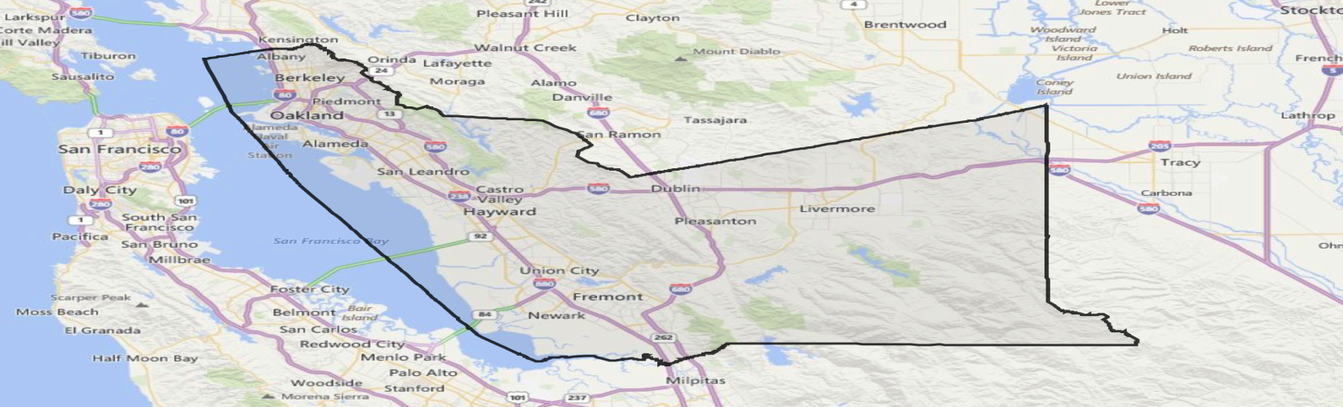

For the Alameda County Local Workforce Development Area

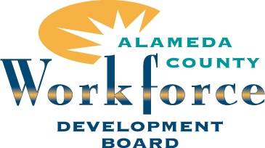

Executive Summary

Alameda County Workforce Development Board

The Alameda County Workforce Development Board (ACWDB) is a 27-member business-led group, appointed by the County of Alameda Board of Supervisor and legislated through the Workforce Innovation and Opportunity Act (WIOA). ACWDB is charged with strengthening workforce development efforts in Alameda County (outside the city of Oakland), setting program policies in alignment with WIOA, and providing administrative oversight of service providers responsible for implementing programs for youth, adult, dislocated and incumbent workers, and employers in Alameda County.

ACWDB’s Mission and Strategic Direction
ACWDB’s mission statement is: “To provide employers and job seekers with universal access to tools, resources and services that assist them with obtaining their employment and business goals.” ACWDB sets the strategic direction for workforce development in Alameda County and convenes employers, workforce development professionals, economic development partners, educational partners and providers, and other related stakeholders to set and implement local priorities that contribute to workforce development. Through its America’s Jobs Centers of California (AJCC), ACWDB provides direct support to jobseekers through a wide array of employment, training, and referral services, and utilizes the workforce development system to engage local employers, understand their hiring needs, and pipeline talented candidates into local businesses. Through its many discretionary grants and initiatives, ACWDB’s legacy of success continues to distinguish itself in addressing the special needs of industry/employers as well as the Veterans, long-term unemployed, and the returning citizens’ populations.

Standing firm on its commitment to a job-driven system, ACWDB provides business services through a unique two-tiered structure designed to engage employers in Alameda County. An internal and dedicated Business Services Unit (BSU) provides Tier I services. The BSU offers customized and cost-effective solutions such as: providing opportunities for customized trainings to meet the needs of employers, Business Assistance Program for advanced manufacturing companies, Rapid Response and Lay-Off Aversion Services, access to regional and economic development information, including Labor Market Information (LMI), business referrals and networking opportunities. The Alameda County Business Development Group (ACBDG) provides Tier II services on the behalf of ACWDB as the Employer Services Hub (ESH), and provides full scope business services to employers in Alameda County. ACBDG facilitates access to tax incentives, such as the Workforce Opportunity Tax Credit (WOTC), On-the-Job Training (OJT) and Customized Training (CT) opportunities and coordinates with AJCCs to create a venue for on-site recruitments, and business-to-business networking opportunities.

Furthering its commitment to employers and industry partnerships in the region, ACWDB is an ongoing and dedicated partner of the East Bay SlingShot Initiative (EBSSI), in partnership with the Workforce Development Board of Contra Costa County and the other local workforce development boards (LWDBs) in the region. EBSSI aims to strengthen regional economic prosperity and improve income mobility by creating stronger relationships between employers and community partners in the region’s key industries: Health Care, Information Communications Technology (ICT), Biomedical, Advanced Manufacturing and Transportation/Logistics.

Regional Context
ACWDB and the neighboring WDBs (in Contra Costa County, the City of Oakland, and the City of Richmond), together constitute the East Bay Regional Planning Unit (RPU). In this booming part of the San Francisco Bay Area, multiple industries are projected to exponentially grow over the next eight to ten years, including Construction and Information Services. Job openings are projected to increase in Health Care and technical trades. While the East Bay expects this growth, it also foresees challenges in serving its diverse population. The region is incredibly diverse in its racial composition and boasts high educational attainment levels (49.9% of individuals have a Bachelor’s degree or higher).

However, ACWDB faces multiple challenges to serving individuals with barriers to employment. 28.0% of Alameda County’s population consists of immigrants and 16.7% of the population, speaks English less than “very well.” These figures bring implications for how cultural sensitivity and translation services must be integrated into service delivery strategies. Over 72,000 households receive cash public assistance or food stamps and 12% of individuals live below the poverty level. Given the increasing cost of living and growing skills and knowledge requirements for jobs, the approximately 400,000 individuals with only a High School diploma may face barriers to obtaining livable wage jobs. ACWDB is tasked with aligning employment and training services to fit the individual needs of jobseekers and to support local employers with talent. It is through this Local Plan that ACWDB provides the strategies and insights needed to further close the gap to employment and continue to boost economic growth across Alameda County and the East Bay region.

Vision of the Local Plan
This 4-year Local Plan serves as a strategic road map to develop a job-driven workforce system in Alameda County. It aligns with the strategies set forth in the East Bay Regional Plan to support economic growth, while facilitating increased access to training and workforce development programs across the East Bay. It is ACWDB’s aim to utilize this plan to further drive income mobility to jobseekers, dislocated and incumbent workers, and individuals with barriers to employment. ACWDB will also utilize the Local Plan as a foundation for proactively engaging employers in Alameda County to facilitate growth and an active supply of qualified workers

This Local Plan articulates ACWDB’s strategies to implement the State’s three primary policy objectives articulated in California’s Unified Strategic Workforce Development Plan. These objectives are as follows:
- Fostering “demand-driven skills attainment” – Workforce and education programs need to align program content with the State’s industry sector needs so as to provide California’s employers and businesses with the skilled workforce necessary to compete in the global economy.
- Enabling upward mobility for all Californians, including populations with barriers to employment. Workforce and education programs need to be accessible for all Californians and ensure that everyone has access to a marketable set of skills, and is able to access the level of education necessary to get a good job that ensures both economic self-sufficiency and economic security.
- Aligning, coordinating, and integrating programs and services to economize limited resources to achieve scale and impact, while also providing the right services to clients, based on each client’s particular and potentially unique needs, including any needs for skills development.

TABLE OF CONTENTS
A. Vision, Goals, and Strategy 6
i. Strategic Vision for Regional Economic Growth and Self-Sufficiency 6
ii. Core Programs and Alignment of Resources 9
B. Local Program Alignment to Implement State Plan Policy Strategies 10
i. Description of the Local Workforce Development System 10
ii. Local Board Support of Seven State Policy Strategies 12
C. Specified Services and Service Delivery Strategies 13
i. Core Programs and Access to Employment, Training, Education, and Supportive Services 13
ii. Career Pathways Development and Co-Enrollment in Core Programs 14
iii. Post-Secondary Credentials and Industry-Recognized Certifications 15
iv. Employer Engagement in Workforce Development Programs 16
v. Meeting the Needs of Local Business 18
vi. Coordination between Workforce Development with Economic Development 19
vii. Strengthen Linkages with Unemployment Insurance Programs 20
D. America’s Job Centers of CaliforniaSM (AJCC) 20
i. Continuous Improvement of Eligible Service Providers 20
ii. Service Delivery in Remote Areas through Use of Technology 21
iii. Compliance with Americans with Disabilities Act of 1990 (42 U.S.C. 12101 et seq.) 22
iv. Roles and Resource Contributions of the AJCC partners 23
v. Executed MOUs and Cooperative Agreements 24
vi. Strategies to provide Indian and Native Americans with Equal Access to AJCC services (WIOA Section 166) 24
vii. Strategies to Provide Migrant Seasonal Farmworkers Equal Access to AJCC services (WIOA Section 167) 25
viii. AJCCs as an On-Ramp for the Regional Sector Pathways 25
E. Programs, Populations, and Partners 26
i. Coordination of Workforce and Economic Development Activities and Promotion of Entrepreneurial Skills Training and Microenterprise Services 26
ii. Adult and Dislocated Worker Employment and Training Activities 27
iii. Coordination of Rapid Response (RR) Activities 28
iv. Youth Workforce Development Activities 29
v. Coordination of Education and Workforce Development Activities 30
vi. Supportive Services 31
vii. Maximizing Coordination with Wagner-Peyser Act Services 32
viii. Title I Coordination with Title II Adult Education and Family Literacy Activities 33
ix. Services for Limited English Proficient Individuals 34
F. Grants and Grant Administration 34
i. Disbursal of Grant Funds 34
ii. Competitive Process to Award Sub-Grants and Contracts 35
G. Performance Goals 35
i. Negotiated Levels of Performance 35
H. High Performance Board (HPB) Efforts 36
i. Compliance with State Issued AJCC Policies 36
I. Training Activities and Services (WIOA Section 134) 37
i. Individual Training Accounts and Customer Choice 37
J. Public Transparency, Accessibility and Inclusivity 38
i. Public Comment Period 38
K. Common Intake and Case Management Efforts 39
i. Current Intake Processes and Allowance for Co-Enrollment 39
L. Other Miscellaneous Information 40
i. Title II Program Applicant Access to the Local Plan 40
ii. Priority of Service 40
iii. Portions of the Local Plan in the Regional Plan Narrative 41
M. Local Board Assurances 42
N. Comprehensive One-Stops and AJCC Partners in the Local Area 42
O. AJCC Memorandums of Understanding (MOU) 42
P. Local Area Grant Recipient Listing 42
Q. Local Board Bylaws 42
R. Administration Designee and Plan Signatures 42
S. Summary of Public Comments 42

ATTACHMENTS

Attachment A – Local Board Assurances – (CWDB Attachment 4)

Attachment B – Comprehensive One-Stops and AJCC Partners in the Local Area

Attachment C – AJCC Memorandums of Understanding (MOU)

Attachment D – Local Area Grant Recipient Listing – (CWDB Attachment 5)

Attachment E – Local Board Bylaws – (CWDB Attachment 6)

Attachment F – Administration Designee and Plan Signatures – (CWDB Attachment 7)
Attachment G – Summary of Public Comments – (CWDB Attachment 10)
Attachment H – Phase I MOU (Between ACWDB and WIOA Mandated Partners)
Attachment I – Table 1: ISOF Tier I Industries
Attachment J – ISOF as a Tiered System (graphic)

PY 2017-2020 Strategic Four-Year
Alameda County Workforce Development Board Local Plan

A. Vision, Goals, and Strategy

Strategic Vision for Regional Economic Growth and Self-Sufficiency
The Alameda County Workforce Development Board (ACWDB) is a business-led organization appointed by the County of Alameda Board of Supervisors that aims to execute and enhance workforce development efforts in Alameda County (outside the City of Oakland), within the East Bay of the San Francisco Bay Area (East Bay). ACWDB develops program policies in alignment with the Workforce Innovation and Opportunity Act (WIOA) and provides administrative oversight of the contractors who provide services to youth, adult, dislocated, and incumbent workers as well as employers in Alameda County. ACWDB’s vision is to create, ‘The best workforce development system that benefits both employers and jobseekers.’

Alameda County boasts a population of over 1.6 million individuals and a median household income of $75,619. As of 2015, Alameda County businesses continue to grow, with projected growth of 50,395 jobs between 2017 and 2022 and an unemployment rate of 4.4%. The dynamic economies of the Silicon Valley, San Francisco County and other surrounding regions, influence the local economy in Alameda County, with advances in technology and dynamic start-up companies. While the economy is increasingly expanding and growing, the high cost of living and high educational benchmarks needed to obtain and maintain local employment present barriers to employment for many in Alameda County and contribute to longer commutes as some relocate in search of more affordable housing. Wage stagnation also affects workers in the East Bay, causing many to linger in a financial holding pattern while the cost of living steadily increases. Consequently, jobseekers and incumbent workers are in need of upskilling and training opportunities that lead to industry-recognized credentials and job placement within local high-growth industries and occupations, to keep at pace with the ever-evolving and dynamic economy in the East Bay economy.

To address these needs under WIOA, ACWDB will continue to: develop service delivery strategies that address jobseekers’ varied employment and training needs regionally and sub-regionally; convene stakeholders in discussions, programs and initiatives that create a robust service delivery network; engage local employers in growing industries by providing them with qualified pools of job candidates; and provide direction for Alameda County to support economic prosperity for all of its residents. The following section details how key elements of the Local Plan that pertain to ACWDB’s vision and strategies to support regional growth and self-sufficiency across Alameda County:

1. Industry Sector and Occupation Prioritization: This effort allows ACWDB to target key employers in Alameda County and align jobseekers to high growth industries and occupations, while also providing quality services to key employers. ACWDB believes that by prioritizing key industries and occupations, it can foster a “demand-driven skills attainment” agenda and enable upward mobility for its residents. ACWDB has worked tirelessly to re-examine and re-define “priority industries and occupations.” In 2015 and in preparation for this 4-year Local Plan, ACWDB conducted a regional labor market study within Alameda County between 2017 and 2022. The study resulted in the formation of the Industry Sector and Occupational Framework (ISOF), which prioritized local industries and occupations in alignment with WIOA and the California Workforce Development Board’s (CWDB) Unified Strategic Workforce Development Plan (State Plan). ACWDB developed the ISOF model using sound research practices as well as qualitative interviews with key stakeholders. In recognition of the changes in cost of living in the Bay Area, ACWDB included wage criterion in the framework as well. The wage criterion for the prioritization of occupations in relation to existing contracts requires that the AJCC prioritize training for clients within occupations that exceed $19.20/hour. This is consistent with the State Board’s Strategic Plan in 2016. It is a goal of ACWDB to use the ISOF to prioritize middle skill occupations in the On-the-Job Training (OJT) and Individual Training Account (ITA) programs in the AJCCs that lead to industry-recognized certificates and credentials. Additionally, employer services [implemented by ACWDB’s contractor, the Alameda County Business Development Group (ACBDG)], also engages employers within the ISOF model to assist employers in meeting their talent needs and in developing OJT opportunities for jobseekers within the AJCCs, to develop a more seamless fit of employers and jobseekers.

To implement the model, ACWDB provides in-service trainings to incorporate the ISOF model in the field with both jobseeker and employer clients. The ISOF was designed to recognize that Alameda County is geographically diverse and that the dynamics of industries vary based upon their location. Therefore, ISOF reflects the growth within the four distinct geographic areas in ACWDB’s LWDA. These sub-regions are as follows:

Sub-region | Description
Tri-Valley Area | Expected to add 9,991 jobs to the region between 2017 and 2022, with the highest growth in Health Care and Social Assistance, Professional, Scientific, and Technical Services (PSTS), Retail Trade, and Construction.6 The cities include Dublin, Pleasanton, Livermore, and Sunol.
Eden Area | Expected to add 10,802 jobs to the region between 2017 and 2022, with the highest growth in Health Care and Social Assistance, Construction, Retail, and PSTS. The cities include Hayward, Castro Valley, San Leandro, San Lorenzo and unincorporated areas of Ashland, Cherryland, and Fairview.
Tri-Cities Area | Expected to add 9,500 jobs to the region between 2017 and 2020, with the highest growth in PSTS, Health Care and Social Assistance, Retail trade, and Construction. The cities include Newark, Fremont, and Union City.
North Cities Area | Projected to add 9,420 jobs between 2017 and 2022, the highest growth in Health Care and Social Assistance, PSTS, Accommodation and Food Services, and Government. The cities include Alameda, Berkeley, Albany, Emeryville, and Piedmont.

In each sub-region, ACWDB has and will continue to build workforce development strategies around these key industries and occupations. This includes examining each industry’s potential positive impact (using LMI to predict economic growth), considering the addition of each industry to the ISOF, and developing targeted strategies to engage industry-specific employers and training providers to craft pathways that funnel into industries and high-growth occupations.

2. America’s Job Center of California Service Delivery: The purpose of the local America’s Job Centers of California (AJCC), dispersed throughout the aforementioned sub-regions system is to advance the economic vitality of the ACWDB’s LWDA by developing and maintaining a high quality workforce that is responsive to the local economic conditions and dually responsive to the sub-regional communities. It provides a mechanism through which ACWDB provides services to jobseekers (in a coordinated fashion with core partners) and access to training programs that lead to industry-recognized credentials and certificates (designed to aide clients in reaching self-sufficiency). The AJCC system defines its strategic vision, mission, and goals based on local community needs, and is charged with integrating a workforce system that is flexible, seamless, and responsive to the needs of both jobseekers and workers.

In order to benefit AJCC clients, ACWDB is working towards greater coordination and integration of core partners within the comprehensive AJCC. ACWDB leverages the resources of the mandated partners and other funding sources to achieve its goals and has successfully facilitated the State’s requirement for a Memoranda of Understanding (MOU) Phase 1 process, which included a commitment to the strategic vision outlined in State Plan: fostering “demand-driven skills attainment”; enabling upward mobility for all Californians; and aligning, coordinating, and integrating programs and services. See Attachment H- the One-Stop Seamless Access Partner Planning Guide which represents the various partners and commitments to collaborate and share resources with the AJCCs.

The AJCCs serve as central and physical locations for the delivery of jobseeker services. The AJCCs in Alameda County are essential in executing industry and occupation-driven strategies at the local level. ACWDB provides oversight of AJCCs, enabling continuous quality improvement, which is foundational for assisting jobseekers and workers reach self-sufficiency and gain career and technical training leading to industry-recognized certificates and credentials. Access to AJCC system services also extends beyond building walls through online linkages to services, as well as referrals to partner entities [e.g. Adult School Consortia, local community colleges, housing agencies, and community-based organizations (CBOs)] to address unique customer needs. In addition, the Alameda County AJCC system is part of a unique partnership called EASTBAY Works, a regional network of four (4) local WDBs in the East Bay that provides connections to each WDB’s partnerships with public entities, non-profit agencies, education agencies, and private organizations. Collectively, EASTBAY Works provides regional employment, Labor Market Information (LMI), education, and training services to both individuals and employers.

Other planned enhancements to the AJCC system include: updates in technology platforms (including online WIOA orientations), a streamlined application process to reduce complications for prospective clients, and greater access to services through the use of marketing and technology, and enhanced client survey tools to gauge customer satisfaction.

3. Continuous Improvement of the Local Workforce System: ACWDB recognizes the opportunity in this local planning process, and the subsequent implementation period, to enhance its local workforce development system and services. Over the next four years, ACWDB will continuously evaluate its systems, policies, and processes to ensure they support the best possible outcomes for employers, jobseekers, and incumbent workers. ACWDB will identify opportunities for improvement through evaluation of program outcomes and processes, as well as feedback from system staff, employers, customers, and partners. Assessment of local system practices and policies will be based on both federal and state guidance and directives to identify best practices recognized by the other LWDAs in California and nationally. To accomplish this, ACWDB will engage in the following practices:
3a. Leveraging Performance Data
3b. System Improvements
3c. Community and Stakeholder Input

3a. Leveraging Performance Data: As ACWDB implements WIOA, it recognizes the need to enhance strategies to support regional economic growth and self-sufficiency. ACWDB will utilize and embrace the spirit of continuous improvement in relation to its service to adult and dislocated workers (A/DW), youth, and employers. In alignment with WIOA, all performance measures will be reflected in contracts for Adults, Dislocated Workers and youth services beginning in Program Year 2017-2018:
- Employment Rate at 2nd Quarter After Exit (Employment or Placement for Youth);
- Employment Rate at 4th Quarter After Exit (Employment or Placement for Youth);
- Median Earnings at 2nd Quarter After Exit; and
- Credential Attainment within 4 Quarters After Exit.

In addition to the WIOA Common measures for A/DW and youth, ACWDB is currently measuring the following business services measurements:
Measurement | Description
How much did we do? | # New Business Registration, # of Job Orders Reported, # of OJT Training Referrals, # Customized Training Referrals
How well did we do? | % Business that are repeat customers, % of Businesses satisfied with services, % Businesses registered are in a Priority Sector
Is anyone better off? | % Job Orders at Livable Wage (1 adult), % Job Orders at Livable Wage (1 adult and 1 child)

ACWDB is also tracking and reporting AJCC outcomes that align with the ISOF. This framework was developed to align outcomes with sector driven strategies. ACWDB plans to align its existing measures with the State’s proposed business services measurements. During the State’s pilot of employer baseline data collection, ACWDB is considering measuring employer penetration rate and repeat business customers. ACWDB is already collecting “Repeat Business Customers” data and is on track with collecting data that serves as a proxy for “Employer Penetration Rate” data, and will utilize these metrics to drive system improvement for all jobseekers and businesses in Alameda County and will also continue to track “customer satisfaction.”

3b. System Improvements: In preparing for this Local Plan, ACWDB convened a Board Retreat in November 2016 to establish a strategy for increased board engagement, solidify ACWDB’s vision for the next five years, and determine the priorities to be addressed in the plan in alignment with the 13 roles of WDBs per WIOA. ACWDB members agreed to the following strategies:
- Develop strategic partnerships and a shared commitment to serve individuals with disabilities and educate employers to dispel myths and create more meaningful employment opportunities;
- Leverage technology to increase ease of utilization of the system for jobseekers; and,
- Engage employers through increased marketing strategies that highlight the success of the system and the clients within the system.

3c. Community and Stakeholder Input: ACWDB engaged various stakeholders in the development of the Local Plan and has gathered feedback from WIOA/CalWORKs clients, local employers, partner agencies, and CBOs. Their recommendations are as follows:
- Foster demand-driven skills attainment and enable upward mobility for all clients in the system, including those with barriers to employment;
- Develop direct career pathways for youth through training and credential initiatives;
- Utilize ISOF to provide training and credential opportunities that lead to sustainable wages within in-demand industries;
- Produce strategies within ISOF to increase employer engagement through partnerships, trainings, and credential completion to creating a “pipeline of talent” into these industries;
- Strengthen strategic partnerships to better serve individuals with barriers to employment;
- Continue to work with key stakeholders, CBOs, and agencies providing supportive services to appropriately serve all clients in Alameda County; and
- Utilize existing partnerships to coordinate and integrate programs and services to economize limited resources and achieve scale, while also providing the right services to clients, based on each client’s particular and potentially unique needs.

The Local Plan further demonstrates ACWDB’s commitment to these strategies, the three policy objectives, and the seven policy priorities outlined in the State Plan. In line with the State Plan and the East Bay Regional Plan, the Local Plan builds upon these key elements (industry and occupational sector prioritization, AJCC services, and continuous improvement efforts) and will further detail the strategies needed to further guide ACWDB in becoming a leader in workforce development.

Core Programs and Alignment of Resources

ACWDB understands the vital need for strong programmatic and fiscal partnerships to align local resources and collaboration to achieve workforce development goals. In order to enhance collaboration among mandated partners, the development of a Memorandum of Understanding (MOU) is a requirement of WIOA that serves as a visionary plan for how the partners will work together as an integrated service delivery system. As stated in ACWDB’s Phase I MOU, the comprehensive AJCC is required to have signed MOUs with each of the core, mandated partners. For a copy of the Phase I MOU, refer to Attachment H and for the partners in the Comprehensive AJCC please see Attachment B. The Phase I MOU includes the following partners who provide Basic Career Services and/or Individualized Career Services within the local workforce development system:
System Partners (as per Phase I MOU) | Basic Career Services and/or  Individualized Career Services Provided
AJCC partners and Contractors (including EASTBAY Works) | Adult, Dislocated Worker, and Youth services
Adult Schools: Mid-Alameda County Consortium (MACC), Southern Alameda County Consortium and Northern Alameda Consortium for Adult Education (NACAE) | Adult Education and Literacy services, and Career Technical Education (CTE) programs
Employment Development Department (EDD) | Wagner-Peyser, Trade Adjustment Assistance (TAA), and Unemployment Compensation services
Department of Rehabilitation (DOR) | Vocational Rehabilitation job placement services
Alameda County Social Services Agency | CalWORKS (TANF) services, SNAP, Title V, and Adult and Aging Services
United Indian Nations | Employment, education, and training for Native American populations
Oakland / Alameda County Community Action Partnership | Community Services Block Grant services
Housing Authority of the County of Alameda | Family Self-Sufficiency services

ACWDB is currently penning the Phase II MOU in alignment with the State’s timeline. Phase II of the MOU describes the resource sharing agreements between the Comprehensive One-Stop/America’s Job Centers of California (AJCC) and each mandated partner. Phase II also describes the cost allocation plan regarding the current costs involved for operating the Comprehensive One-Stop/AJCC within our Local Area. Sustainability of the service delivery system, under the existing MOU, rests upon resource sharing and the use of joint infrastructure cost funding agreements. ACWDB and its mandated partners are making timely progress in MOU Phase II.

B. Local Program Alignment to Implement State Plan Policy Strategies

Description of the Local Workforce Development System

The local workforce development system delivers services through a network of AJCC centers and partnerships with government entities, adult schools, community colleges, and community-based organizations (CBOs). The system offers a range of services aimed at serving jobseekers at any point in their career development and provides business clients with employer services. The following services are the key pillars of the Alameda County workforce development system, with the primary goal to align the regional system and fulfill the seven policies identified in the State Plan.

System Structure - AJCC and Youth Programs: Easily accessible services are available through each of the six (6) AJCCs. The following lists the AJCCs in the region, location and population served:

Service Delivery Area |  |  | Service Provider | AJCC Location or Service Area | Cities Served
1 | EDEN | Adult/DW | Rubicon Inc. | Hayward | Hayward, Castro Valley, San Leandro, San Lorenzo and unincorporated areas: Ashland, Cherryland and Fairview
1 | EDEN | Youth Services | Hayward Adult School | Hayward
2 | NORTH CITIES | Adult/DW | Peralta Community College District | Alameda & Berkeley | Alameda, Berkeley, Albany, Emeryville and Piedmont
2 | NORTH CITIES | Youth Services | Berkeley Youth Alternatives | Berkeley | Alameda, Berkeley, Albany, Emeryville and Piedmont
3 | TRI-CITIES | Adult/DW | Ohlone Community College | Newark & Fremont | Newark, Fremont and Union City
3 | TRI-CITIES | Youth Services | La Familia/East Bay Community Services | Fremont | Newark, Fremont and Union City
4 | TRI-VALLEY | Adult/DW | Las Positas Community College District | Dublin | Dublin, Pleasanton, Livermore and Sunol
4 | TRI-VALLEY | Youth Services | La Familia/East Bay Community Services | Livermore | Dublin, Pleasanton, Livermore and Sunol

Jobseeker Services: Jobseeker services are designed to meet the requirements of WIOA. Each AJCC provides four levels of service based on the jobseeker’s needs and employment goals:

Universal  Services | Adult Basic  Career Services | Individualized Career Services | Training Services
- Job Vacancy Postings  - Computer lab with internet access for the job search / training program search  - Labor Market Information  - Phone Banks  - Software for resume development  - One Stop/AJCC Services Orientation | - WIOA Eligibility Screening/Determination  - Initial Assessment of Skills  - Job Search Assistance/ Placement  - Job Vacancy Listings  - Unemployment Information  - Financial Aid Information  - Referrals/coordination to/with service organizations  - CalJOBS Database Access | - Comprehensive Assessment of Skills  - Development of Individual Employment Plan  - Career Guidance  - Short Term Pre-Vocational Training  - Group Counseling  - Individual Counseling | - Individual Training Accounts  - Vocational Training  - On-The-Job Training  - Customized Training  - Occupational Skills Training  - Workplace training and related instruction  - Skills Upgrading and Re-training  - Job Readiness Training  - Pre-apprenticeships  - Work-based Learning

Youth Services: Services to youth are in alignment with the State Plan and in partnership with education, community colleges, and local service providers. Priorities include: fostering in-demand skills attainment; enabling upward mobility; aligning, coordinating, and integrating programs; and providing equal access to services for youth with barriers to employment. In-school youth (ISY) are made aware of career pathway opportunities and are connected to the appropriate post-secondary education institutions and work-based learning opportunities aligned with high-need and high-growth sectors. In addition to the Youth Career Readiness Program, ACWDB supports ISY and out-of-school youth (OSY) through the East Bay Career Pathway Trust (CPT) Programs. ACWDB’s CPT opportunities include:

CPT Program Effort | Description CPT Program
CPT-I- Peralta College: East Bay Career Pathways | ACWDB, as a sub-contractor to Oakland Workforce Development Board (OWDB), acts as Employer-Education Liaison for Peralta Community College District’s North Cities sub-region for program years 2015-2018. ACWDB and OWDB facilitate the project’s Work-Based Learning component, engaging businesses in four priority industry sectors to interact with K-12 students through activities such as: job shadowing, worksite visits, career fairs, and WIOA internships.
CPT-II- Alameda County Office of Education (ACOE) Project Pathways-Resilient Youth | ACWDB is partnering with ACOE from 2015-2019 to facilitate a strategic role in sharing regional sector work in the priority industry sectors. CPT-II builds on the CPT-I infrastructure to create seamless college and career pathways for disengaged, disconnected youth ages 16-24. Youth are offered multiple entry and exit points to access education and career pathways and to build skills for high wage careers in Education/Early Child Education, Building and Trades/Energy, and Hospitality and Tourism.
CPT-II – San Jose Evergreen Community College District (SJECCD) Workforce Institute | ACWDB has a MOU with SJECCD to serve as a planning partner for 2016-2018 in the Tri-Cities and Tri-Valley areas. ACWDB will assist with the connectivity between employers and the classroom through facilitating developmentally appropriate work-based learning activities and support through the transition from secondary to post-secondary enrollment and employment.
CPT-II Supportive Partner | ACWDB acts as a supportive partner to other CPT-II initiatives in the region including Livermore Unified School District (LUSD), the Diablo Gateway Initiative (DGI), and the Eden Area Regional Occupational Center’s (ROP) employer engagement efforts in their CPT-II grant for the Eden Mid-County Area.

Business Services: ACWDB’s Business Services operates under a two-tiered structure designed to engage employers. This includes a dedicated Business Services Unit (BSU) to provide Tier I services, and a contractor, KRA Corporation [dba the Alameda County Business Development Group (ACBDG)] to provide Tier II services, acting as the local workforce development area’s (LWDA), Employer Services Hub (ESH) , delivering full scope business services.

Tier I services through the BSU offers customized and cost-effective solutions to engage all businesses within Alameda County. Services include:
- Developing industry partnerships;
- Designing customized certificated skills training to meet employers hiring needs;
- Providing Rapid Response and Lay-Off Aversion Services, including rapid re-employment services;
- Offering a Business Assistance Program for advanced manufacturing Companies;
- Linking incumbent workers to education and skills upgrade opportunities to ensure competitiveness;
- Providing access to regional and economic development information including LMI and regional research and advocacy for business development and workforce planning;
- Providing assistance to and executing Employment Training Panel (ETP) grants;
- Collaborating with economic development departments, Employment Development Department (EDD), and Trade Adjustment Act (TAA); and,
- Referring businesses to recruitment and training resources through regional connections, the Employer Services Hub, or training vendors.

The Employer Services Hub (Tier II) provides a range of employment, education, training, and retention services in their outreach to businesses. Services include information on:
- Employee Recruitment – Posting of job openings, resume review, pre-screening and referral of qualified jobseekers;
- Business Incentives - Tax credit information, On-the-Job Training and Customized Training funding;
- Coordination with AJCCs - On-Site Recruitment events and On-The-Job Training Agreements;
- Employer Resources and Tools - Online CalJOBS job posting, candidate recruitment database, labor law compliance information, and directory of services and resources that affect employers;
- Intensive Employer Services - Job profiling, individual recruitment plans, group and individual counseling, skills assessment, occupational profiling, and employer seminars; and
- Employer Focused Events - Employer assistance to identify resources, partners and opportunities.

Local Board Support of Seven State Policy Strategies

ACWDB’s strategic direction aligns with and supports the execution of the seven policies outlined in the State Plan through the following:

Policy 1 - Sector Strategies: ACWDB will use its ISOF model and its partnerships with education providers to target employers within in-demand industries and will target opportunities within in-demand occupations. Sector strategies are promoted through the ISOF model, which provides service providers with information on growing industry sectors and occupational groups. This enables them to design programs and curricula that serve the demands of the labor market and to direct participants to in-demand occupations. ACWDB is also a committed partner to the East Bay SlingShot Initiative (EBSSI), which establishes regional sector partnerships with employers in Advanced Manufacturing, Information Communications and Technology, Transportation and Logistics, Bio-Technology, and Health Care. The EBSSI has proven to be an effective regional strategy at engaging employers regularly to develop goals and priorities that employers care about the most, contributing to the regional labor landscape and economy.

Policy 2 - Career Pathways: ACWDB is actively involved in Career Pathways I (CPT I) and (CPTII) and Earn and Learn of the East Bay, in an effort to enhance career pathways within the prioritized industries. ACWDB staff regularly share LMI to several Adult School partners in the AB 86/104 Adult School Consortia, assisting partners in the development of career pathways. ACWDB is an active partner in the Community College District’s Strong Workforce Program (SWP) to develop CTE programs.

Policy 3 - Earn and Learn and Apprenticeships: ACWDB will engage employers and organized labor to create opportunities to combine applied learning with compensated work experience and support skills attainment among those with barriers to employment. The Earn and Learn Campaign will be scaled to meet the needs of Alameda County’s career pathway partners and schools involved. The campaign will provide:
- Proven tools and processes to support work-based learning and employer engagement to structure experiences, which support the needs of employers;
- Increased sector-driven work experiences;
- Marketing tools to engage employers in a larger campaign with their industry peers;
- An opportunity for employers through a variety of media to identify their interest in working with schools in providing work-based internship opportunities; and
- Regional marketing efforts to heighten visibility and association with a brand that stands for quality.

Pre-apprenticeships and Apprenticeships: A designated ACWDB staff provides leadership and guidance on the development of pre-apprenticeship and apprenticeship programs, who is currently working with an internal team of staff to design the system and foundation for rolling out apprenticeships across the county. ACWDB will also work toward aligning the Local Plan with the State Plan and Directives related to apprenticeship programs, and ensure that service provides are given the appropriate guidance on establishing and/or enhancing apprenticeship programs for clients (including for individuals with disabilities and other barriers to employment), focusing primarily on middle-skilled occupations within the ISOF that align well with an apprenticeship model.

Policy 4 - Regional Organization: ACWDB will expand established relationships between core partners and representatives of industry, workforce, education, and economic development with the goal of developing synergistic partnerships to support regional growth. EASTBAY Works is a regional partnership established in 1998 between the WDBs serving Alameda County, Contra Costa County, Richmond, and Oakland. The result of this partnership is a uniform system which promotes a similar customer experience across all AJCCs in the region. ACWDB will align its regional goals with the goals in the PY 2017-2020 East Bay Regional Plan. Broadly, the PY 2017-2020 East Bay Regional Plan articulates that the East Bay Regional Planning Unit (RPU) will work toward the following efforts: (1) establishing common operational practices to promote seamless customer experience (2) developing strategic service alignment to maximize program participation and completion rates, credential attainment, and employment outcomes for in-need populations, as well as better coordinate employer services and (3) facilitating enhanced regional tracking to monitor and improve workforce development activities, with the goal of creating an unprecedented level of community-wide accountability and shared commitment for outcomes for all partners.

Policy 5 - Supportive Service Provision: To address the multiple barriers that jobseekers face outside of obtaining training and case management, ACWDB seeks to provide supportive services to meet participant’s ancillary needs. These include child care, transportation support, and support such as training materials or professional clothing. During the series of focus groups launched to support the local planning process, community agencies and clients recognized a need to fill the ‘gap’ which exists in the provision of supportive services. Focus group participant agencies also committed to working more closely with ACWDB to meet those needs.

Policy 6 - Cross-System Data Capacity: ACWDB will use diagnostic and performance data to direct workforce development activities towards growing industries and occupations and measure outcomes for individuals receiving workforce services. A limitation exists in the current system for tracking services provided to customers who have not yet applied for or enrolled in WIOA funded services. This function currently is reserved within the current CalJOBS system for participation in Wagner-Peyser programs. CalJOBS allows WIOA staff to access reports that reflect the number of individuals who utilize the CalJOBS system based on residency within the Local Area. The State, in collaboration with CalJOBS developer, Geographic Solutions, Inc. (GSI), will determine how mandated partner programs will utilize the system for tracking and reporting. In the release of “California Performs” system, developed by Future Works, training is expected in 2017. ACWDB’s Business Services HUB is also utilizing the CalJOBS system for tracking services to employers.

Policy 7 - Integrated Services and Braided Resources: ACWDB has convened negotiations with several required partners in an effort to facilitate program alignment within the workforce system, and promote accessibility into varying programs utilizing a unified service delivery system. ACWDB’s completion of Phase II of the MOU has established an agreement with several required partners to braid resources and offset the infrastructure costs involved in operating a Comprehensive One-Stop/AJCC. The MOU stipulates that partners will commit resources on the basis of the benefits received from partnering with the Comprehensive One-Stop/AJCC. As the designated convener, ACWDB will continue to maintain an ongoing dialogue with its partners to identify collaborative opportunities. Moreover, additional partnerships with other agencies will continue to be developed, as well, in an attempt to further integrate the workforce development system.

C. Specified Services and Service Delivery Strategies

Core Programs and Access to Employment, Training, Education, and Supportive Services

ACWDB will utilize an integrated service delivery (ISD) model to facilitate increased access to the full spectrum of workforce services, including employment, training, education, and supportive services for all jobseekers, including those experiencing barriers to employment. The focus of first engagement will be to identify and understand the needs of each customer and direct them to the appropriate staff person or program to meet those needs. This will allow for seamless service delivery from the customer’s perspective across adult, dislocated worker, youth, Wagner-Peyser, and Vocational Rehabilitation programs. Populations with barriers to employment will receive dedicated services to meet their specific needs, by leveraging referrals to other agencies. ACWDB will use the following innovations to expand access to services, especially for those with barriers to employment:

Partnerships to Increase Physical and Programmatic Access: ACWDB will continue to work with partners in the community to develop innovative programs and services that address the unique challenges of those with barriers to employment. At a recent ACWDB retreat, board members committed to exploring and expanding access to employment opportunities for individuals with disabilities. ACWDB noted that the East Bay Innovations Partnership dedicates its efforts to integrating individuals with disabilities into the workforce and addresses wage and capacity building for workers. ACWDB has provided resources in a “Train the Trainer” program designed to support workers to more effectively work with individuals with disabilities. ACWDB staff also participates on the Disability Task Force in partnership with the Alameda County Public Health Department and are working with the Adult School to develop opportunities to transition adults with disabilities from training and education to employment. ACWDB is expanding access to services in remote areas through partnerships with local transit authorities to provide discounted transit options or vouchers to jobseekers to allow them to travel to AJCCs. Other strategies include partnerships with local libraries, K-12 schools, and other supportive service providers to use their facilities as access points to AJCC services. Other strategies and plans will be discussed and put in place on an ongoing basis to address the needs of WIOA target groups: the formerly incarcerated, older adults, Veterans, foster youth, English Language Learners (ELL), single parents, migrant and seasonal workers, homeless individuals and the long-term unemployed.

Employer Engagement through Marketing to Expand Knowledge of Services: ACWDB is developing marketing materials to refine its brand and expand awareness of the workforce development system to the public. AJCC partners have agreed to a collaborative marketing strategy to inform employers, jobseekers, incumbent workers, and the community about the services and resources available through the AJCC and EASTBAY Works regional partnership. Other strategies include connecting with small business, developing value-added employer services, and creating a marketing campaign for employer services. Enhanced marketing efforts will serve both employers and jobseekers; employers can recruit talent from and network in the workforce development system, while jobseekers can be identified for employment opportunities with small and large companies in Alameda County.

Technology and Data Sharing Practices: The core programs utilize technology to expand access to employment, training, education, and supportive services beyond the use of the CalJOBS system. ACWDB is exploring a variety of strategies to create efficiencies in the workforce system, including: a virtual service delivery platform; an online orientation for WIOA programs; exploring a Linked-In platform pilot; and the development of a “technology assessment triage tool” to gauge client comfort and knowledge of technology. This tool will help determine the value of technology in accessing programs and supportive services and will contribute to expanding access to WIOA programs and partner services.

Career Pathways Development and Co-Enrollment in Core Programs

ACWDB is building career pathways with a focus on demand-driven skills attainment and enabling upward mobility for all Californians, as outlined in the California State Plan. In developing and promoting these opportunities throughout Alameda County, the following strategies are being employed:

ACWDB Efforts to Co-Enroll Customers: ACWDB will encourage the co-enrollment in Title II Adult Basic Education services, TANF/CalWORKS, and other programs for WIOA participants. ACWDB is currently working to co-enroll participants in Youth Career Readiness Programs and WIOA Adult programs to provide needs-based services to WIOA eligible youth who are 18 years of age or older. ACWDB will provide technical assistance and resources to AJCC staff and leadership to ensure the co-enrollment of OSY in WIOA Adult programs. ACWDB will also support the use of Individual Training Accounts (ITAs) for youth ages 18 and older and further combine these with work-based learning opportunities. Youth involved in CPT I and II will also be co-enrolled in WIOA. ACWDB also works with both Title II and Title III providers to co-enroll participants.

Training Provider Partnerships: ACWDB is working to strengthen relationships with training providers and employers to develop well defined career pathways, particularly in priority industries such as Health Care and Social Assistance; Professional, Scientific and Technical Services; Construction; and Advanced Manufacturing/Transportation and Warehousing. ACWDB partners with Adult School Bridge Transition Programs and community colleges to seamlessly transition adult school learners onto college campuses through training and education that will lead to sustainable careers. ACWDB has also prioritized the Strong Workforce Initiative through the California Community College District and has been an active participant in developing a labor market framework.

Additionally, ACWDB spearheaded the Veterans Engineering Technology Program Cohort Model, a partnership with the Las Positas/Chabot community college district and the Lawrence Livermore National Laboratory (LLNL), which has gained National attention and press coverage, to develop Veterans’ skills for entry-level engineering technology positions through an applied curriculum that incorporates compensated work experience. The program is a cohort model that creates a career pathway for Veterans transitioning to engineering-related careers. ACWDB has also established a Health Care Information Technology (IT) and Security cohort program in collaboration with the Tri-Cities AJCC and Ohlone College, which is an accelerated one-year certificated program for the long-term unemployed, Adult and Dislocated Workers, seeking to adequately prepare students for employment opportunities in Health Care IT and Security. ACWDB anticipates building off the success of these cohort models and establish replication, with additional target populations.

Employer-Driven Partnerships: ACWDB has established an Employer Services Hub (ESH) to centralize employer services administered by a single entity. The provider, KRA Corporation, referred to as the Alameda County Business Development Group (ACBDG), is responsible for marketing to Alameda County businesses. The ESH model provides a centralized local service area effort to promote employer services, focus on growth industry sectors, and maximize business partnerships. ACBDG is developing a strategic plan to take business services to the next level, which will include a countywide career expo, industry panels, and Career Pathways Trust (CPT) involvement. ACBDG’s services focus on: OJT, Customized Training (CT), recruitment assistance, and links to other County departments with incentives to improve results for local businesses. Employer engagement strategies are proving to be a solution which is benefitting both jobseekers and employers. Along these same lines, ACWDB will work toward identifying employers interested in apprenticeship models, as a proven method that is mutually beneficial for both employers and jobseekers.

East Bay Earn-and-Learn Initiative:
The ACWDB Youth Committee (YC) has adopted the East Bay Earn-and-Learn Initiative as a means to engage employers in the development of internships, pre-apprenticeships, and apprenticeships for WIOA youth. Similar to WIOA Adult and DW programs, ACWDB intends to develop career pathways for youth through employer-driven partnerships, including training opportunities that lead to stackable certificates and credentials and sustainable employment at each level of training achieved. In addition to East Bay Earn and Learn, ACWDB is already an active partner in CPT I & II initiatives. See Section B.1 for more information.

Post-Secondary Credentials and Industry-Recognized Certifications

The goal of the California State Plan is to create one million “middle-skill” industry-valued and recognized post-secondary credentials between 2017 and 2027. ACWDB will continue to work and partner with the community colleges to increase access to industry-recognized credentials and degrees. Three of the AJCCs within ACWDB’s LWDA are community college-based, offering an advantage to ACWDB and close connections with the community college. ACWDB is also an active partner in the Strong Workforce Program (SWP), which was created to expand the availability of workforce development and community college CTE programs, pathways, courses, degrees, credentials, and certificates. As part of the Bay Area Community College Consortium (BACCC), ACWDB contributes to regional efforts to invest in quality educational programs that provide direct linkages to employment via the obtainment of industry-recognized certificates. ACWDB is also a partner to the local community colleges through a statewide STEM Core initiative and through the three Adult School Consortia which provide transitional bridge programs to community colleges and their respective CTE programs. The following section further details ACWDB’s efforts to increase post-secondary credentials and industry-recognized certifications through these partnerships.

Adult Schools and Community College District Partnerships: ACWDB has a legacy of solid collaborative relationships with its three community college districts which are now organized into three Adult School Consortia. The consortia collaborated to plan for its roll out and for both the Adult Education and Family Literacy Act (AEFLA) and the Chancellor’s SWP. The consortia work on creating programs that articulate with the community college system by presenting labor market research and reports, advising on CTE programming, and participating on the Consortia sub-committees for targeted groups/services (e.g. Adults with Disabilities, English Language Learners, pre-apprenticeships, etc.). The ACWDB Director sits on two Consortia leadership committees and several industry advisory councils. ACWDB will also approve the Consortia’s AEFLA Plan documents to ensure alignment with the Local Plan and is participating in the SWP planning at the community colleges. Discussions focus on leveraging the insights of the respective data leads in the East Bay Region, to build consensus on a comprehensive framework for CTE planning and for determining criteria for occupations that take priority in the region. Discussions on data sharing and performance are ongoing. The community college-based AJCCs present a unique opportunity for continued planning with the SWP and consortia principals, as an influx of grants to expand career pathways and career and technical education programs is anticipated.

AJCC and Youth Readiness Programs: ACWDB will align ITAs and OJTs with the ACWDB’s ISOF to inform areas in which dollars should be invested within the AJCC programs and Youth Work Readiness programs. The ISOF is comprehensive and reflects vetted industries and occupations with projected growth of at least 50 jobs over a five-year period (2017 - 2022), with emphasis on high-growth industries and occupations. ACWDB will focus its programs on high-growth, middle skill occupations within the ISOF. ACWDB utilizes Table 1 in Attachment I to strategically align funding and investments in educational programs within ISOF industries and occupations. All AJCC managers and staff are trained on this framework and utilize it to guide clients to training and education programs. Clients are encouraged to pursue career pathways which lead to sustainable careers with livable wages.

ACWDB will also implement training policies to ensure that AJCC provides services that lead to self-sufficiency and a livable wage, in keeping with the established living wage standard in Alameda County. ACWDB will encourage and train AJCC staff to utilize “customer choice” to drive training selection within these growth fields by using the ISOF. Since the ISOF is a tiered system that prioritizes industries in Tier I, occupations in Tier II, and customer choice of occupation in Tier III, jobseekers can choose an occupation of choice using established criteria. This will certify that training selections are made in line with LMI trends observed through the wealth of ACWDB’s LMI research tools. Refer to Attachment J for more information.

Employer Engagement in Workforce Development Programs

ACWDB believes that employers’ needs must be communicated and shared across the local and regional workforce system in a streamlined approach. To achieve this, ACWDB will expand upon existing efforts to engage employers within in-demand industry sectors and occupations reflected in the ISOF and the East Bay SlingShot Initiative (EBSSI). The following examples highlight continued efforts to facilitate employer engagement, specifically for small businesses and employers within in-demand sectors and occupations.

Messaging and Marketing Strategies: ACWDB is developing strategies to target and engage employers that best align with the goals of the greater workforce system. Strategies will be designed to engage employers who are most in need of hiring. ACWDB will focus on the messaging of its services, including preparing descriptions of the jobseeker and business services offered by workforce system. This information will be provided clearly and concisely, utilizing client success stories. ACWDB will distribute printed marketing materials directly to employers through the use of social and traditional media platforms to publicize the benefits of collaborating with ACWDB and any upcoming employer events.

Business Services Unit (BSU): The BSU is an internal employer-focused unit and provides customized incumbent worker trainings to businesses of all sizes throughout Alameda County. The training program serves the interests of workers and employers by supporting access to high-quality, market-driven education and skills training. The program provides assistance to employers confronted with the need for new and upgraded worker skills to maintain or increase their competitiveness in the local, regional and global economies. Incumbent workers develop portable skills that benefit their employers, that facilitate transition between jobs, and that enhance their potential for increased earnings.

BSU staff continue to be active partners in the EBSSI, support industry events (such as National Manufacturing Day), and work closely with Adult School, Community College, Economic Development, and State partners to address the specific talent and training needs of employers. The BSU has expanded staff to include a full-time Work-Based Learning Coordinator to focus on connecting in-demand employers with K-12 students and disconnected youth through Career Pathways.

The BSU will continue to partner with MANEX, the Corporation for Manufacturing Excellence, to identify small manufacturing businesses in Alameda County who are in need of business assistance to streamline operations, promote growth, and avoid layoffs. This award-winning program has saved dozens of small businesses over the past several years, and is a model that can be replicated in other in-demand industries. ACWDB is planning to expand to new industries in the future. ACWDB also supports the development of small businesses within Alameda County and will continue to host events, like the Small Business Symposium, to encourage small business development and share resources to retain small business in Alameda County.

Employer Services Hub (ESH): ACWDB has invested in employer engagement in a unique way, focused on Business to Business (B2B) engagement, ensuring that employers receive relevant business services and that employers’ talent and supply needs are met, proving to be a solution that works to the benefit of jobseekers and employers. ACWDB established an ESH in 2014 to centralize employer services to be administered by a single entity. Employer services are overseen by the Alameda County Business Development Group (ACBDG), who communicates available services to employers and to the AJCCs across the system. ACBDG’s employer outreach connects employers to the local workforce development system at no cost to employers, and supports ACWDB’s aim to connect jobseekers to in-demand sectors and occupations.

By conducting a thorough employer needs assessment, ACBDG takes stock of the knowledge and skills that prospective employees need to have on their first day of employment. ACWDB gathers employer feedback that focuses on priority industry trends, gaps in the talent pool, and credentials currently required by employers. This is communicated to ACWDB staff through the Systems and Strategies and Organizational Effectiveness Committees of the ACWDB and to the AJCCs throughout the LWDA, to ensure that AJCC staff can prepare jobseekers for the real-time employment needs of employers. ACBDG has also hosted a county-wide Career Expo to assist employers in finding talent and continues to provide comprehensive services to employers.

Pre-apprenticeships and Apprenticeships: A designated ACWDB staff has a role in establishing and identifying opportunities for pre-apprenticeships and apprenticeships and helps to direct and identify opportunities for rolling out these programs in the County. ACWDB will continue efforts to expand pre-apprenticeship and apprenticeship opportunities, and will also work to identify employers who may take interest in these models, focusing primarily on middle-skilled occupations within the ISOF that align well with an apprenticeship model.

Industry Sector and Occupational Framework (ISOF): ACWDB’s ISOF is a larger strategic initiative to target small, medium, and large employers in the LWDA. The ISOF is a tiered industry and occupational framework with both wage and growth criteria, to assist ACWDB contracted service providers determine priorities for employer engagement, ITAs, OJTs, and Youth Career Pathways. Many small cities in Alameda County are home to small businesses, and ACWDB recognizes the employment pipelines to build and connect local jobseekers to employment.

Earn and Learn of the East Bay: As an employer engagement campaign, ACWDB is engaged in working with education partners to develop “Earn-and-Learn” work-based learning activities (e.g. year round and summer jobs, internships and apprenticeships, or industry-led summer learning experiences) among multiple regional organizations. This allows for greater coordination, alignment, and scale to better connect students and young adults with meaningful work experience. The campaign facilitates employer participation on Industry Advisory Boards to advise and assist educators in creating career pathway programs and serving as guest speakers in high school and community college classrooms.

Sector Partnerships, Employer Discussions, Panels, and Events: ACWDB is a regional partner to the EBSSI, which is a regional effort to engage employers within high-growth industries in both Alameda and Contra Costa Counties (see).

ACWDB convenes employer and industry panels to design services that align with the needs of the business community. These panels focus on advanced manufacturing, information technology, health care, bio-medical devices, and transportation and logistics industries and occupational clusters. The goal of these panels is to increase and improve employer engagement throughout the County.

ACWDB is also a member of the Greater Bay Area Rapid Response Roundtable (GBARRR). GBARRR creates a forum for the Greater Bay Area to focus on coordinating services to dislocated workers, planning effective layoffs and other employer activities. The Roundtable’s vision is to promote and build capacity and share best practices in service delivery. ACWDB’s Business Assistance Program (BAP) in partnership with MANEX, is a promising practice, developed in response to the layoffs throughout supply chains following the closure of several large manufacturers. The BAP partnership is a true resource for employers within the manufacturing industry and provides supports and resources to employers in business retention and growth. ACWDB’s goal is to help local business develop a strong workforce through a demand driven and comprehensive approach to train, sustain, and enhance workers.

Meeting the Needs of Local Business

ACWDB’s efforts to engage local business, understand their talent needs, and train and provide suitable candidates manifest in multiple initiatives. The following section details ACWDB’s initiatives, partnerships, and strategies to support a system that meets local business needs:

Focus on Employer Engagement Goals: ACWDB decided to prioritize employer engagement for the upcoming years, aligning with the thirteen priority functions of local WDBs under WIOA as a logical and initial area of focus. ACWDB has also designated on the Organizational Effectiveness (OE) Committee to focus on the continuous improvement of the system, including the engagement of local businesses. The OE Committee is responsible for evaluating and recommending improvements around customer satisfaction of employers, employer measurements, market penetration, LMI data utility, and outreach strategies and evaluation. The OE Committee and the ACWDB approve performance goals for the ESH and monitor performance on an on-going basis. ACBDG provides a robust array of services to employers, including recruitment services, business incentives (e.g. Work Opportunity Tax Credit), LMI, research and advocacy services for business development and workforce planning, and employer resources and tools.

ACWDB utilizes the Results-Based Accountability (RBA) framework, initially adopted by the Alameda County Social Services Agency (ACSSA), to assess the quality and quantity of service to local employers. The RBA framework determines performance by addressing three areas around quantity, quality and outcomes, couched within three crucial yet simple questions: “How much was done?”, “How well was it done?”, and “Is anyone better off?” ACBDG is required to demonstrate that their work incorporates best or promising practices that will lead to meeting the performance measurements in the RBA framework, and in meeting the needs of employers. ACBDG aims to strategically enhance business services, including continuing a countywide career exposition, leading industry panels, increasing involvement in CPT, and working closely with AJCC and ACWDB staff.

Employer Forums to Design Services: The local AJCCs conduct career forums composed of employers within the ISOF to engage jobseekers in learning about industry growth and career opportunities. These gatherings aim to convene employers and design services that align with the needs of the business community. Panels focus on the industries and occupational clusters within Advanced Manufacturing, Transportation and Logistics, Professional, Scientific and Technical Services, Healthcare, and Construction. AJCCs meet with ACDBG on a weekly basis to discuss employment opportunities within the ISOF for jobseekers and to discuss the needs of employers within the ISOF to ensure that services are aligned to local employer need.

Participation in Earn and Learn of the East Bay and Career Pathways Trust: ACWDB collaborates with multiple partners as part of the “Earn and Learn of the East Bay” employer engagement campaign to meet the needs of local businesses. ACWDB works with education partners to develop “Earn and Learn” work-based learning activities among multiple regional organizations. The campaign will be scaled on the needs and opportunities of local career pathway partners and the school districts involved. For schools and employers, programs will provide: 1) proven tools and processes to support work-based learning and employer engagement; 2) increased sector-driven work experiences; 3) marketing tools in engaging employers; 4) an opportunity for local employers to identify their interest to work with schools and/or multiple school districts for student work-based internship opportunities; and 5) participation in a regional marketing effort.

Innovative Strategies for Layoff Aversion and Rapid Re-Employment: ACWDB’s robust layoff aversion and rapid re-employment strategies facilitate proactive layoff prevention by using data to identify vulnerable local companies. This provides a mechanism through which staff can conduct direct outreach to encourage utilization of services such as the Business Assistance Program, which aims to customize solutions to the needs of employers. This program offers assistance to manufacturing firms through business process re-engineering to address workforce issues. ACWDB partners with Manufacturing Excellence (MANEX) and works closely with the Employment Training Panel (ETP), to identify opportunities to create customized training programs with local employers.

Employer Research Studies: ACWDB conducted a comprehensive research study in 2015 known as the “Anchor Institutions Initiative.” In partnership with the Alameda County Social Services Agency (ACSSA), ACWDB and its contractors surveyed and interviewed five large, local anchor institutions to understand their hiring needs, local procurement practices, and community engagement efforts. Findings highlighted the education, training, and work experiences needed in each anchors’ workforce. ACWDB will build off of the findings in this study to create actionable strategies in working with Anchor Institutions that may provide job opportunities for adult, dislocated worker, and youth participants.

Coordination between Workforce Development with Economic Development

ACWDB aims to develop stronger ties between elected officials, economic development, and workforce development partners to present a unified approach to workforce and economic development activities in the regions. ACWDB leverages strong relationships across stakeholder groups to carry out workforce activities, in partnership with economic development agencies. As a long-standing member of the East Bay Economic Development Alliance (EBEDA), ACWDB attends events regularly hosted by EBEDA that focus on the local and regional economies. ACWDB will continue to pursue opportunities to work in conjunction with (via its membership in and partnership with) the EBEDA, Economic Development Council and local economic development agencies, to gain and shed insights on the labor market that may enhance workforce activities.
ACWDB will continue to host and co-host employer forums with these partners. ACWDB staff will also continue to contribute to EBEDA’s “Data and Research Group” to ensure that internal knowledge of employment trends can inform day-to-day AJCC services.

ACWDB also has a long-standing relationship with local economic development agencies and works closely with the various economic development agencies within the various cities in Alameda County to share labor market information and information about various employer events. These partnerships focus on developing a regional economic strategy to better coordinate efforts. This includes addressing: the need to develop a system for continuously upgrading the quality of the workforce; the skills gap as evidenced by the growing local population of retiring baby boomers and implications on educational needs of job candidates; the continued flow of local venture capital that is expanding the advanced medical/bioscience manufacturing sectors; job growth in key industries (Health Care, Engineering, Advanced Manufacturing, Transportation and Logistics, Construction, Energy, and Information and Communication Technologies); the role of Advanced Medical/Biosciences Manufacturing Pipeline for Economic Development (AM2PED) in integrating local business incubation and job creation strategies; and the growing demand for Professional Scientific and Technical Services (PSTS) workers.

Strengthen Linkages with Unemployment Insurance Programs

ACWDB works closely with Employment Development Department (EDD) partners including Wagner-Peyser, Unemployment Insurance, and the Veterans Employment Program. Wagner-Peyser delivers services through the AJCC system, and includes information sharing on Unemployment Insurance (UI). Wagner-Peyser funded staff are co-located in some AJCC offices in Alameda County. The Fremont site is managed by the Local EDD Job Services Office and the Hayward site or the Eden Area Comprehensive Career Center offers integrated services with the local EDD Job Services Office. All sites utilize the Labor Exchange System and provide access to CalJOBS for job search and resume posting. The AJCCs partner with EDD by providing information to participants regarding UI eligibility and the claims filing process. Any individual may file a UI claim either by phone or online. A dedicated telephone line and internet are available in the AJCC resource room so that the claims process and required follow-up may be completed. The dedicated phone line provides instant access to the UI Call Center and serves to better serve customers, reducing wait time and providing individual service.

It is ACWDB’s goal to ensure that all jobseekers are connected with the services which they are eligible such as employment, training, and education available through the AJCC, as well as access to information on UI. UI recipients are encouraged to enroll in WIOA through the AJCC to benefit from re-employment programs and services available to them, including job search orientation and workshops, development of an individual work search and employment plan, access to LMI, education and training services, individual counseling, and case management. The AJCCs work to integrate services such as Job Services, Older Worker programs, Vocational Education, Social Services, Vocational Rehabilitation, Business Development, and Youth services through partnerships with local, state, and national partners. Multilingual staff are available to English Language Learners in filing for UI benefits and meeting their employment needs. During the MOU Phase II development and negotiation process, the partnership between ACWDB and Wagner-Peyser and UI programs will further be solidified and strengthened. ACWDB has worked closely with EDD in MOU I and continues to do so in the second phase of the MOU process, to strengthen the ongoing partnership and determine how to share costs and refer clients between both programs.

D. America’s Job Centers of CaliforniaSM (AJCC)

Continuous Improvement of Eligible Service Providers

ACWDB provides comprehensive oversight and guidance to assist system providers with accomplishing Local Area performance goals and encourage continuous improvement in service delivery. At the federal level, the U.S. Departments of Education and Labor and other related agencies provide the tools and technical assistance with which WDBs can work toward continuous improvement in services to youth and adults with barriers to employment. Performance measures, in particular, drive continuous improvement efforts at the local level. As noted in WIOA, AJCCs are evaluated by their ability to accomplish performance goals, integrate services, and meet local jobseeker needs, while continuously improving their efforts over time. WIOA serves as a catalyst for innovation to improve system performance, as local areas are provided with flexibility to continuously improve their systems. To embrace this goal, ACWDB is constantly challenging itself to exceed performance and utilize innovation, technology, and communication strategies to better connect jobseekers and employers in the broader workforce and economic development system.

Board Committee Performance and Program Monitoring: ACWDB employs performance measures for all programs and provides regular performance and program monitoring to understand the strengths, weaknesses, and opportunities for improvement in service delivery. ACWDB designates the Organizational Effectiveness Committee to focus on the continuous improvement of the system, monitoring customer satisfaction of jobseekers and employers.

Continuous Improvement of Service Providers: ACWDB is currently monitoring the success of the fairly new ESH in its implementation, to ensure that proper coordination takes place between the ACBDG and the local AJCCs to facilitate communication of both the supply and demand side of the workforce development system. By separating the efforts on “supply” and “demand,” ACWDB can more easily monitor system progress and allow for “checks and balances” of each side of the system. This involves ensuring consistent communication between both sides to guarantee that jobseeker services are tailored to fit local employers’ needs. Since its implementation, the ESH strategy has required several strategic planning meetings hosted by the ACBDG and/or ACWDB; training of staff on the online business tracking software; clarification of roles and responsibilities; and continued clarification of how the performance metrics will be tracked and reported. ACBDG continues to meet and exceed expectations in measuring the quality of services delivered and the engagement of employers to assist the AJCCs with placement of individuals in livable wage sustainable employment.

Additional Continuous Improvement Efforts: ACWDB was awarded $500,000 by DOLETA in June 2015 as part of the “Linking to Employment Activities Pre-Release (LEAP)” Initiative, which provides start-up capital needed to develop a specialized AJCC at Santa Rita Jail (SRJ). Locally, the “Alameda County Beyond the Gates (ACBG)” project offers comprehensive approaches that support sustainable employment, economic mobility, and pro-social choices for those re-entering the community from incarceration and performance is shared with ACWDB staff and communicated regularly to the ACWDB and appropriate committees. Youth Career Readiness Programs are also monitored for performance in relation to the WIOA common measures for WIOA Youth, as a function of the Youth Committee and the OE Committee of the ACWDB. ACWDB will also engage in reinforcing customer satisfaction surveys to get a real sense from the customer’s perspective, the quality of service delivery in the AJCCs. Along the same lines, ACWDB will assess how services are being marketed to Universal Customers to understand current levels of engagement and adapt and/or develop strategies accordingly. This information will be aligned with the Local Area performance measurements.

Service Delivery in Remote Areas through Use of Technology

ACWDB currently utilizes CalJOBS to facilitate case management, customer tracking, and performance outcomes. This also includes a new Customer Relationship Management (CRM) component to better engage customers. ACWDB also utilizes Metrix, an online training tool, to increase remote access to educational programs and attainment of online certificates. The 2-1-1 community service information provider, Eden Information and Referral (Eden I&R), is also leveraged to connect customers to a wider array of services. The following section details additional strategies to facilitate access to services through the AJCC system as well as the plan for using technology to enhance customer service.

Exploration of Virtual Service Delivery Platforms and Related Technologies: ACWDB will utilize technology to add efficiency to the workforce system by diverting those that do not require in-person interaction to a virtual service delivery platform. ACWDB is considering the development of a screening tool at intake to establish customers’ needs and comfort with technology, enabling staff to triage customers into segments and meet their technology needs. In addition to a virtual platform, ACWDB will explore potential technology practices to increase access for customers, including: an online orientation for WIOA programs; use of its current library partnership for access basic education certifications and other workforce services; a Linked-In platform pilot; expansion of the use of technology to increase access to supportive services; and use procurement practices to further engage technology in the system. Multiple partners have expressed interest in collaborating on these efforts, including public libraries, AJCC service providers, community centers, EDD, employers, education providers, and social service agencies. ACWDB will also employ effective strategies to market and publicize the improvements made in the technologies that facilitate greater access for jobseekers in the local workforce development area (LWDA), therefore heightening awareness of AJCC and workforce development services.

Increased Partnerships to Reach Remote Areas: ACWDB will develop strategies to expand access to services in remote areas through partnerships. ACWDB will strategically address challenges such as: limited availability of services to widely dispersed customers, especially for clients living in more remote parts of Alameda County, significant transportation barriers related to the lack of public transportation, and the lack of telecommunications infrastructure, including internet services, in remote areas. ACWDB will address these challenges by exploring partnerships with local transit authorities, like Bay Area Rapid Transit (BART), AC Transit, and/or other local transit lines, to provide discounted transit options to jobseekers to allow them to travel to AJCCs, training programs, or employers.

In partnership with the educational entities, ACWDB will enhance its efforts to bear light on short and mid-length online programs that lead to industry recognized credentials and certificates, through its existing partnership with the adult schools and community colleges. ACWDB will collaborate with local libraries, K-12 schools, and other supportive service providers to explore the use of their “brick and mortar” facilities as access points to AJCC services and as connections to computers and internet access.

Compliance with Americans with Disabilities Act of 1990 (42 U.S.C. 12101 et seq.)

Alameda County’s AJCCs have been regularly monitored by the State of California to ensure compliance with Equal Employment Opportunity (EEO) requirements. These assessments specifically address the availability of services for individuals with disabilities. ACWDB will work to ensure that AJCC staff has the proper training to specifically serve individuals with disabilities. AJCC partners agree to not discriminate, harass or allow harassment against any person because of age, race, culture, religious or political affiliation, gender, national origin, ancestry, physical or mental disability, medical condition, veteran status, marital status, or sexual orientation. Therefore, all partners in the AJCC system agree to comply with section 188 of WIOA in relation to the American with Disabilities Act of 1990 and receive training on the specifics of the act related to the provision of services and accessibility. AJCC partners agree to plan towards developing innovative ways to increase customer access through center locations, referrals, and use of technology. Creative access planning will include exploration of co-location, direct linkages, cross-training, and referrals as outlined in a forthcoming planning guide. The following section details specific strategies utilized to serve individuals with disabilities and the actions ACWDB will take to expand services to them and other special populations.

Engagement of Employers for Individuals with Disabilities: ACWDB has prioritized facilitating and expanding programmatic access for individuals with disabilities, including engaging employers to ensure integrated employment opportunities. ACWDB staff participates on a Disability Task Force to facilitate rapport with disability advocates and stakeholders and to better position ACWDB for partnerships and opportunities to collaborate. A Department of Rehabilitation (DOR) representative is also a member of the WDB and has led to enhanced coordination in the MOU process. ACWDB is also involved in the East Bay Innovations Partnership, which is dedicated to integrating people with disabilities into the workforce and addressing wage and capacity building for support workers. ACWDB has provided resources for the “Train-the-Trainer” program, designed to support workers and counselors to work more effectively with individuals with disabilities in 2014. ACWDB’s youth service provider, La Familia, also initiated a cohort for students with disabilities, a model that ACWDB anticipates expanding. ACWDB staff has provided LMI data to the Southern Alameda County Consortia CTE, Adults with Disabilities work group, and has explored potential partnership with Ability Now Bay Area for their remarkable small business center, serving people with disabilities.

ACWDB will work with employers to hire individuals with disabilities and will provide staff training to increase knowledge on legal issues when hiring individuals with disabilities. ACWDB plans on developing an educational workshop to familiarize employers with the benefits of hiring individuals with disabilities and clarify any questions regarding perceived risks. ACWDB will implement a pilot program designed to place individuals with disabilities in employment while providing support to employers. This will alleviate concerns with hiring individuals with disabilities and position employers as leaders for accessibility in the business community.

Engagement of Relevant Stakeholders: ACWDB has identified multiple stakeholders to engage in these efforts, including the Department of Rehabilitation, and Alameda County Health System. Additionally, ACWDB plans to engage advocacy groups, including: Emotional/Behavioral Disabilities Network; Deaf Counseling, Advocacy, and Referral Agency; National Alliance on Mental Illness; and LightHouse for the Blind and Visually Impaired. ACWDB also identified additional community or special interest organizations, including the Alameda Chamber of Commerce, local rotary groups, and the Society for Human Resources Management.

Roles and Resource Contributions of the AJCC partners

As noted in the Memorandum of Understanding between The Alameda County Workforce Development Board and the Workforce Innovation and Opportunity Act Mandated Partners, ACWDB collaborates with AJCC partners to provide service delivery that is integrated, accessible, comprehensive, customer focused, and performance-based. The AJCC system is coordinated through sub-contractors, who operate the six (6) AJCC centers, in partnership with government and CBOs.

Shared Roles and Services of AJCC Partners: Phase I of the MOU process provides a comprehensive description of services delivered in the workforce system. The agreement coordinates services to ensure that customers can access the workforce system from any entry point. Phase II of the MOU process is the Resource Sharing Agreement, which allows ACWDB and other partners to share in infrastructure and system costs. Phase I is complete and Phase II will be completed by June 30, 2017. Phase II will confirm plans for infrastructure cost sharing and identify on-site partners, including WIOA, TANF, Title V Senior Services, and DOR. Phase II will involve all mandated partners with staff located in an AJCC to provide funds or in-kind resources for the infrastructure (e.g. rent, equipment, or technology) of the physical location. All mandated partners that are not located in the comprehensive AJCC will contribute their proportionate share to sustain the workforce system (e.g. personnel costs or services). ACWDB will align with the State guidance to determine which mandated partners will provide which resources.

Jobseeker services provided through the AJCC system include: Universal Services, Adult Basic Career Services, Individualized Career Services, and Training Services. Mandated partner agencies include: ACWDB (WIOA Title 1 Adult, Dislocated Worker, Youth), Alameda County Adult School Consortiums (WIOA Title II Adult Education and Family Literacy Act, Carl Perkins Career Technical Education), Employment Development Department (WIOA Title III Wagner-Peyser, Trade Adjustment Assistance Act, Unemployment Insurance), California Department of Rehabilitation (WIOA Title IV Vocational Rehabilitation), Alameda County Social Services Agency/Workforce and Benefits Administration (Temporary Assistance for Needy Families/CalWORKs), Alameda County Social Services Agency/ Department of Adult and Aging Services, Area Agency on Aging (Title V Older Americans Act, Veterans); United Indian Nations (Native American Programs); Oakland/Alameda County Community Action Agency (Community Services Block Grant); and Housing Authority of the County of Alameda (Housing and Urban Development).

AJCC partners agree to continue to provide services, per their agency goals, that support the AJCCs. Each has agreed to share responsibilities to strengthen the capacity and effectiveness of the AJCCs in achieving service goals for jobseekers, employers, and employees. Partners agree to: 1) Participate in joint planning, plan development, and modification of activities to accomplish the following: a). Make planned services available, b). Continuous partnership building, c). Continuous planning in response to state and federal requirements, d). Responsiveness to local and economic conditions, including employer needs, and e). Partnership in the development of common data collection and reporting needs); 2) Make applicable service(s) available to customers through the AJCC system delivery system; 3) Participate in the operation of the AJCC system, consistent with the terms of the MOU and requirements of authorized laws; and 4) Participate in capacity building and staff development activities in order to ensure that all partners and staff are adequately cross-trained.

Resource Contributions: AJCC partners agree to share in the operating costs of the AJCC system, either in cash or through in-kind services. The cost of services, operating costs, and infrastructure costs will be funded by all AJCC partners, based on proportionate use, through separately negotiated cost sharing agreements, and based on an agreed upon formula. For those mandated partners who do co-locate with an AJCC, a Cost Allocation Plan, based on staff hours and operating costs, will be completed by each mandated partner able to co-locate. The Cost Allocation Plan will be developed in cooperation with the individual AJCC center’s local partners, and will be appropriately referenced in the Local MOU agreements in operation at the comprehensive AJCC. AJCC partners will ensure that shared costs are supported by accurate data, consistently applied over time, and the methodology used to determine the shared costs are reflected in a separate Cost Allocation Plan that will be negotiated in good faith and implemented by December 31, 2017 or as required by the State of California Employment Development Department. Current Cost Allocation Plans will remain in effect with AJCC partners until new plans are executed.

Executed MOUs and Cooperative Agreements

Please refer to Attachment C for copies of the executed Phase I MOU and cooperative agreements. ACWDB is in the process of writing the Phase II MOU, with a targeted completion of June 30, 2017.

Strategies to provide Indian and Native Americans with Equal Access to AJCC services (WIOA Section 166)

ACWDB recognizes the unique employment barriers that Native Americans face in today’s economy. ACWDB will work to formalize a written policy and strategy to increase access for Native Americans to local AJCC services and partners. ACWDB will collect and analyze demographic data on the local Native American population to determine their place of residence, educational attainment, and unemployment. Through partnership with the United Indian Nations, Inc. (UIN), ACWDB will work to understand local Native Americans’ service needs and discuss strategies to provide them with appropriate services, especially if individuals live in remote areas and need access to services virtually. ACWDB will then work on a plan to address the needs of Native Americans. Training will also be provided to staff on cultural sensitivity to ensure communication is appropriate and respectful of customers.

The Comprehensive One-Stop Career Center (COSCC), operated by Rubicon Programs Inc. (Rubicon), received a Letter of Commitment from the UIN as a supporting partner of the comprehensive AJCC. According to this letter, effective February 1, 2016, UIN will, “…work closely with Rubicon to ensure success of UIN referred clients by sharing resources and information to identify and alleviate employment barriers…refer eligible clients for appropriate COSCC services…disseminate COSCC program information to program participants and constituents…accept eligible referrals of One-Stop customers from COSCC staff to UIN services as appropriate.” As referenced in the MOU, UIN is contracted to provide AJCC services including: Basic Career Services (Outreach, Intake, Orientation; Initial Assessment; Labor Exchange, Job Search Assistance; Referrals to One-Stop Partners; Labor Market Information; Support Service Information; Unemployment Info and Assistance; and Financial Aid Information) and Individualized Career Services (Comprehensive Assessment; Career Plan, Counseling; Short-Term Pre-Vocational Services; Internships, Work Experience; and Workforce Preparation/CTE Training). Refer to Attachment C for the Phase I MOU, which details this partnership. ACWDB is also interested in exploring partnership with the Native American Health Center, to explore outreach strategies and the development of cohort training programs for Native American clients.

Strategies to Provide Migrant Seasonal Farmworkers with Equal Access to AJCC services (WIOA Section 167)

ACWDB utilizes data and LMI to enhance service delivery, including demographic data, collected and analyzed to enhance service delivery. ACWDB provides staff with tools and training on cultural sensitivity to ensure that staff communicates appropriately with all customers. ACWDB will work closer with the local Adult Schools to get a better understanding of the needs of ELL and Migrant Seasonal Farmworkers and formalize plans to better meet their needs. Similarly, ACWDB will work with its youth services provider, La Familia, as MSFW have been identified in the Youth Career Readiness Programs. ACWDB will first assess the existence and capacity of AJCC and partner programs to service MSFW and immigrant populations. The ACWDB youth services provider, La Familia, is designated to provide services in the Tri-Valley Area of Alameda County (including the City of Livermore and Sunol). ACWDB has noted that a small group of clients from the migrant community, refugees, and unaccompanied youth have sought services with La Familia program. These customers most often connect to their agency through the “Cultura y Bienestar Program,” a Vocational English as a Second Language (VESL) program and their Unaccompanied Immigrant Youth (UIY) programs. The Tri-Valley AJCC, on the other hand, has not experienced a high volume of immigrant customers into the center. Though this AJCC collaborates with partners in the Livermore and Pleasanton communities to help serve immigrant populations, ACWDB has observed that immigrant clients do not often physically enter the AJCC for services. Recently, the Adult School resumed service delivery in the Tri-Valley area, which would prove as an asset to immigrant adults.

ACWDB will discuss the possibility of committing staff to conduct outreach to MSFW during their work season either at their places of work or at partner sites. ACWDB will also explore the formation of partnerships or MOUs with local MSFW and immigrant-facing service providers (e.g. Migrant Education Even Start). Depending on customer need, ACWDB will also craft strategies to increase partnership with ELL providers to serve immigrant communities in which English is not the native language. In addition, ACWDB will develop strategies to collaborate with employers for short-term OJTs to provide learning opportunities to these skilled clients. ACWDB will explore the potential to leverage the Social Services Agency’s Language Access programs and expertise in serving ELL communities to explore multi-generational/two-generational approaches to serve both MSFW/immigrants and their children.

AJCCs as an On-Ramp for the Regional Sector Pathways

ACWDB recognizes the key elements of the East Bay’s successful sector partnerships, that they are: employer-driven, involve work groups based on priority, place responsibility on employers to expand the table, encourage education and workforce development partners to participate as jobseeker issues come about, place workforce as the highest or second-highest priority, and utilize additional funds to achieve goals (e.g. East Bay SlingShot and SB1070 CTE Pathways).

Participation in East Bay SlingShot Initiative: ACWDB participates in the East Bay SlingShot Initiative (EBSSI), a regional industry-sector partnership between four local WDBs in the East Bay. The initiative is aimed at building regional industry sector partnerships between business, economic development, education, and workforce development organizations in five key industry sectors. It focuses on five priority industry sectors (Advanced Manufacturing, Biomedical/Biotechnology, Healthcare, Information Communication Technology, and Transportation & Logistics), in which the participating WDBs must focus strengthening the jobseeker pool with all of the information that surfaces as a result of engaging employers. ACWDB will receive funds in PY 2016-2017 to cover staff costs for coordinating with the WDB of Contra Costa County and other partners in the East Bay to develop and support regional industry sector partnerships with business, economic development, education, and labor to create a coordinated, industry-driven system.

AJCC Services: ACWDB will leverage the AJCC as an on-ramp for the jobseeker by aligning the EBSSI with the ISOF and ensuring that information about the EBSSI is made available to the AJCC operators to integrate with existing programs and initiatives. AJCC leadership, management, and staff will communicate and meet regularly to ensure that all jobseeker and business-facing activities (including in-person case management, employer outreach, and onsite recruitment activities) reflect the industry needs prioritized in ISOF and in the EBSSI. ACWDB can then work to align the goals of EBSSI, with the goals and performance of AJCCs.

Involvement in EASTBAY Works: ACWDB will also continue to collaborate with other partners involved in EASTBAY Works to help develop regional sector pathways, as described in the regional plan, and share best practices for ramping AJCC customers into the regional sector pathways.

E. Programs, Populations, and Partners

Coordination of Workforce and Economic Development Activities and Promotion of Entrepreneurial Skills Training and Microenterprise Services

ACWDB designs its AJCC services to accommodate jobseekers across the entire employment continuum, which includes the delivery of or connection to entrepreneurial skills training and microenterprise services. ACWDB will work to increase entrepreneurial skills training and microenterprise services in the AJCCs through its existing partnerships with local economic development agencies and East Bay Economic Development Agency (EBEDA). ACWDB will leverage its existing community college partnerships to ensure that AJCC customers are aware of business courses and certificates offered on campus or online. ACWDB also facilitates ongoing support to small businesses in Alameda County and will continue to connect small business owners to resources and training opportunities.

Expansion of Jail-Based AJCC: ACWDB’s jail-based AJCC offers training in entrepreneurship for participants, pre-release. This provides another avenue for formerly incarcerated individuals, as they may face barriers in re-entering the workforce upon release. The model has been successful and ACWDB anticipates expansion of the efforts to serve other populations.

Programming with Partners: Furthermore, ACWDB will provide AJCC management and staff with the training and resources needed to connect small business, entrepreneurs and aspiring entrepreneurs to such local supports. These include partner programs such as the Alameda County’s Small, Local, and Emerging Business (SLEB) program, which provides a 10% bid preference on eligible contracts to these business and expands their opportunities for local procurement and contracting. ACWDB will also work to convene key partners that provide appropriate training and supports to entrepreneurs and small businesses, especially the Alameda County Small Business Development Center (SBDC), which provides training and networking supports to local small businesses. ACWDB will engage the local SBDC and other economic development partners, such as EBEDA and Economic Development Council, to better integrate their efforts to breed economic growth in Alameda County. In doing so, ACWDB may work with these partners to organize forums with local employers to provide them with direct linkages to qualified jobseekers. This will expand economic growth by filling employment gaps in all types of organizations, which provides even more potential job opportunities to jobseekers.

Creation of Educational Programs: ACWDB will collaborate with local adult schools, trade associations, and anchor institutions to implement programs that will best serve entrepreneurs and small businesses. By engaging local adult schools in this conversation, ACWDB can connect jobseekers to “just-in-time” training, which can be customized to the needs of small employers. Additionally, ACWDB will ensure that trade associations are involved in strategic decision-making around how AJCCs can pipeline jobseekers into careers at smaller trade-based employers. ACWDB may prioritize small businesses that align with the ISOF framework industries to connect with national associations for those industries, such as the National Association of Manufacturing or Associated Builders and Contractors, Inc. By partnering with these trade associations, ACWDB will work to understand the unique needs of small employers within these industries and work to connect them to the appropriate local resources.

Purchasing Policies: As noted in ACWDB’s Anchor Institution Initiative research report in 2015, multiple large, local anchor institutions noted their interest in partnering with ACWDB to create a purchasing policy to incentivize their procurement of goods and services from local small businesses. ACWDB may involve these institutions, as well as its key economic development partners, to craft formal strategies that support the growth of these local small employers and expand economic growth across the county.

Adult and Dislocated Worker Employment and Training Activities
ACWDB contracts with service providers in Alameda County to offer employment and training services to support jobseekers through all phases of their employment process, as detailed below.

AJCC On-Site Resources: AJCCs provide onsite resources including the following: a career services resource room, access to computers and the internet, office equipment (e.g. copiers, fax and telephones), access to business resources and interview rooms, individualized career assistance and career counseling, referral to career training, GED and ESP programs, access to LMI, and assistance with program placement. ACWDB addresses employers’ skills needs for their current and future workforce by working with training providers as they design and implement training programs. Training providers will involve employers to provide input into the design of relevant training, as well as offer feedback on the effectiveness of the training. This coordinated approach will ensure that trainers are providing “just in time,” relevant training. ACWDB and training providers will utilize industry cluster studies and labor market data on growth occupations, as well as the State’s online Eligible Training Provider List (ETPL), to align curriculum with in-demand skills needs.

AJCC Career and Training Services: Basic Career Services, or “universal access,” are made available to all participants in an effort to meet a variety of needs of both adult and dislocated workers. ACWDB provides Career Services under the categories of universal services, basic career services, individualized career services, training, and follow-up services. The service delivery approach allows for maximum flexibility in service provision while meeting participant needs. The following list details specific services provided within this category:

Specific Services | Description of Services
Basic Career Services | Initial assessment of skill levels such as literacy and English language proficiency; Labor exchange services including job search and placement assistance; provision of information on in-demand industry sectors and occupations and non-traditional employment; provisions of referrals to programs and services; provision of labor market employment statistics; provision of training provider program cost and training services; information and referral to supportive services including child care, transportation, and housing; assistance with establishing financial aid; and assistance in filing UI claims.
Individualized Career Services | Comprehensive and specialized assessments; development of Individual Employment Plans (IEP) to identify employment goals; provision of group and or individual counseling; career planning; short-term pre-vocational services and workshops; workforce preparation activities; job search assistance; and English language acquisition services referral.
Follow-up Services | Provided after participants are placed into unsubsidized employment and may include career services transition guidance and support.
Training Services | Individual Training funded through WIOA Adult and Dislocated Worker funding; CalWORKS specific Job Search and Job Readiness training; and Work-based Learning Environment Training. Additional training for youth include: Career Readiness Program for Youth’s Work Experience; Basic Skills Acquisition; and reconnection to education.
Employer Identified- and Work-Based Training | Customized Training; On-the-Job Training opportunities; Internships; Pre-Apprenticeships and Apprenticeship Training; and Incumbent worker training for workers/jobseekers, aimed at increasing skill levels.
Vocational Training and Job Placement | Aligns training within assigned priority sectors and occupations to meet the needs of industry. The training leads to industry-valued credentials and as appropriate, these programs are blended with soft skill training to fully prepare trainees for success in the workplace.
Entrepreneurship or Sole-Proprietorship Training: | Offered in the AJCC in the Santa Rita Jail facility on key sectors as well as entrepreneurship. Further training for the AJCCs is being planned for participants interested in new business start-up, as well as those seeking self-employment, freelance consulting or sub-contractor work.
Discretionary Training Programs | Adult and Dislocated Worker services at Ohlone College provided under the H1-B, Ready-to-Work grant are intended to fill high level jobs within the IT sector. This also includes a DOL Grant, Linking to Employment Activities Pre-Release (LEAP) training, which provides funds for participants in the Santa Rita Jail AJCC.

In addition, in examining ITAs and OJTs more closely, ACWDB developed the ISOF, which elevated priority to a new group of industry sectors and occupations. As a standard set by ISOF, a percent of ITAs and OJTs must be dedicated to ISOF industries and occupations, thereby increasing aligning training efforts with the growth in the economy. In the area of Youth funds, 90% of these funds are dedicated to OSY for job readiness, reconnection to training and education, which represents an increase of 15% over the federal mandate of 75%.

Coordination of Rapid Response (RR) Activities

ACWDB’s nationally recognized Rapid Response strategies are designed to be pro-active and business-focused while meeting the needs of both business and impacted employees. Historically the ACWDB’s investment, policies, and coordinated network of providers have benefitted a multitude of workers and employers, large and small, in its service area. Case studies have been developed in and around Alameda County’s legacy of plant closures, base closures, and mass layoffs. Each Rapid Response is specifically designed to include strategies and activities to respond quickly to an announcement of a closure or layoff which results in a mass job loss. An experienced coordinator, together with a team of professionals, effectively mobilizes the network of partners to launch planning and pre-layoff activities, with the goal of mitigating the number of jobs lost and/or reducing the amount of time employees remain unemployed. ACWDB employs a “rapid-reemployment” principle in its design framework and draws on the ISOF and industry sector partnerships to assess the industry attributes and worker skills that would be relevant to reemployment. Engagement of the business industry is essential to the rapid reemployment strategy.

Rapid Response Planning Team: Under the direction of the Rapid Response Coordinator, a planning committee comprised of key workforce partners may convene, which includes representatives from EDD, the nearest AJCC, labor representatives, and other support services providers (including mental health professionals, if needed). A representative from the Department of Labor’s Wage and Benefits Administration is also on the team to discuss COBRA and ERISSA laws. Often the planning committee includes other RR Coordinators from the region. The partners work to ensure that the system implements a strategic and comprehensive approach to address area dislocations. The convening of these partners lays the foundation for the coordination of services to affected dislocated workers and leads to resource and information sharing to maximize use of public resources to support workers in rapid re-employment.

Coordination of Greater Bay Area Rapid Response Roundtable: ACWDB Director Patti Castro has served as one of the Co-Founders of the Greater Bay Area Rapid Response Roundtable (GBARRR), facilitating meetings and best practice forums while providing statewide leadership over Rapid Response activities. ACWDB hosts and coordinates the GBARRR focused on a business engagement model, services to dislocated workers, layoff aversion, and identification of supportive services. Regional collaboration is an important element for setting regional standards for quality services, leveraging resources and providing maximum service to the dislocated workers, in that employees often reside outside of the county in which they are employed. The GBARRR consists of members from Alameda, Oakland, Richmond, Contra Costa, Napa, Marin, Solano, Santa Cruz, San Benito, Stanislaus, San Joaquin, San Jose region (both NOVA and Work 2 Future), San Francisco, and the Peninsula. Membership also included staff from the CA Labor Federation. Guests include staff from the State Workforce Development Board and EDD. ACWDB participates in the Statewide Rapid Response Roundtable and invests time in planning with the CA Labor Federation’s Building Workforce Partnerships annual conference.

ACWDB Regional Coordination for Rapid Responses: ACWDB works to meet the needs of employers and supports economic growth through the coordination, collaboration, and communication with employers, economic development entities, and service providers, in the following areas: SlingShot sector partnerships; customized training, including training for incumbent workers; Industry Sector Occupational Framework (ISOF); labor market analysis; lay-off aversion; membership in and partnership with East Bay Economic Development Alliance; membership in and partnership with Economic Development Council; and partnerships with the CA Labor Federation and the AC Central Labor Council. ACWDB will continue to collaborate and coordinate with the State of California, Chief Elected Officials, and other key stakeholders to respond to employers’ mass layoffs, plant closings, and other events that adversely impact workers. ACWDB continues to enhance its partnerships in both the public and private sectors to effectively support layoff aversion and reemployment activities, but does so as part of its business engagement focus.

As discussed by the ACWDB during its Board Retreat, some of the priorities which ACWDB will address around the Rapid Response system include: enhancing communication regarding career pathways across the workforce system; improving the matching of jobseekers to employers in CalJOBS; building greater capacity and expertise on Rapid Response internally; and using the Customer Relationship Management (CRM) software within the CalJOBS system to better drive decisions during the Rapid Response.

Youth Workforce Development Activities

A central priority of ACWDB is to ensure that the workforce needs of youth are met. The needs of youth in Alameda County are diverse and include a variety of critical services in the areas of life skills, transition services, job and career advice, communication, time management, GED programs, and bilingual education. Youth often need assistance addressing learning disabilities, dealing with mental health issues, coping with homelessness, and navigating the foster system. Many of these issues must be addressed prior to the youth becoming and remaining employable. Through its nearly 20 (from Eden I&R’s 211 database) youth provider programs in the local area, ACWDB seeks to find ways to address the above issues as well as to provide job readiness, placement, and retention services to assist youth in career path and skills development. The following section examines ACWDB’s priorities and strategies around youth workforce development activities in Alameda County.

Focus on Work-Based Learning: ACWDB has a focus on work-based and contextualized learning opportunities and seeks to support a variety of youth including those emancipating from the foster care system, dropping out of school, living with disabilities, and others at risk. Work-based learning or work-based competencies can be defined as an educational strategy that links school-based instruction with activity that has consequences beyond the class or valued beyond success in school. Work-based activities allow a continuum that can begin with career exploration activities and progress to career preparation activities, such as apprenticeships, beyond high school.

Efforts of ACWDB Youth Committee: ACWDB aims to provide funding for services that support youth programs and training that lead to credentials, certificates and/or degrees. ACWDB is guided in this area by a Youth Committee (YC) which maintains as its core the following: recommend eligible providers of youth activities to be awarded grants or contracts by the WDB to carry out youth activities; conduct oversight of such providers; coordinate youth activities under WIOA and other duties deemed to be appropriate; and development of policy planning and local initiatives. As a best practice, the YC works to align policies, programs and resources to develop a high functioning career pathway network and work-based learning business engagement system. The YC is planning to use provisions of WIOA to target workforce development funds for proven strategies such as intensive job training and career pathways programming for lower-skilled, older youth and low-income youth.

Through the efforts of the YC, ACWDB has built important partnerships with education, economic development, adult education, local universities and community colleges, and local business leaders to effectively meet a number of challenges which youth face. ACWDB, through its funding and programming efforts, strives to provide every youth with personal support and employment services which helps them in their chosen career pathway. This includes the following strategic focuses to serve youth:
- A strong emphasis on career pathways – WIOA requires WDBs to convene their local partners in designing local and regional career pathways that encourage cross-program partnerships. They are also engaged to develop Integrated Education and Training (IET) programs which, when combined with support services, can be the foundation for robust career pathways initiatives.
- A focus on services that lead to a recognized postsecondary credential – This strategic focuses involves measuring programs’ performance based (in part) on WIOA participants’ credential attainment.
- Priority of service policies for WIOA Title I Adult Funds – This stance requires that priority be given to recipients of public assistance, other low-income individuals, and individuals with basic skills deficiencies and can be leveraged to support older youth with co-enrollment strategies between the Youth Career Readiness program and WIOA Title I.

The YC is prioritizing strengthening Career Readiness Programs to include career pathway models by providing an array of activities listed below:
- Continue with Career Readiness “Bridge Programs” – This will continue to provide innovative remedial education models to prepare students for postsecondary options;
- Develop instructional approaches to deliver educational activities – This will innovate methods used to help individuals obtain a GED, understand credit recovery, and engage in alternative educational environments to complete a secondary school degree;
- Continue summer employment programs; and
- Expand activities and/or behavior change that address negative behaviors – This will help ACWDB ensure successful completion of education/training and offer strategies for overcoming these barriers.

Youth Career Readiness Program: Youth services are delivered through competitively-procured youth service providers. Service providers are required to develop a preparation strategy focused on college readiness and career pathway instruction that includes work skills for in-demand sectors and occupations. Providers’ programs and services offer regional LMI, advanced training, and skills development opportunities. Training includes access to paid and unpaid work experiences and related employment workshops and employment activities. Youth service providers receiving WIOA youth funding are required to make available the following program design elements:

Youth Program Design Elements
Tutoring and study skills training | Supportive services
Dropout recovery services | Mentoring
Paid and unpaid work experiences (which may include summer employment opportunities and other employment opportunities, pre-apprenticeship programs, internships and job shadowing) and work-based training opportunities | Labor market and employment information about in-demand industry sectors or occupations available in the local area
Occupational skill training aligned with in-demand industry sectors or occupations in the local area | Activities that help youth prepare for and transition to post-secondary education and training
Education and training for a specific occupation | Follow-up services
Community service and peer-centered activities | Comprehensive guidance and counseling

ACWDB’s youth programs are model programs which offer many of the above activities and practices. Assessments are offered to youth participants to determine which components are essential to their personal and career growth. The Individual Assessment helps to establish the individual service strategy. The overarching goal of the service strategy is to connect the young adult with employment, education, and the supportive services which they require to obtain a viable career pathway, as well as successfully leveraging the larger system to achieve educational and work opportunities. This is especially important for youth with disabilities, as the AJCC can connect them with essential supportive services necessary to obtain employment (e.g. job accommodation services). The individualized approach has been highly successful in the local area and has served to better connect youth to employment and training.

Coordination of Education and Workforce Development Activities
ACWDB is working to coordinate relevant secondary and post-secondary education programs with workforce development activities as a method to coordinate strategies, enhance services, and avoid duplication of efforts. The following section details multiple partnerships and collaborations through which ACWDB will coordinate educational programs to enhance service delivery capacity and increase credentialing of jobseekers.

Involvement in Collaborative Partnerships: ACWDB has developed several collaborative partnerships in an effort to coordinate educational strategies including the Strong Workforce Program Regional Planning effort, which includes collaboration between workforce development, Adult Education, K-12 education, and other educational programs. The collaboration serves to strengthen the relationships between 28 local community colleges, 13 WDBs, 62 Adult Education Centers, 28 colleges,16 Adult Education Consortia, and 189 high schools. Another collaboration involves the Bay Area Community College Consortium (BACCC), which involves representatives from 28 colleges serving over 328,000 students and 95,000 CTE students of which are a part of over 200 unique CTE programs. The BACCC is highly involved in the WIOA regional planning process and is working to ensure that each of the respective systems are working together to meet labor market priorities and regional joint ventures focused on new CTE certificate programs. The BACCC and its partners’ work will inform sector strategies, occupational cluster identification, career pathway development, and strategies to address skills deficits.

Relationships with Higher Education: ACWDB maintains working relationships with a large number of institutions of higher learning including community college and universities. The AJCCs meet regularly with the educational organizations to develop strategies that assist individuals to move through employment towards gainful employment and sustainable careers. Four of the six AJCCs are located on college campuses, which bring a number of new opportunities to align career pathway programs, new CTE classes, and job prep activities under the Strong Workforce Program (SWP). In particular, California State University, East Bay (CSUEB) hosted the East Bay STEM Institute, co-sponsored by ACWDB, which plans county-wide or district-wide STEM activities. In addition, the institute supports specialty programs like Biotech Partners in ACWDB’s north cities sub-region’s high schools. CSUEB is an anchor institution in Alameda County, and ACWDB acknowledges opportunities to utilize employer engagement strategies with this anchor institution and align with its workforce activities and training.

Partnerships with K-12 Education: K-12 education, higher education, adult education, and K-12 representatives, are engaged in planning discussions on the Youth Committee of ACWDB, which include addressing youth employment, dropout prevention and recovery, and college participation and success. Together, stakeholders assist in the coordination of education and workforce activities, as well in the design of model programs which support education and career preparation, for both in and out-of-school youth. As a part of ACWDB’s regional workforce and economic development networks, a strong emphasis has been placed on support of career pathways. ACWDB participates in the East Bay Career Pathways Consortium, a reform effort supported by the California Department of Education (CDE), specifically in CPT I and CPT II.

Collaboration with Carl T. Perkins, Career Technical Education (CTE): ACWDB has established ways in which it facilitates a closer alignment with Carl D Perkins Technical Education (CTE) programs offered via the Adult School Consortia (which includes colleges as co-leads). Each of these three collaborative efforts are supported by staff assigned to a sub-region cluster of Adult Schools, community colleges, AJCCs, youth providers, and libraries. These networks focus on CTE skill attainment to build a strong, systemic approach to building career pathways. ACWDB presents the latest data regularly to these networks that in turn, enables decisions based on relevant job market information. ACWDB shares the ISOF as a model that CTE partners can adopt to counsel jobseekers and assist with the individual decision-making. Staff participated in the latest rounds of CTE planning at both the Adult School Consortia meetings and at individual colleges.

Supportive Services

Service providers, on the behalf of ACWDB, ensure that information is provided to their WIOA participants regarding the availability of supportive services and make appropriate referrals to those services and assistance. Most notably, service providers to adult, dislocated workers, and youth participants, rely on the partnerships they form with CBOs and on the Eden I&R Database to facilitate referrals to the vast network of supportive services. This includes providing support to those who are unemployed, underemployed, and those anticipating layoff by providing information about Unemployment Insurance and AJCC services. It also includes referrals to services such as child care, transportation, counseling, child health assistance, free tax preparation assistance, housing programs, food banks, and other supportive services to facilitate program completion.

The AJCCs and Youth Service Providers work with community partners to identify and locate child and or dependent care; transportation; cash assistance for auto repair and other automobile-related costs, uniforms, tools, or other items required for employment; and emergency services, such as utilities, food, and health and medical services. Customers in need are regularly referred to local community partners to address supportive service needs and to ensure those needs do not become a future barrier to training or work. The following supportive services are provided to participants in accordance with state and federal regulations:

Service | Description
Transportation | The AJCCs and Youth Service Providers work to provide individual bus tickets or train passes to clients requiring transportation to attend training or job interviews.
Child Care | Customers are screened for eligibility for CalWORKS funded supportive services, including transitional child care.
Housing | Housing works to support participants in securing permanent housing, and other supportive housing services through rental assistance programs, security deposit assistance, and utility assistance.

ACWDB ensures that service providers facilitate helpful and reliable information and referral of services to community organizations in order to avoid duplication of resources. Service providers assess participant supportive service needs, record those needs in each case management file, and assist in meeting those needs in order to ensure full participation in job search and training activities and to avoid further barriers to employment. ACWDB will strengthen supportive services through oversight and assisting contracted service providers in identifying the unmet needs of clients and forming further partnerships with CBOs and businesses within the local community, to assist WIOA Title I clients.

Maximizing Coordination with Wagner-Peyser Act Services

The Employment Development Department (EDD) serves as a core partner in the AJCC. EDD provides Basic Career Services, which fall under Labor Exchange services, to all eligible customers, including WIOA Title I (Adult, Dislocated Worker, and Youth formula) programs, Title II Adult Education and Literacy Act programs, and Title III Wagner-Peyser (WP) Act employment services. Basic Career Services may involve activities such as outreach, intake, and orientation to the AJCC system. Other services may also be provided by WP staff such as job preparation, referral to programs and services, provision of LMI, referral to supportive services, assistance in establishing financial aid for training purposes, and provision of information on unemployment insurance programs.

ACWDB acknowledges that the collaboration between WIOA adult and dislocated worker funding programs and WP employment services is critical to the success of the AJCC system. AJCC staff work closely with WP partners to offer seamless delivery of programs and services such as job search workshops, assistance in identifying jobs and training opportunities, interview preparation, and resume writing. WP staff collaborate with AJCC staff to make available additional jobseeker resources such as tools to assist in job identification, which include LMI, O*NET Online, and other career exploration tools (e.g. California Occupational Guides, mySkills, myFuture, and My Next Move). In the ISD model, services and activities are designed to encourage coordination, improve employment outcomes, and eliminate duplication of services among system partners. Services are regularly adapted to meet the needs of special populations, including Veterans and jobseekers age 55 and above.

WP-funded EDD staff are co-located at some of the AJCC locations in the local service area. Staff oversight and service delivery responsibilities are shared. Of the six (6) AJCCs located in Alameda County, the Fremont site is managed by the local EDD Job Services Office and the Hayward site, currently operated by Rubicon Inc., has integrated the local EDD Job Services Office within the AJCC facility. EDD shares job listings through CalJOBS throughout the EASTBAY Works system, which includes both Alameda County and Contra Costa County.

Title I Coordination with Title II Adult Education and Family Literacy Activities

ACWDB will continue to offer strategies for coordinated delivery of adult education and literacy services in collaboration with the Adult School Consortia and in conjunction with WIOA Title I. ACWDB is actively engaged in strengthening efforts and building systems between Title I and Title II programs to provide education and employment opportunities jobseekers who may benefit from co-enrollment in WIOA Title II and vice versa. It is anticipated that the leveraging of training resources will benefit participants of both program systems, increase certifications and credentialing in growth industries, and contribute to expanding a cadre of middle class workers. The following section describes ACWDB’s engagements with adult education and literacy providers in line with this plan.

Collaboration with Adult Schools and Consortia: ACWDB continues to provide leadership in policy development, program coordination, and alignment with local education stakeholders including K-12 education, Adult School Consortia, and Community Colleges for their “Strong Workforce Initiative.” ACWDB has been a contributing partner to the Adult School Consortia within Alameda County by providing LMI, advising on CTE offerings, implementing ISOF, and offering opportunities for continued and expanded partnership. ACWDB has organized its operations sub-regionally aligning the three (3) Consortia (including colleges) around the appropriate AJCCs, youth providers, libraries, and other community-based organizations to encourage Title I and II program collaboration. These networks will consider resource sharing, co-enrollment, policies for support services, student success, and transfers to higher education or entry into employment. Basic skills and literacy are the first ramp into a career pathway, thus access points can be at any of the network’s entry points. Communication around adult literacy offerings and strategies are more likely to be effective if the networks are robust, aligned, and resourced. Many of the County libraries are now offering basic skills (Math and English), therefore, the addition of their partnerships can help expand services in basic skills and literacy offerings.

MOUs with Adult Basic Education Providers: ACWDB has included also developed a formal MOU with each of the Adult Basic Education (ABE) providers in its MOU. This will assist in the development of service provision strategies for adults with barriers to employment, improve customer service and service provision, and support shared organizational efforts. Consistent with federal WIOA guidelines, ACWDB is proactively coordinating with the WIOA Title II Adult Basic Education providers during the preparation of the Local Plan and in the Title II application process. ACWDB has ensured the providers’ activities and services are in alignment with the strategy and goals of this Local Plan. This includes collaborative approaches to developing career pathways which lead to employment.

Title II Grant Application Process: It is planned that the Title II Adult Education and Family Literacy Act (AEFLA) grant applications will be submitted online. ACWDB will then review all AEFLA applications submitted to the California Department of Education (CDE). The review process will serve to determine whether the applications are consistent with the Local Plan. Upon completing this review, AWDB must submit a recommendation to the CDE to promote alignment with the Local Plan. The application review process will take place between May 17, 2017 and May 31, 2017. The CDE will consider the recommendations of the LWDB in making grant awards to the Title II providers. In review of the application, ACWDB will consider the alignment of the application’s approach with the content of the Local Plan and consider if the application meets the needs of Alameda County residents. The review process will include:
- Staff review of state guidelines and of the Local Plan to create a process to consider alignment with local strategies;
- Establishment of a review team to provide written feedback of the Title II Adult Education and Literacy Providers applications; and
- Compiled, written feedback and recommendations which may be incorporated into the Title II applications.
ACWDB is highly committed to ensuring on-going collaboration and partnership with the Title II providers and anticipates that this process will greatly benefit the residents of Alameda County through a co-located and streamlined service delivery process.

Services for Limited English Proficient Individuals

Alameda County has a population of approximately 1.6 million residents and is incredibly ethnically and culturally diverse (with 13.3% of the population being Black or African American, 17.6% being Latino, and 5.6% being Asian). Approximately 13.2% of the County’s population is foreign-born and 21.0% of families speak a language other than English in the home. This rich cultural diversity has implications on the way that the local workforce development system serves its customers, largely in the way that AJCCs provide services that are culturally sensitive and that are in languages other than English. In particular, ACWDB acknowledges the challenges immigrants experience with overcoming language barriers and its criticality to social and cultural adjustment to life in the United States. With this in mind, ACWDB will continue to provide enhanced services to Limited English Proficient (LEP) individuals.

ACWDB is fortunately embedded within the Social Services Agency that has invested in a Language Access programs that ACWDB can leverage for WIOA clients. This includes access to translated forms and documents, language interpreters, and other services upon request. AWDB aims for all individuals seeking employment services and support receive equal access to the services offered. The AJCC provides translated written materials into a variety of languages including Spanish, Vietnamese, Chinese, Cambodian, Farsi, and Tagalog. This ensures that there is an effective exchange of information between staff and participants while services are being provided.

It is ACWDB’s plan to provide, Limited, or Non-English speaking individuals with equal services from the AJCC and to ensure information about services and benefits are communicated to non-English speaking and LEP individuals in a language which they understand. A client will be considered LEP if he or she is not able to speak, read, write, or understand the English language that allows for effective interaction with the workforce system staff. LEP individuals will be made aware of the availability of free interpretive services and translation services when it appears that the individual is not able to communicate effectively in English. Such services will be provided during all normal business hours, without unnecessary delay. Notice of availability of free interpretive services is available and visible in the form of signage at primary points of contact in the reception and waiting areas. As agreed to in the Phase I MOU process, all AJCC partners will ensure LEP jobseekers are provided with accessible services and communications. Partners have agreed to support referral plans for jobseekers whose language needs cannot be accommodated at the AJCC. Partners will provide: high quality language accessible services; service related marketing and educational materials in a variety of appropriate languages; staff training and instruction on how to effectively refer LEP clients to appropriate resources and arrange for interpretation services; access to the Language Line Services, a 24-hour telephone translation service; and staff training. ACWDB will also work toward partnering with CBOs that serve under-served LEP/ELL clients, to bring awareness of programs and services.

During the course of the provision of services to individuals with basic skills challenges, the AJCC will coordinate the need to address any skills gaps which exist with the Adult Education providers. The training providers within the Adult Education system, serves LEP clients on an on-going basis. ACWDB will continue to work with Local Adult Schools to understand LEP client need, leverage the demographic data being collected by the Adult Schools, and will also establish a plan to work closer with more CBOs serving LEP clients to further integrate LEP clients in the workforce development system. ACWDB will also seek ways to partner with entities serving refugee and immigrant communities, to understand how to best provide access to basic skill and employment needs.

F. Grants and Grant Administration

Disbursal of Grant Funds

The Alameda County Auditor-Controller’s Office formulates the County’s accounting policies and procedures related to the disbursal of WIOA funds. The County of Alameda Board of Supervisors is the Local Chief Elected Official (CEO) and is therefore responsible for grant disbursals under WIOA allocated to the ACWDB for workforce development activities within the LWDA. The Alameda County Auditor-Controller’s Office is responsible for the accounting policies and procedures related to the disbursal of WIOA funds, but the Local CEO, is responsible for the disbursal of funds for WIOA.

Competitive Process to Award Sub-Grants and Contracts

Adult and Dislocated Worker formula funds are allocated by the full membership of the WDB for the delivery of WIOA services through the area’s six AJCCs. One of the six AJCC locations was “grandfathered” as a comprehensive AJCC operation with all co-located partners present, as required by WIOA. The comprehensive AJCC was still competitively procured and Rubicon Programs won the competitive process. For the remaining AJCCs, ACWDB utilizes a competitive Request for Proposal (RFP) process to select the operators for a three-year cycle. ACWDB staff manages the RFP process from start-to-finish and ensures a rating panel is assembled in a manner that is free from conflict of interest. Recommendations for AJCC providers are reviewed and initial approval is determined by the Systems and Strategies Committee (formerly the Workforce Systems Committee) before presentation to the full WDB for approval.

For the disbursal of WIOA youth formula dollars for the delivery of WIOA Youth Work Readiness programs, ACWDB utilizes a competitive RFP process to select providers for the Youth Work Readiness program model established by the Youth Committee (formerly the Youth Advisory Council) and approved by the full membership of the WDB. The RFP seeks service providers for a three-year cycle of service delivery. ACWDB staff manages the RFP process from start-to-finish and ensures a rating panel is assembled in a manner that is free from conflict of interest. Recommendations for Youth service providers are reviewed and initial approval is determined by the Youth Committee before presentation to the full WDB for approval. All other grants and sub-grants are awarded utilizing a competitive RFP process.

G. Performance Goals

Negotiated Levels of Performance

ACWDB aims to achieve state and federal performance accountability measures. A variety of strategies will be enacted to ensure that the local workforce development area obtains employment with sustainable wages.

PY 2017/2018 Local Area Performance Negotiations: The State mandated that Local Areas negotiate performance for PY 2017/2018 prior to the September 30, 2016 deadline. ACWDB did submit a proposal that was accepted by the State. However, during negotiations, the State indicated that PY 2017/2018 would be renegotiated during the 3rd or 4th quarter of this program year (between January 1, 2017 and June 30, 2017). There is anticipation that there will be minimal flexibility going forward due to the introduction of a tool [Statistical Adjustment Model (SAM)] that will be used to measure past performance and calculate future performance levels. Adjustments to performance levels may be made during negotiations in order to account for expected economic conditions and characteristics of individuals to be served in the local area.

Performance under WIOA: ACWDB has negotiated the following local area performance measures/goals for PY 2017-18, with the State and the Local CEO, consistent with WIOA Section 116(c). Local Area Performance Measures/Goals have been approved and include the following measures for all WIOA Formula populations (Adults and Dislocated Workers and Youth):
PY 2017-18 Proposed Performance Goals
 | Adults | Dislocated Workers | Youth
Employment Rate 2nd Quarter After Exit | 65.5% | 71.0%* | 61.0% | Employment or Placement Rate 2nd Quarter After Exit
Employment Rate 4th Quarter After Exit | 63.0% | 69.5%* | 61.0% | Employment or Placement Rate 4th Quarter After Exit
Median Earnings 2nd Quarter After Exit | $5,157* | $7,523* | BASELINE | Median Earnings
Credential Attainment within 4 Quarters After Exit | 63.0%^ | 66.0%^ | 47.0% | Credential Attainment within 4 Quarters After Exit

NOTE: Employment rate at 2nd and 4th Quarter After Exit for youth includes “Placement” in Employment, Advanced Training, Post-Secondary Education; or the Military.

H. High Performance Board (HPB) Efforts

Compliance with State Issued AJCC Policies

ACWDB is in compliance with all state-issued AJCC policies including the Priority of Service (POS), WIOA Phase I MOU, and WIOA Phase II MOU. In that the next HPB certification process will take place mid-way through the Local Plan, ACWDB will await formal guidance on certification and continue to adopt statutory best practices involving planning efforts with partners and alignment with regional labor market needs. ACWDB will continue to monitor the implementation of the priority of service policy within the AJCC and keep the MOU Phase II moving along a trajectory that aligns with the processes and deadlines set by the State. ACWDB looks forward to the State’s formal release of high-performing board criteria in 2019. In the meantime, consistent with the State’s WIOA Combined Plan, ACWDB is aligning its efforts both locally and regionally with the State’s following three priority policies.

WIOA Adult Program Priority of Service (POS): ACWDB has implemented and updated its POS policy through an Action Bulletin, which reinforces the EDD Directive WSD 15-14 and confirms the updates effective September 16, 2016 regarding the POS Policy for Adult funded WIOA career and training services. The Board may establish additional priority groups for the local area (e.g. individuals with disabilities, formerly incarcerated, etc.). Action Bulletins are similar to directives, in that they call on service providers to take action on programmatic policies, usually in conjunction with State policy. Priority has been established with respect to funds allocated for adult and training activities. In alignment with the POS issued by the State, AJCCs must provide priority to recipients of public assistance, other low-income individuals, Veterans and individuals who are basic skills deficient, therefore prioritizing individuals with barriers to employment. Priority is provided in the following order:
- Covered persons (Veterans and all eligible spouses) for WIOA Adult formula funds. This refers to Veterans and eligible spouses who are low-income and recipients of public assistance. They receive first priority with Adult formula funds.
- Second are non-covered persons who are low-income or recipients of public assistance. They are then given priority for Adult formula funds.
- Third, when eligibility requirements are met and all other statuses are equal, veterans, and eligible spouses will receive priority over individuals who do not meet priority of services definition.
- Fourth are other individuals not included in WIOA’s targeted priority populations. POS may be applied across three different types of programs: 1) universal access; 2) discretionary targeting programs; and 3) statutory targeting programs, like National Emergency Grant (NEG) or others.

WIOA Phase I Memorandum of Understanding: The overall MOU development process is taking place in two phases. ACWDB has established MOUs with each of its partners in the comprehensive center. Phase I of each completed MOU addresses service coordination and collaboration amongst the partners, and the Chairperson of the ACWDB, Local CEO, and AJCC partner(s) have signed it. During the Phase I Service Coordination, all required partners in the local area have agreed to share roles in the service provision to customers of the AJCC system. The completed MOU will serve as a foundation for ACWDB and the AJCC partners to create a unified service delivery system that meets the needs of shared customers. The major components of ACWDB’s MOU address shared customers, shared services, and shared costs, including joint infrastructure funding. The MOU development process included defining the mission and vision of the AJCC, identifying the partners to be included in the MOU process, defining the system and its design, and describing the services to be offered by each of the partners for shared customers. Each of the required partners has also agreed to contribute toward the shared maintenance of the AJCC system, which is a customer-focused approach to service delivery.

WIOA Phase II Memorandum of Understanding: Phase II, which is now in process, addresses how to functionally and fiscally sustain the unified system described in Phase I through the use of resource sharing and joint infrastructure costs. The State has compiled a matrix of the AJCC required partners at the state and local level, as well as the preferred points of contact for MOU negotiations and signatures, which ACWDB has met. Phase II of the MOU is referred to as the Resource Sharing Agreement. This agreement will be established to determine shared infrastructure and system costs. This will allow all partners to benefit from having the AJCC as a physical location available for use by clients. There are currently two levels of support:
- All mandated partners with staff located (full time, part time, intermittently) must pay with funds or in-kind resources for the infrastructure of the physical location. This cannot be personnel costs, but should be items such as rent, equipment, or technology which supports the site infrastructure.
- All mandated partners that are not located in the Comprehensive AJCC must contribute their proportionate share to sustain the workforce system. This can be personnel costs, services, or other non-infrastructure costs. The State is currently gathering data to determine the guidelines for those mandated partners to share resources. ACWDB has been asked to identify how many funds the partners are contributing to the system through their own funding. ACWDB will await further guidance from the State as to how to utilize the resource information. Phase II of each MOU will be completed no later than June 30, 2017.

I. Training Activities and Services (WIOA Section 134)

Individual Training Accounts and Customer Choice

Training services are an important part of workforce development and addressing barriers to employment. Training provides the opportunity to prepare jobseekers to obtain industry-valued credentials and to obtain skills which are in-demand and meet the needs of employers. ACWDB offers access to various training opportunities through its contracted providers: occupational skills training, OJTs, ITAs, incumbent worker training, Metrix Online Training, access to entrepreneurial training, and customized trainings initiated by employers. This section explains ACWDB’s coordination of training services to ensure customer choice.

Eligible Training Provider List: WIOA clients accessing training opportunities must select a training provider from the Eligible Training Provider List (ETPL). California’s ETPL is disseminated publicly through the AJCC system and its partner programs. At the comprehensive AJCC, 70% of ITAs and OJTs must be within ACWDB’s ISOF to ensure that clients are entering a thriving or high-growth industry or occupation. The workforce development system established under WIOA emphasizes Informed Consumer Choice, job-driven training, provider performance, and continuous improvement. The quality and selection of providers and programs of training services, including Registered Apprenticeship programs and others, is vital to achieving these core principles. Therefore, ACWDB will continue to expand the number of training providers on the ETPL, including the number of registered apprenticeships, and will focus on training providers that offer industry recognized credentials and certificates within ACWDB’s ISOF and offering a variety of career and training services to the local area. ACWDB will continue to work to ensure the listing contains an ample amount of providers with expertise in assisting individuals with disabilities and adults in need of education and literacy activities in order to offer the maximum level of consumer choice.

Additional ACWDB Responsibilities: ACWDB has several functions around training providers including: making determinations on the initial eligibility of entities providing a program of training services; renewing the eligibility of providers; and considering the possible termination of an eligible provider due to the provider’s submission of inaccurate eligibility and performance information or the provider’s substantial violation of WIOA. ACWDB also maintains the authority to set additional eligibility criteria, information requirements, and minimum performance levels for local providers beyond what is required by the Governor’s procedure.

ACWDB also makes ITAs available as the primary method for procuring training services under WIOA. A training contract may be made available in other situations, such as with OJT opportunities, if there is interest by employers to initiate an OJT. ACBDG markets the OJT to all employers and facilitates the connection of the employer to the jobseeker for an OJT opportunity, through the collaboration and coordination with AJCC staff. The selection of training services and providers are offered in order to offer customer choice, and is linked to an in-demand occupation, which is informed by positive performance ratings of training providers and coordinated with other sources of financial assistance. Specialized training services are available through the AJCC system for veterans, spouses of veterans, English language learners, low-income individuals, youth and adults with disabilities, and participants with special needs and or barriers to employment.

Participant Requirements: ACWDB adopts the best practice of requiring participants to complete the “Steps to Success” prior to referral for training. Steps to Success are tasks to be completed prior to consideration for participation in WIOA funded programs. As each of the steps or tasks are completed, an AJCC staff member verifies the successful completion of the steps.

Participants interested in receiving training must complete an objective assessment and individual employment plan which determines their priority sector interest. They must also establish that they have been unable to obtain employment that leads to self-sufficiency through intensive services. This determination may be made by demonstrating a lack of adequate job skills; insufficient education for the job they are pursuing; lack of job orders; lack of transferrable skills; lack of work readiness skills; economic conditions in workforce area; and the fact that the industry may be restructuring. If these conditions are met and the participant can demonstrate that they have participated in case management, completed an objective assessment, developed an individual employment plan, received counseling and career planning, and other intensive services, then they may seek enrollment in training.

Prior to enrolling in training, WIOA requires that the individual apply for financial aid, including PELL grants, complete a performance appraisal of one or more schools, and conduct an informational interview or job shadow an individual in a priority sector. Participants must also complete LMI research, which provides an analysis to ensure the link between in-demand jobs and the appropriate training connection is made. They must also complete an incumbent interview in the field of interest. The training program and or school of choice must be visited, the facility toured, and conversations held with other current students. Then finally, the family finances must be reviewed with the jobseeker to ensure family has assessed self-sufficiency while in training.

ACWDB will work toward eliminating the sequence of services in alignment with WIOA, while still keeping intact eligibility criteria to ensure that WIOA clients have access to training within in-demand and high-growth industries and occupations.

J. Public Transparency, Accessibility and Inclusivity

Public Comment Period

ACWDB engaged relevant stakeholders throughout the planning process, including the public comment period. To date, ACWDB has convened ACWDB members, leadership, staff and relevant stakeholders, including representatives from Adult Education, Community Colleges, Vocational Rehabilitation, system contractors, local CBOs, WIOA and CalWORKs clients, and employers, throughout the strategic planning process. Their feedback was garnered through focus groups, interviews, electronic surveys, and other forms of communication (e.g. email, phone calls). Additionally, ACWDB held community presentations to kick-off the 30 day public comment period, at the Castro Valley Library and Berkeley Public library and included EEO information on all flyers. ACWDB staff also requested Spanish-to-English Interpretation services, provided by Excel Interpretation Services. The presentations were open to the general public. During the entire process, the process for commenting on and accessing the Local Plan was explained, as well as ways to access the Local Plan (ACWDB’s website, social media and hard copies available upon request).

All participants that participated in the focus groups as well as those who participated in the 30-day comment period, representing the various target populations and the workforce development system, were invited and encouraged to share with their networks. Notice of this publication and comment period were announced through the website and social media outlets (Facebook and Twitter). Email notices were also distributed to the County of Alameda Board Supervisors and all board members of ACWDB. ACWDB staff also alerted the system that meetings are always open to the public and invited, and people could also attend the committees and the WDB meeting to weigh-in on the Local Plan.

The following organizations and groups were invited to and/or participated in the development of the Local Plan and/or 30-day public comment period: WIOA and CalWORKs clients; Alameda County Housing and Urban Development; Community Child Care Council (4C’s) of Alameda County; all of the MOU phase I and II partners (please see Attachment H); Alameda County Library; Alameda County Public Health Department- Developmental Disabilities Council; Ability Now Bay Area; Abode Services, Bay Area Rapid Transit (BART), Beyond Emancipation, Rubicon Programs; all AJCCs and youth service providers in the ACWDB’s local workforce development area, including La Familia, Berkeley Youth Alternatives and Youth Enrichment Services; KRA, Social Services Agency (SSA); Eden Information & Referral (I&R); Alameda County Probation, Mid-Alameda County Consortium; Hayward Unified School District; Eden Area ROP, Tri-Valley ROP; Unity Council; San Leandro Adult School; Las Positas College; Tri-Valley ROP; Vietnamese American Community Center of the East Bay; Alameda Point Collaborative, Day Labor Center; California School for the Blind and Deaf, East Bay Innovations; Lighthouse for the Blind and Visually Impaired; Alameda County Sheriff’s Office; Building Opportunities for Self Sufficiency; Five Keys Charter School; Fremont Family Resource Center; Department of Rehabilitation; Department of Children and Family Services; United Indian Nations; EDD; California Labor Federation; Adult and Aging- Social Services; Alameda County Transportation Commission; San Lorenzo Adult School, the Board of Supervisors and their respective staff; community members at large, and employers across key industries. Additionally, the Local Plan was made available on ACWDB’s website and Facebook. Information on how to access the Local Plan was also communicated. The posting period began on January 11, 2017 and ended on February 15, 2017. Public comments were directed to Latoya Reed, Management Analyst at ACWDB at Latoya.Reed@acgov.org and will be submitted to the State, according to the WIOA Final Local Plan Guidance as highlighted in Attachment G.

K. Common Intake and Case Management Efforts

Current Intake Processes and Allowance for Co-Enrollment

ACWDB currently tracks intake and case management through use of the State's CalJOBS system. Early intervention and co-enrollment in TAA is a high priority and in maintaining state and federal compliance. Typically, TAA/Co-enrollment begins through the Rapid Response process and thereby ensuring all partners and resources are available to participants. As per the California State Plan, EDD in partnership with the AJCCs has pledged to continue pursuit of more collaborative co-enrollment policies between WIOA Title I Section 167 (Migrant and Seasonal Farmworkers) and other WIOA funded programs that will assist the WIOA Title I network provide mutual farmworker customers with an enhanced and accessible range of services. The effort will be augmented by the mutual use of the State’s CalJOBS system. Cross referral to programs will also take place. The below chart represents the Individualized Career Services committed to managing co-enrolled participants in Attachment H.

Program Title | Description
Title I – Workforce Innovation and Opportunity Act | Overview | Workforce development activities and services in the local area.
Title I – Workforce Innovation and Opportunity Act | Services for Shared Customers | Comprehensive Assessment, Individual Employment Plan, Career Plan, Counseling, Short Term Pre-Vocational Services, Internships, Work Experience, Out of Area Job Search, Financial Literacy, English Language Acquisition (youth), Workforce Preparation/CTE Training (youth), and High School Diploma/equivalency/Basic Skill Education (youth).
Title II – Adult Education and Family Literacy | Overview | The connections between adult education, postsecondary education and the Local area will be strengthened. A strong emphasis will be placed on ensuring the local area offers adult education and skills development, including Career Pathways, to accelerate achievement of diplomas and credentials, but most importantly, to become a partner in their children’s education and improving their family’s economic futures.
Title II – Adult Education and Family Literacy | Services for Shared Customers | Short term Pre-Vocational Services, Internships, Work Experience, Financial Literacy, English Language Acquisition, Workforce Preparation/CTE Training, and AB 104 Program Areas.
Title III – Wagner-Peyser Act | Overview | A closer alignment will take place in performance metrics and there will be an increased connection between job training and employment services, the workforce system, and the Unemployment Insurance system.
Title III – Wagner-Peyser Act | Services for Shared Customers | Out of Area Job Search, Workforce Preparation/CTE Training, Veterans Services
Title IV - Vocational Rehabilitation | Overview | Efforts will be made to continue to help individuals with disabilities acquire the skills they need to be successful in the workplace, including vocational rehabilitation training and services. The main activity to support individuals with disabilities in WIOA is integrated employment opportunities. Young people with disabilities will gain many more opportunities to improve their career prospects and gain employment transition services.
Title IV - Vocational Rehabilitation | Services for Shared Customers | Comprehensive Assessment, Individual Employment Plan, Career Plan, Counseling, Short Term Pre-Vocational Services, Workforce Preparation/CTE Training, Assistive Devices for persons with disabilities

L. Other Miscellaneous Information

Title II Program Applicant Access to the Local Plan

Title II applicants have begun writing their applications, and staff have provided applicants access to the current Local Plan, which is set to expire in 2017. Title II programs will submit their applications through an online system to the California Department of Education (CDE). CDE will provide Local Area Administrators with access to the online Adult Education and Family Literacy Act (AEFLA) applications. Local Administrators will then complete their review and submit recommendations through the online system during the May 17, 2017 through May 31, 2017 review process period. CDE will then consider the results of the review by Local Boards in their award making process.

Consistent with the EDD Information Notice released December 27, 2016 on the Local Board Review of WIOA Title II AEFLA applications, ACWDB is working to coordinate activities with the education and training providers in the local area. ACWDB will further review the WIOA Title II applications submitted to CDE from eligible providers within the local area to ensure consistency with the areas Local Plan. The Board will review will be based on the State determined 14 considerations that providers must respond, most importantly the Needs Assessment, Alignment with One-Stop Partners, Learning in Context, Partnership and Support Services for Development of Career Pathways, and Alignment with the Local Workforce Development Board Plan.

Priority of Service

The ACWDB will ensure priority of services for veterans, their spouses, recipients of public assistance, other low-income individuals, and basic skills deficient individuals for career and training services within the WIOA Adult funding stream. In particular, the Alameda County AJCC system seeks to ensure access and priority to veterans and eligible spouses and individuals (both adults and youth) with barriers to employment. For individuals who express an interest in services, staff will assess their needs, document their barriers, and tailor services to support and remediate barriers. Services may include direct referral to partner agencies that have experience in the area identified. Professional development and training will be provided to staff to ensure, not only sensitivity to the needs of these unique populations, but cross-training of competencies in areas of client need. Enrollments will be tracked to monitor and ensure services are provided to those with barriers to employment.

Portions of the Local Plan in the Regional Plan Narrative

Multiple sections of the ACWDB local plan are being exclusively handled in the narrative content of the East Bay regional plan or are reflected in both plans. These sections are as follows:

Section | Description
Regional Economic and Background Analysis | This includes an economic analysis, skill needs analysis, regional labor force analysis, workforce activities analysis, and the method used to assess industry workforce needs. This is being handled exclusively in the regional plan.
Information on Regional Sector Pathways | This includes the method used to determine the alignment of education and training to regional needs, existing career pathways, and existing efforts to further develop career pathways.
Information on Industry-Valued Post-Secondary Credential Attainment | This includes a method to determine recognized credentials, a method to ensure credentials’ future relevance, a method to determine the value of credentials, training providers, and goals and local contributions for credentials. This aligns with section C-iii in the ACWDB local plan.
Information on Accessibility and Inclusivity | This includes the involvement of stakeholders representing target populations, participation of Adult Basic Education Consortia, basic skills needs, the integration of basic skills in pathway programs, the streamlining of intake of basic skills needs, ensuring accessibility for individuals with disabilities in pathway programs, involving TANF participants in pathway programs, the delivery of supportive services with pathway programs, the role of CBOs in pathway programs, and a method to retain participants.

The regional plan also provides the following additional content: Regional Partners who are party to the plan; Job Quality Considerations; Regional Assessment; Additional Federal Requirements; Regional Memorandum of Understanding(s) or Cooperative Service Agreements; and Community College and AEBG Related Attachments.

M. Local Board Assurances – (CWDB Attachment 4)
Refer to Attachment A

N. Comprehensive One-Stops and AJCC Partners in the Local Area
Refer to Attachment B

O. AJCC Memorandums of Understanding (MOU)
Refer to Attachment C

P. Local Area Grant Recipient Listing – (CWDB Attachment 5)
Refer to Attachment D

Q. Local Board Bylaws – (CWDB Attachment 6)
Refer to Attachment E

R. Administration Designee and Plan Signatures – (CWDB Attachment 7)
Refer to Attachment F

S. Summary of Public Comments – (CWDB Attachment 10)
Refer to Attachment G

ATTACHMENTS

Attachment A – Local Board Assurances

Attachment B – Comprehensive One-Stops and AJCC Partners in the Local Area

Attachment C – AJCC Memorandums of Understanding (MOU)

Attachment D – Local Area Grant Recipient Listing

Attachment E – Local Board Bylaws

Attachment F – Administration Designee and Plan Signatures
Attachment G – Summary of Public Comments
Attachment H – Phase I MOU (Between ACWDB and WIOA Mandated Partners)
Attachment I – Table 1: ISOF Tier I Industries
Attachment J – ISOF as a Tiered System (graphic)

Attachment A – Local Board Assurances
Local Board Assurances
Through PY 2017-20, the Local Workforce Development Board (Local Board) assures the following:
- The Local Board assures that it will comply with the uniform administrative requirements referred to in the Workforce Innovation and Opportunity Act (WIOA) Section 184(a)(3).
- The Local Board assures that no funds received under the Workforce Development Act will be used to assist, promote, or deter union organizing (WIOA Section 181[b][7]).
- The Local Board assures that the board will comply with the nondiscrimination provisions of WIOA Section 188.
- The Local Board assures that the board will collect and maintain data necessary to show compliance with the nondiscrimination provisions of WIOA Section 188.
- The Local Board assures that funds will be spent in accordance with the WIOA, written Department of Labor guidance, and other applicable federal and state laws and regulations.
- The Local Board assures it will comply with future State Board policies and guidelines, legislative mandates and/or other special provisions as may be required under Federal law or policy, including the WIOA or state legislation.
- The Local Board assures that when allocated adult funds for employment and training activities are limited, priority shall be given to veterans, recipients of public assistance and other low-income individuals for intensive and training services. (WIOA Section 134[c][3][E], and CUIC Section 14230[a][6])
- The Local Board certifies that its America’s Job Center of CaliforniaSM (AJCC) location(s) will recognize and comply with applicable labor agreements affecting represented employees located in the AJCC(s). This shall include the right to access by state labor organization representatives pursuant to the Ralph Dills Act (Chapter 10.3 [commencing with Section 3512] of Division 4, of Title 1 of the Government Code, and CUIC Section 14233).
- The Local Board assures that state employees who are located at the AJCC(s) shall remain under the supervision of their employing department for the purposes of performance evaluations and other matters concerning civil service rights and responsibilities. State employees performing services at the AJCC(s) shall retain existing civil service and collective bargaining protections on matters relating to employment, including, but not limited to, hiring, promotion, discipline, and grievance procedures.
- The Local Board assures that when work-related issues arise at the AJCC(s) between state employees and operators or supervisors of other partners, the operator or other supervisor shall refer such issues to the State employee’s civil service supervisor. The AJCC operators and partners shall cooperate in the investigation of the following matters: discrimination under the California Fair Employment and Housing Act (Part 2.8 [commencing with Section 12900] of Division 3, of Title 2 of the Government Code), threats and/or violence concerning state employees, and state employee misconduct.
- The Local Board assures that it will select the One-Stop Operator with the agreement of the CEO, through a competitive process, or with approval from the local elected official and the Governor’s Office. (WIOA Section 121[d][2][A]). The AJCC Operator is responsible for administering AJCC services in accordance with roles that have been defined by the Local Board.

Attachment B – Comprehensive One-Stops and AJCC Partners in the Local Area

Name of Partner Agency | Activity/Resource
Employment Development Department | Wagner/Peyser, Unemployment Insurance, TAA/NAFTA, and Vets Employment.
Swords to Plowshares | Veterans Services
Alameda County Library | Adult Literacy
City of Hayward Economic Development Department | Economic Development
DOR | WIOA IV Vocational Rehabilitation
Castro Valley Adult & Career Education | WIOA II Adult Literacy and Carl Perkins Post- Secondary
Eden I&R | Supportive Services Referrals
Family Emergency Shelter Coalition | Housing Services
Housing Authority of the County of Alameda | HUD Employment & Training
Job Corps | Youth Job Corps
SER Jobs | Title V Older Worker
Hayward Center for Education and Careers | Adult Literacy, Youth Programs
CEC Rubicon | TANF, CalWORKS
BEE Program | HUD
United Indian Nation | Indian Nation

Attachment C – AJCC Memorandums of Understanding (MOU)

Please see Attachment H

Attachment D – Local Area Grant Recipient Listing

STATE of CALIFORNIA
LOCAL AREA GRANT RECIPIENT LISTING
[WIOA Sections 107(d)(12)(B)(i)]
Alameda County Workforce Development Board
(Name of Local Workforce Development Area)
Entity | ORGANIZATION | CONTACT  (NAME/TITLE) | Mailing Address  (STREET, CITY, ZIP) | Telephone, Fax,  E-Mail
Grant Recipient (or Sub-recipient if applicable) | Alameda County Workforce Development Board | Wilma Chan, President of the Board of Supervisors | 1221 Oak Street, Suite 536  Oakland, CA 94612 | (510) 272-6693  (510) 268-8004  http://acgov.org/board/district3/contactus.htm
Fiscal Agent | Alameda County Social Services | Lori Cox | 2000 San Pablo Avenue, Oakland, CA 94612 | (510) 271-9100  Lori.cox@acgov.org
Local Area Administrator | Alameda County Workforce Development Board | Patti Castro | 24100 Amador Street, Suite 610c, Hayward, CA 94544 | (510) 259-3843  (510) 259-3845  pcastro@acgov.org
Local Area Administrator Alternate | None | None | None | None

Signature: ______________________________________________________ _____________________________
Chief Elected Official Date
If a Local Grant Sub-recipient has been designated, please submit a copy of the agreement between the Chief Elected Official and the Sub-recipient. The agreement should delineate roles and responsibilities of each, including signature authority.
Attachment E – Local Board Bylaws
ALAMEDA COUNTY WORKFORCE DEVELOPMENT BOARD
BYLAWS

Article I: Name and Local Workforce Development Area

1.1 Name. The name of the organization is the Alameda County Workforce Development Board (hereinafter “WDB”). These Bylaws shall govern the WDB.

1.2 Local Workforce Development Area. The WDB serves a Local Workforce Development Area (hereinafter “LWDA”) consisting of Alameda County, excluding the City of Oakland.

Article II: Purpose, Goals and Responsibilities

2.1 Purpose. Pursuant to the Workforce Innovation and Opportunity Act (hereinafter “WIOA”) Section 107 (29 USC Sec. 3122), the purpose of the WDB is to develop a workforce development system that increases access and opportunities to employment, education and training, and supports the retention, earnings, and occupational skill attainment of participants. The WDB will ensure that the workforce development system is responsive to the needs of employers in local businesses, and improves the quality of the workforce, mitigates welfare dependency, and enhances the productivity and competitiveness of the local economy.

2.2 Goals. The goals of the WDB shall be as defined in the Local Plan adopted by the WDB.

2.3 Responsibilities. In accordance with the WIOA, Section 107(d), the responsibilities of the WDB shall include the following:

2.3.1 In partnership with the Alameda County Board of Supervisors, Local Chief Elected Official, to develop a four year Local Plan that is consistent with WIOA Section 108;

2.3.2 Carries out the analysis of the regional labor market and economic conditions, assist in the development of a state-wide workforce and labor market information system and conduct other research as necessary, in order to develop and implement the Local Plan;

2.3.3 Convenes, brokers and leverages the stakeholders in the local workforce development system, in the development of the Local Plan, and identifies expertise and resources to leverage support for workforce development activities;

2.3.4 Leads efforts to engage with a diverse range of employers to promote business representation on the WDB, and to develop linkages of employers for the utilization of the local workforce development system;

2.3.5 Ensures that workforce development activities meet the needs of employers and support economic growth in the region, through the enhancement of communication and coordination among employers, economic development and service providers, in order to ensure jobseeker skill development for in-demand industries and occupations;

2.3.6 Leads efforts with secondary and post-secondary education programs to develop and implement career pathways for adults, youth and individuals with barriers to employment;

2.3.7 Leads efforts to identify, promote and disseminate information on proven and promising strategies for meeting the needs of employers, workers and jobseekers (including individuals with barriers to employment), in the local workforce development system;

2.3.8 Develops strategies for using technology to maximize the accessibility and effectiveness of the local workforce development system for employers, workers and jobseekers;

2.3.9 In partnership with the Board of Supervisors, provides oversight of the One-Stop and youth delivery systems and ensures the appropriate use and management of the funds and the system to maximize performance outcomes;

2.3.10 In agreement with the Board of Supervisors, negotiates local performance accountability measures;

2.3.11 In agreement with the Board of Supervisors, selects operators of One-Stop Career Centers and selects operators of providers of youth services;

2.3.12 Identifies eligible providers of training services and career services;

2.3.13 Ensures that consumer choice requirements are met by ensuring that there are sufficient providers of career and training services in the LWDA, including eligible providers with expertise in serving individuals with disabilities;

2.3.14 In the workforce development system, coordinates with education providers, Adult Schools, Vocational Rehabilitation and providers of Career and Technical Education, as defined by the Carl D. Perkins Education Act of 2006;

2.3.15 Conducts oversight of local programs;

2.3.16 Develops a budget for the activities in the LWDA that are consistent with the Local Plan, subject to the approval of the Board of Supervisors;

2.3.17 Annually asses the physical and programmatic accessibility in alignment with WIOA Section 188 and applicable provisions of the Americans with Disabilities Act (ADA).

Article III: membership of wdb

3.1 Appointments. Members of the WDB shall be appointed by the Alameda County Board of Supervisors. Whenever possible, the appointment process shall consider the geographic, demographic and industrial makeup of the business community and workforce of the LWDA. Each WDB member must have optimum policy-making responsibility within his/her organization or business. The WDB shall be subject to certification by the Governor as set forth in the WIOA Section 107(c)(2).

3.2 Number and Composition The number of members and composition of the WDB shall be determined by the Board of Supervisors, subject to the requirements set forth below. Resolutions of the Board of Supervisors determining the number and composition of the WDB are incorporated in these Bylaws by reference.

3.2.1 The WDB must include all representatives required by the WIOA Section 107(b)(2), as amended from time-to-time;

3.2.2 The WDB must include all representatives required by the Governor and the State of California Workforce Development Board;

3.2.3 The WDB may include additional members who are not currently WDB members as determined by the Board of Supervisors, pursuant to the WIOA Section 107(4)(A);

3.2.4 Fifty-one percent (51%) of WDB membership must be representatives of private sector business, nominated by local business organizations and/or business trade associations;

3.2.5 Twenty percent (20%) of the WDB membership must be representatives from workforce organizations;

3.2.6 Fifteen percent (15%) of the WDB membership must be representatives from labor organizations;

3.2.7 Pursuant to the WIOA Section 107(b)(2)(C), the WDB must also have representation from Higher Education and Economic and Community Development.

3.3 Term of WDB. Each WDB member shall be appointed to serve a two-year term. No member may serve more than four (4) complete terms, except as specified below.

3.3.1 In order to prevent a situation where the membership of the entire WDB expires on the same date, WDB members appointed prior to July 1, 2012 shall serve a regular two year term. WDB members appointed after July 1, 2012 will serve a special initial three year term, before having their term length return to two year durations.

3.3.2 Terms shall begin on July 1 of the year of appointment or upon special appointment by the Board of Supervisors and end on the respective June 30 of the respective year, except if a member is appointed to fill a vacancy created by the termination of a member before the normal expiration of his/her term. In this situation, the term of such successor shall be the remaining term of the member vacating the position.

3.3.3 Members appointed prior to July 1, 2012 may serve not more than six (6) terms.

3.4 Designees. Pursuant to the WIOA Section 107(4)(A), members of standing committees may include members of the WDB and shall include other individuals appointed by the WDB who are not members of the WDB, but who the WDB determines has appropriate experience and expertise. A designee may attend meetings of the committee for which s/he is a designee, and may vote on matters before that committee.

3.5 Resignation. Any WDB member may resign by submitting written or oral notice to the WDB Chairperson and WDB Director. The WDB Director shall provide written notice of all resignations to the Board of Supervisors and the County Administrator’s Office.

3.6 Removal of Members. A WDB member’s appointment may be terminated by resignation, death, incapacity, or removal. The WDB Executive Committee may remove a member for failure to regularly attend scheduled meetings of the WDB or for conduct detrimental to the interests of the WDB, including, but not limited to, conduct forbidden by a Code of Conduct duly adopted by the WDB.

3.7 Failure to attend meetings. A WDB member may be terminated for failure to attend three-fourths of the meetings during a twelve (12) month period, or failure to attend three (3) regular meetings, consecutively. The WDB Chairperson shall have the authority to excuse not more than two absences, per member, per year, upon finding extraordinary circumstances.

3.8 Procedure for removal. The WDB Executive Committee may remove a WDB member based on the criteria defined above. To remove a member, the Executive Committee shall follow the following procedure:

3.8.1 The member in question shall be given notice not less than fourteen (14) days prior to the meeting at which the Executive Committee will vote on his/her removal. This notice shall be:

3.8.1.1 In writing, detailing the time and place of the meeting where such action will be taken; and

3.8.1.2 Mailed to the member in question with a return receipt requested.

3.8.2 The member in question shall be given reasonable opportunity to speak before the Executive Committee; however, failure to appear before the Executive Committee shall not be an impediment to the removal action.

3.8.3 A member may be removed by a majority vote of the Executive Committee members present, provided that a quorum is present, and that the quorum includes the WDB Chairperson or Vice-Chairperson. If the member is not present, the WDB Chairperson shall inform the member in writing of the committee’s decision within five (5) calendar days of the meeting.

3.8.4 A member who is removed by the Executive Committee may ask the full WDB to review his/her removal. To do so, the member must, within ten (10) calendar days of the decision, make a written request that the WDB review his/her removal at its next regular meeting. The member shall be given a reasonable opportunity to speak. Unless a majority of a quorum of the WDB (not counting the member whose continued membership is at issue) ratifies the decision of the Executive Committee, the member may complete his/her term as a WDB member. If the member is not present, the WDB Chairperson shall inform the member in writing of the WDB’s decision within five (5) calendar days of the meeting.

3.8.5 If the WDB ratifies removal of a member, the member may ask the Board of Supervisors to review the WDB’s decision. To do so, the member must, within ten (10) calendar days of the decision, make a written request that the Board of Supervisors review his/her removal at its next regular meeting of the Board of Supervisors. Unless the Board of Supervisors ratifies the WDB’s decision by majority vote, the member may complete his/her term as a WDB member.

3.9 Vacancies. Whenever a vacancy occurs on the WDB, the WDB Chairperson shall request that the Board of Supervisors fill the vacancy as soon as possible using the appointment process described in Section 3.1 of these Bylaws.

3.10 Expenses. Members of the WDB shall serve without salary or compensation. In the event the WDB requests that a member incur expenses as a result of service to the WDB, the member may be reimbursed for said expenses in a manner approved by Alameda County. For purposes of this section, the term “service” does not include attendance at regular or special WDB meetings or committee meetings. Notwithstanding this paragraph, the WDB may provide that a stipend be paid to youth ages 14 through 21 who participate in meetings or activities of the Youth Committee.

Article IV. Meetings.

4.1 Quorum. Unless a quorum is present, no business requiring a vote of the WDB, or the Executive Committee may be transacted. A quorum shall be the number of members equal to, or greater than, 50% of the appointed voting members of the WDB and the Executive Committee.

4.2 Public Meetings. The WDB shall comply with the rules established by the Ralph M. Brown Act (Government Code Sections 54950 et seq.) (hereinafter “Brown Act”) in conducting all meetings. Pursuant to the WIOA Section 107(e), the WDB shall make available to the public, on a regular basis through open meetings and website postings, information about its activities, including information about the Local Plan before it is submitted, the membership, designation and certification of One-Stop Career Center operators, and the award of grants or contracts to eligible providers of youth activities. The WDB shall also make available to the public, on request, minutes of its meetings.

4.3 Agendas. The agenda for WDB regular meetings, special meetings, and meetings of standing committees shall specify the time and place of the meeting and shall contain a brief description of each item of business to be transacted at the meeting, including items to be discussed in closed session. At least seven (7) days before a meeting, copies of the agenda shall be mailed to members of the WDB (or to standing committee members in the case of a committee meeting); posted in a place freely accessible to the general public; mailed to any radio station, television station, or newspaper of general circulation that has made a written request for notice of special meetings; and mailed to any other person who has made a written request for such notice during the current calendar year. Emergency meetings shall be noticed in compliance with the Brown Act.

4.4 Regular Meetings.

4.4.1 Regular Meetings of the WDB. Regular meetings of the WDB shall be held on the second Thursday of March, May, September, and December of each calendar year. The WDB shall set the date, time, and place of regular meetings by resolution and shall state the date, time and place of each meeting in the agenda to be posted for that meeting.

4.4.2 Regular Meetings of Standing Committees. Regular meetings of standing committees of the WDB shall be held as frequently as the committee Chairperson deems necessary. Each committee shall set the date, time, and place of regular meetings by resolution and shall state the date, time and place of each meeting in the agenda to be posted for that meeting.

4.5 Special Meetings. Special meetings of the WDB may be called at the discretion of the WDB or at the written request of a majority of WDB members. A minimum of seven (7) days written notice to all members shall be required to call for a special meeting.

4.6 Adjourned Meetings. Regular, special and committee meetings of the WDB may be adjourned in compliance with the Brown Act.

    - All persons who were entitled to notice of the adjourned meeting shall receive notice of the date, time and place to which the meeting is adjourned, or of the next meeting at which items on the agenda of the adjourned meeting will be considered. A notice of adjournment shall be posted in the place where the meeting would have been held, and in a place accessible to the general public, stating the date, time and place of the next meeting. In the case of a cancelled committee meeting, the notice should state whether the agenda items will be considered at the next committee meeting or at a meeting of the full WDB.

4.7 Closed sessions. Closed sessions shall be conducted in accordance with the Brown Act.

4.8 Voting. Each member of the WDB shall have one (1) vote. Every decision or act made by a majority of the WDB members present at any meeting where a quorum is present shall be regarded as the official action of the WDB. The only exception to this rule is that a two-thirds majority of the WDB is required to modify these Bylaws or to remove a WDB officer for cause. See Section 6.3.

4.9 Accessibility. All WDB meetings shall be accessible to persons with disabilities in compliance with the ADA.

4.10 Conduct of Meetings. All questions not provided for under the Brown Act or in these Bylaws shall be decided in accordance with the most current edition of The Standard Code of Parliamentary Procedure by Alice Sturgis.

Article V. Committees.

5.1 Standing Committees of the WDB.

5.1.1 Standing Committees. The standing committees of the WDB shall be the Executive Committee, Organizational Effectiveness Committee, Systems and Strategies Committee and Youth Committee. The WDB may create additional standing committees by majority vote. Additional standing committees shall be subject to the same rules and procedures as the standing committees created in these Bylaws. The standing committees shall make recommendations to the full WDB. The action of all committees is subject to the approval of the full WDB.

5.1.2 Appointment of WDB Standing Committee Members and Chairpersons. Pursuant to the WIOA Section 107 (4)(A), the WDB standing committees must be chaired by a member of the WDB, may include other WDB members and shall include other individuals who are not members of the WDB but the WDB determines has appropriate experience and expertise. The WDB Chairperson shall appoint the chairpersons of the standing committees and shall approve the membership of the committees. All committees shall select a Vice-Chairperson from among the members of that committee.

5.1.3 Committee Membership and Quorum. Each standing committee shall have a minimum of five (5) members. There is no quorum requirement for standing committees, except that, for the Executive Committee to act on behalf of the WDB, its quorum must include either the WDB Chairperson or WDB Vice-Chairperson and meet the 50% quorum requirement set forth in Section 4.1.

5.1.4 Chairperson as Non-voting member. The WDB Chairperson is a non-voting member of all standing committees other than the Executive Committee.

5.2 Failure to attend meetings. A member of a standing committee of the WDB may be removed from the committee if s/he (or his/her designee) fails to attend two-thirds of the meetings during a twelve (12) month period, or fails to attend three (3) consecutive meetings. Although absences will not normally be excused, the committee Chairperson may exercise the authority to approve absences in extraordinary circumstances. The WDB Chairperson, at his/her discretion, may permit the member so removed to rejoin the same committee or another committee.

5.3 Ad Hoc Committees. The WDB Chairperson may appoint ad hoc committees, as necessary, to deal with items not usually reviewed by standing committees.

5.4 Executive Committee of the WDB.

5.4.1 A majority of the Executive Committee shall be representatives of private sector business. The minimum number of members of the Executive Committee is five (5), and the maximum number is seven (7). The members of the Executive Committee shall be the Chairperson and Vice-Chairperson of the WDB; the chairperson of each of the other standing committees; and an additional member(s) if necessary to maintain a private sector majority. Such additional member(s), if needed, may be a Chairperson of an ad hoc committee or a member-at-large. The Chairperson of the WDB shall be the Chairperson of the Executive Committee, and shall be authorized to appoint such additional member(s).

5.4.2 The primary responsibilities of the Executive Committee include coordination of the other committees’ work, administrative issues, budget review and approval, legislative and governmental affairs, marketing and branding, and personnel matters. The Executive Committee shall have the power to act on behalf of the WDB at any time, provided that the Executive Committee quorum includes either the WDB Chairperson or WDB Vice-Chairperson and meets the 50% quorum requirement set for in Section 4.1. Any action taken by the Executive Committee on behalf of the WDB must be ratified by the WDB at its next regularly scheduled meeting.

5.4.3 The quorum necessary for the Executive Committee to recommend actions to the WDB shall be 50% of the membership of the committee. No officers need to be present at the WDB meeting for the Executive Committee to recommend actions to the WDB. Vacancies occurring on the Executive Committee shall be filled as soon as possible in the manner provided by these Bylaws.

5.4.4 Should the Chairperson of any standing committee not be able to attend the Executive Committee, the Vice-Chairperson of that committee may attend the Executive Committee meeting and vote on behalf of the absent member. The presence of a committee Vice-Chairperson will count as part of the quorum only in the absence of the regular Executive Committee member.

5.5 Organizational Effectiveness Committee of the WDB. The Organizational Effectiveness Committee (hereinafter “OEC”) aims to develop a proactive approach to organizational performance and provides performance oversight that informs the other standing committees of the WDB of processes and techniques that continually improve services and efficient practice. The OEC ensures ongoing review of customer satisfaction of jobseekers and employers, Labor Market Information (LMI), performance, contract renewals, outreach strategies, metrics and measurements.

5.6 Systems and Strategies Committee of the WDB. The Systems and Strategies Committee (hereinafter “SSC”) aims to assist staff in developing sound policies in implementing operational changes to the workforce development system in the LWDA. The SSC examines the comprehensive workforce development system, identifies braided and leveraged funding opportunities, employer engagement strategies, sector strategies, regional initiatives and local trends, and assists in the development of partnerships, career pathways and the Local Plan. The SSC also recommends the contracted service providers for One-Stop Career Center operations and business services, and determines innovative service models for target groups, including individuals with disabilities and oversees the allocation of funds to contracted service providers.

5.7 Youth Committee of the WDB. The Youth Committee (hereinafter “YC”) is a standing committee of the WDB pursuant to the WIOA Section (4)(A)(iii). The YC recommends eligible contracted providers of WIOA youth services, provides oversight of said contracted providers of WIOA youth services, coordinates WIOA youth activities and develops the portion of the Local Plan related to youth who are eligible for services under the WIOA. The YC may also assist in policy planning, local initiatives, and other duties deemed to be appropriate for the YC. The YC shall have a joint meeting with the SSC at least once per year, to elevate youth related initiatives and efforts.

Article VI. Officers.

6.1 Officers. The officers of the WDB shall consist of a Chairperson and Vice-Chairperson. The WDB Chairperson shall be a WDB member representing private sector business.

6.2 Election and Term of WDB Officers. The WDB shall elect its Chairperson and Vice-Chairperson during the second quarter meeting of every even numbered year. The term of office shall be two years. The WDB Chairperson and Vice-Chairperson shall serve until a successor is elected, or until death, resignation, or removal from office for cause. A vacancy in an office shall be filled promptly by vote of the WDB. An officer selected to fill a vacancy shall serve for the balance of the term of the individual whose vacancy s/he is selected to fill.

6.3 Removal. The WDB Chairperson or Vice-Chairperson may be removed for cause by a two-thirds vote of a quorum of the Executive Committee meeting (excluding the officer in question from the quorum). Cause for removal shall include conduct detrimental to the WDB; failure to attend three (3) consecutive WDB meetings (whether 3 consecutive regular, 3 consecutive special or 3 consecutive Executive Committee meetings) or two-thirds of such meetings during a twelve-month period; or failure to carry out the duties assigned by these Bylaws or by the WDB. Notice of impending removal, opportunity to speak, and opportunity to ask the full WDB for review shall be given in the same manner as required for removal of a member, as set forth in Section 3.8 of these Bylaws, except that a vote of two-thirds of a quorum of the WDB is required to ratify an Executive Committee decision to remove an officer. The decision of the full WDB to remove an officer is not subject to review by the Board of Supervisors.

6.4 WDB Chairperson. The WDB Chairperson shall be the presiding officer of the WDB and of the Executive Committee. The WDB Chairperson shall be a voting member of the WDB and the Executive Committee, and shall serve as an ex-officio, non-voting member of all standing committees. The WDB Chairperson’s duties shall include:

6.4.1 Appoints all committee chairpersons and committee members; including members of ad hoc committees;

6.4.2 Acts as a liaison to the Board of Supervisors and representing the WDB to the Board of Supervisors and the general public;

6.4.3 Requests the appropriate parties to initiate the process for filling vacancies on the WDB as they occur;

6.4.4 Communicates to the WDB membership pertinent matters that affect the WDB’s operations, such as: informing WDB membership of processes to amend bylaws, electing new WDB officers, etc.;

6.4.5 Signs applications and documents required by the California State Workforce Development Board, as necessary;

6.4.6 Appoints a Parliamentarian, who shall advise the WDB Chairperson on matters of parliamentary procedure;

6.4.7 At the WDB Chairperson’s discretion, proposes a Code of Conduct for WDB members, to be effective upon adoption by a majority of the WDB;

6.4.8 Determines portions of the Local Plan that are to be developed by the Youth Committee because those portions related to WIOA eligible youth;

6.4.9 Additional powers and duties as may be assigned from time-to-time by the WDB.

6.5 Vice-Chairperson. The WDB Vice-Chairperson shall perform such duties, and have such responsibilities, as the WDB may from time-to-time assign or delegate. In the absence of the Chairperson, the Vice-Chairperson shall perform all the duties of the Chairperson.

6.6 Acting Chairperson. In the absence of the Chairperson and Vice-Chairperson at a meeting, the most senior private sector WDB member present shall perform all duties of the WDB Chairperson for that meeting.

Article VII. Staff.

7.1 Staff. The WDB shall be provided with staff support by the administrative entity for the Alameda County Local Workforce Development Area, which is the WDB Department of the Alameda County Social Services Agency. Staff of the WDB shall maintain all minutes and other documents of the WDB.

Article VIII. Conflict of Interest Policy.

8.1 Conflict of Interest Policy. The WDB shall adopt a conflict of interest policy for its members and staff, in compliance with state and federal laws and regulations, and subject to the approval of the Board of Supervisors. The WDB shall revise the conflict of interest policy from time-to-time, subject to the approval of the Board of Supervisors, if changes in circumstances or changes in applicable law or regulations warrant such revision. The WDB Chairperson shall ensure that each WDB member and each staff person who is either subject to the conflict of interest policy or is responsible for investigating possible conflicts of interest on the part of WDB members or staff shall receive a copy of the current version of the conflict of interest policy.

Article IX. Amendment of Bylaws

9.1 Procedures. The WDB Chairperson or Vice-Chairperson shall direct WDB staff to mail proposed amendments of these Bylaws to all WDB members at least ten (10) calendar days before the WDB meeting at which the WDB will vote on the proposed amendments. Amendment of the Bylaws requires a two-thirds vote of the members present at a meeting where a quorum is present. Approved amendments shall take effect immediately. Any amendments to the proposed amendments shall be handled according to the same procedures as the original amendments.

Article X. Severability

10.1 Severability. If any part of these Bylaws is held to be null and/or void, the validity of the remaining portion of the Bylaws shall not be affected.

Approved as to form:
Donna Ziegler, County Counsel

By: _____________________________

Date: ___________________________

Attachment F – Administration Designee and Plan Signatures

Attachment G – Summary of Public Comments
Local Board Record of Comments
Section 108 of the Workforce Innovation and Opportunity Act (WIOA) requires the Local Boards to publish the local plan for public comment. The Local Workforce Development Board (Local Board) should include with their local plan submittal, all comments that have been received that disagree with the local plan, how the Local Board considered that input and its impact on the narrative in the local plan. Please provide these comments in the following format:
Local Plan Section | Comment/Response
Comment 1.  Section:  C.IV- Service Expansion | Comment: One commenter wanted to understand why marketing efforts will only be limited employers and not jobseekers
Comment 1.  Section:  C.IV- Service Expansion | Local Board Response: ACWDB identified at their Board Retreat in early November 2016, that in relation to the thirteen (13) roles they are responsible for under WIOA, employer engagement would be amongst their top three (3) priorities. Board members arrived at marketing as a strategy to reach and engage more employers, in an effort to increase employer utilization of services provided by ACWDB and its service providers. It is not the intention of the Board to limit marketing to employers, as marketing to jobseekers is an existing strategy employed by service providers working on the behalf of ACWDB. To this point, ACWDB is also committed to effective marketing to jobseekers. ACWDB has articulated in Section D.2. of the Local Plan, its plan to expand access to jobseekers through the use of technology. Such expansion requires effective marketing strategies. To this end, ACWDB has added the following in Section D.2 of the Local Plan: “ACWDB will employ effective strategies to market and publicize the improvements made in the technologies that facilitate greater access for jobseekers in the local workforce development area (LWDA).”
Comment 2.  Section:  General Comment | Comment: Two commenters expressed concern that the Local Plan seems to focus on individuals with barriers to employment, which seems to be a paradox to the agenda of a job-driven system, which puts the employer in the driver seat and requires a skilled workforce. Along the same lines, another commenter expressed concern that funding may be diverted to CBOs to serve people with barriers to employment, leaving more middle class people without services.
Comment 2.  Section:  General Comment | Local Board Response: ACWDB is aware that employers lead the demand for required skills, and at the same time understands that WIOA is inclusive of individuals with barriers to employment. To reconcile this gap ACWDB has articulated in the Local Plan, efforts to establish or continue effective and promising practices to serve individuals with barriers to employment so that they are prepared to meet employer demand. These efforts include: continue to utilize sector strategies, continue and expand partnerships with community-based organizations (CBOs) and agencies serving WIOA target groups to identify and serve individuals with barriers to employers, and to continue to position the Local AJCCs as access points to regional sector pathway programs and training opportunities within high-growth occupations. The Local Plan is also inclusive of other groups too: employers, youth, dislocated and incumbent workers, and does not singularly focus on WIOA target groups. However, serving people with barriers to employment is a provision of WIOA, and ACWDB will uphold its commitment to fully implementing WIOA with direction provided from the State. The Local Plan does not state that that ACWDB will divert funding away from the AJCC to CBOs, but rather, will work on forming closer partnership with CBOs to facilitate promising strategies and better access to the support services for all jobseekers.
Local Plan Section | Comment/Response
Comment 3.  Section: General Comment | Comment: One commenter expressed that the America’s Job Centers of California (AJCC) need to serve a larger volume of clients so that clients are well-positioned to meet the wage criteria set in ACWDB’s Industry Sector and Occupational Framework (ISOF) model as service providers aren’t meeting ISOF wage criteria. The commenter expressed that Universal Customers should be thoughtfully engaged and ramped into services to better meet performance goals, particularly in achieving better wages. The commenter also suggested that stronger collaboration between partners and more staff assistance in promoting and facilitating the use of services, is needed to ensure that jobseekers (including Universal Customers) are aware of all of the services in the AJCC, including online certificate programs, like Metrix.
Comment 3.  Section: General Comment | Local Board Response: Board’s Response: The ISOF model was approved by the ACWBD and effective on July 1, 2016. The ISOF model prioritizes industry and occupational growth, as well as wages, for driving decisions around training services and workforce program development. The Organizational Effectiveness Committee of the ACWDB is committed to reviewing performance data and ensuring that service providers meet performance goals, including those related to the ISOF model. Being a relatively new approach, service providers are already meeting and/or exceeding their contract performance goals related to the ISOF model. The Local Plan articulates a vision for expanding access to jobseekers, dislocated and incumbent workers but will include the following: “ACWDB will assess how services are being marketed to Universal Customers (UCs) to understand current levels of engagement and adapt and/or develop strategies accordingly.”
Comment 4.  Section: General Comment | Comment: One commenter mentioned that the Local Plan should include language around cohort training opportunities in the AJCC.
Comment 4.  Section: General Comment | Local Board Response: The AJCCs are currently using cohort training models in their programs, particularly AJCCs tied to the local community colleges, and identifying WIOA clients as participants for those cohort models. Language in the Local Plan has been added to capture current efforts of cohort models in conjunction with the AJCC.
Comment 5.  Section: General | Comment: One commenter expressed that AJCC operators are not fully utilizing the CalJOBS system to identify job seekers or to post job orders.
Comment 5.  Section: General | Local Board Response: AJCCs are highly encouraged and make use of the CalJOBS system, and ACWDB has also contracted with the Business Development Group (BDG) to identify job leads and engage employers in Alameda County, with specific WIOA funding. These efforts are comprehensive. BDG is currently exceeding their contract performance for posting job orders in CalJOBS. There is no evidence that suggests that the AJCC operators are not using CalJOBS to identify jobseekers and employers. AJCC operators employ various outreach strategies to recruit and attract jobseekers and employers in AJCC programs and services.

Comment 6.  Section: General Comment | Comment: One commenter expressed how well sector partnerships are working within the EASTBAY Works network, but that small businesses need to be included in the effort. The same commenter also mentioned that sector partnerships seem to have greater presence within EASTBAY Works than within the Local Workforce Development Area (LWDA).
Comment 6.  Section: General Comment | Local Board Response: The sector partnership effort in EASTBAY Works is commonly referred to as East Bay SlingShot Initiative (EBSSI), and is open and welcoming of participation from employers of all sizes. Information for participation is available to employers on the respective sector partnership websites. EBSSI is also a regional effort focused on five high-growth industries between both Alameda and Contra Costa counties, so the effort is not tied to just one particular local workforce development area (LWDA). As a partner to the EBSSI and as a member of EASTBAY Works, ACWDB is an active participant at the EBSSI and contributes to its ongoing success.
Comment 7.  Section: General Comment | Comment: One commenter expressed that stackable credentials aren’t in alignment with the clients they currently serve, because many are already professional clients over the age of 50 who don’t necessarily need credentials, as they sometimes get overlooked for having too many credentials.
Comment 7.  Section: General Comment | Local Board Response: ACWDB will uphold its goal of stackable credentials as it is in alignment with the State Plan, and remains a promising strategy to ensure that people can compete in California’s economy. With more of California’s economy requiring middle-skilled abilities and credentials, ACWDB is committed to assisting more Californians obtain middle-skilled industry-recognized credentials so they can stay competitive in the future economy. In addressing clients with different needs, AJCCs need to ensure that clients receive a tailored approach in accessing the appropriate services to help them toward their employment goals.
Comment 8.  Section: General Comment | Comment: One commenter expressed concern that the aspiration to reach online enrollment in the Local Plan, may be at odds with the rules and regulations of WIOA and take away the human-to-human interaction that an AJCC staff can provide to a client.
Comment 8.  Section: General Comment | Local Board Response: ACWDB wants to offer online enrollment/orientation, as a strategy to reach jobseekers who may have limited ability to access an AJCC because of transportation costs or because a person lives in a more remote part of the County. ACWDB intends to offer this as an alternative to in-person enrollment/orientation, but does not plan to eliminate in-person enrollment/orientation.
Comment 9.  Section: General Comment | Comment: One commenter expressed concern that Rapid Response events don’t seem to work well in a recovering economy, as a recruitment strategy for WIOA programs.
Comment 9.  Section: General Comment | Local Board Response: Rapid Response is a statutory requirement under the law and ACWDB will continue to require that AJCC staff assist in providing information about WIOA programs to laid-off and affected workers at layoff aversion and other related events.

Local Plan Section | Comment/Response
Comment 10.  Section:  E.IX- Paragraph 3 | Comment: One commenter suggested that ACWDB add the following to the end of the third paragraph in section E.IX:  “ACWDB will also work with community-based organizations that serve under-served and hard to reach communities to assure information about services and benefits are reaching them and that they are availing themselves of these services and benefits proportionate to their respective population.”
Comment 10.  Section:  E.IX- Paragraph 3 | Local Board Response: ACWDB will add the following to the end of Section E.IX: “ACWDB will work toward partnering with community-based organizations that serve under-served LEP clients to bring awareness of programs and services.”
Comment 11.  Section: E. IX- Paragraph 4, Sentence 1 | Comment: One commenter suggested that ACWDB adds the following language to the fourth paragraph in section E.IX: “…most especially community-based non-profits that serve refugee and immigrant communities.”
Comment 11.  Section: E. IX- Paragraph 4, Sentence 1 | Local Board Response: The beginning of the first sentence in Section E. IX in the fourth paragraph is as follows:  “During the course of provision of services to individuals with basic skills challenges, the AJCC will coordinate the need to address any skill gaps which exist with the Adult Educations providers.” ACWDB will add the following: “…and will seek ways to partner with entities serving refugee and immigrant communities.”
Comment 12.  Section: E. IX.- Paragraph 4, Sentence 2 | Comment: One commenter would like ACWDB to add the following to the end of the second sentence in the fourth paragraph in Section E. IX: “…and to identify necessary funding to execute the plan once devised to assure refugees and immigrants are adequately supported.”
Comment 12.  Section: E. IX.- Paragraph 4, Sentence 2 | Local Board Response: The second sentence in the fourth paragraph in Section E. IX is as follows:  “The training providers of Adult Education serve LEP clients on an on-going basis and the ACWDB will continue to work with Local Adult Schools to understand LEP client need and will also establish a plan to work closer with more CBOs serving LEP clients to further integrate LEP clients in the workforce development system.”  The sentence in the Local Plan will remain the same. WIOA requires ACWDB to fund career services through the AJCC system. The identification of funding for target populations could be a shared stakeholder responsibility, for which ACWDB is happy to partner. ACWDB recognizes that when funding is an issue on the table with partners, it is the collective responsibility of the partners to set an agenda for developing and achieving funding goals.
Comment 13.  Section: E. IX. | Comment: One commenter suggested that the following paragraph be added to the end of section E.IX:  “In order to help the LEP community better, we need to identify and be more precise in counting the different refugee and immigrant communities (e.g., recent immigrants, permanent residents, refugees, asylees, etc.) in the City of Oakland and County of Alameda. Each LEP community has unique cultural characteristics (e.g. Southeast Asians within Asian category) that require different strategies to move them towards gainful employment. By counting these communities and having more refined breakouts of who they are, we can create specific solutions to their respective employment challenges.”
Comment 13.  Section: E. IX. | Local Board Response: The section will remain the same. ACWDB is responsible for counting and tracking WIOA enrollments and WIOA program performance. Many programs keep a pulse on the demographics of the people they serve and sometimes assign staff to examine and analyze demographic data on a more macro level. It may be helpful for agencies to undertake the most appropriate data analyses required for their respective programs and populations. ACWDB can work with partners and collectively arrive at solutions together.

Attachment H – Phase I MOU (Between ACWDB and WIOA Mandated Partners)



MEMORANDUM OF UNDERSTANDING

BETWEEN

THE ALAMEDA COUNTY

WORKFORCE DEVELOPMENT BOARD AND THE WORKFORCE INNOVATION AND OPPORTUNITY ACT MANDATED AJCC PARTNERS

July 1, 2016 – June 30, 2019

MOU – WIOA AJCC Partnership 06.20.16

Memorandum of Understanding between

The Alameda County Workforce Development Board and the Workforce Innovation and Opportunity Act

Mandated Partners

I. Purpose of Memorandum of Understanding (MOU):

The purpose of this MOU is:
- To define and reinforce cooperative working relationships between the Alameda County Workforce Development Board (ACWDB) and the designated One-Stop/America’s Job Center of California (One-Stop/AJCC) partner agencies in accordance with the requirements of Workforce Innovation and Opportunity Act (WIOA);

- To define the roles and responsibilities of these entities, in the performance of their combined goal of establishing a workforce development system through a One-Stop method of service delivery that is:
- Integrated
  - Offering as many employment, training, and education services as possible for employers and individuals seeking jobs or wishing to enhance their skills;
- Accessible
  - Offering coordinated, “universal access” to the system overall. Embracing a “no wrong door” approach for customer access to all partner services through comprehensive and affiliate sites;
- Comprehensive
  - Offering a large array of useful information with wide and easy access to needed services;
- Customer Focused
  - Providing a client-centered approach and the means for customers to judge the quality of services and make informed choices; and
- Performance-Based
  - Identifying clear, mutually-negotiated outcomes to be achieved as well as the methods and means for measurements, including the attainment of customer satisfaction.

- To commit to data-driven, informed decision-making and adoption of evidence-based practices in service delivery planning.

- To describe how costs of services and the operating cost of the system will be funded.

II. Strategic Vision
The Alameda County Workforce Development Board coordinates the One-Stop/AJCC system through sub-contractors, which operate four (4) One-Stop/AJCC centers in Alameda County, and in partnership with other government and community-based organizations. The One-Stop/AJCC system defines its strategic vision, mission, and goals based on local community needs, and is charged with integrating a workforce system that is flexible, seamless, and responsive to the needs of both jobseekers and employers and leverages the resources of the mandated partners and other funding sources.
Strategic Vision
“The purpose of the Alameda County One-Stop/America’s Job Center of California system is to advance the economic vitality of the Alameda County Local Workforce Development Area (Local Area) by developing and maintaining a high quality workforce that is responsive to the local economic conditions. This will be accomplished through the delivery of integrated workforce services, education, and career/technical certificated training.”

III. Compliance with the Workforce Innovation and Opportunity Act of 2014
In the spirit of cooperation and collaboration, this MOU is entered into, by the ACWDB, in partnership with the Alameda County Board of Supervisors, the Alameda County One-Stop/AJCC system, and the mandated partners identified under the WIOA of 2014. The AJCCs that are operating in ACWDB’s Local Workforce Development Area (Local Area) includes thirteen (13) cities and the County’s unincorporated areas, excluding the City of Oakland.
The WIOA empowers the One-Stop/AJCC system to be customer-focused; to help Americans access the tools they need to manage their careers through information and high quality services; and to help U.S. companies find skilled workers. The system is built on six (6) broad principles:
- Increase access to education, training and employment for individuals with barriers to employment;
- Align systems in support of a comprehensive, accessible and a high quality workforce development system;
- Improve relevance to local and regional labor market to secure employment with sustaining wages;
- Promote improvement of the services and system design to address employment and skill needs of workers, jobseekers, and employers;
- Increase prosperity of workers and employers; and
- Increase employment retention and attainment of post-secondary credentials to prepare a workforce for a competitive economy.

Required Partner Agency | WIOA Program Areas
Alameda County Workforce Development Board | - WIOA Title 1 Adult  - Dislocated Worker  - Youth
Employment Development Department | - WIOA Title III Wagner-Peyser  - Trade Adjustment Assistance Act  - Unemployment Compensation
California Department of Rehabilitation | - WIOA Title IV Vocational Rehabilitation
Alameda County Social Services Agency/ Workforce and Benefits Administration | - Temporary Assistance for Needy Families (TANF)/CalWORKs
Alameda County Adult School Consortiums | - WIOA Title II Adult Education and Literacy  - Carl Perkins Career Technical Education
Alameda County Social Services Agency/ Department of Adult and Aging Services, Area Agency on Aging | - Title V Older Americans Act  - Veterans
United Indian Nations | - Native American Programs
Oakland/Alameda County Community Action Agency | - Community Services Block Grant
Housing Authority of the County of Alameda | - Housing and Urban Development

V. Services provided through the One-Stop/AJCC system
The local One-Stop/AJCC system is a comprehensive system designed to meet the needs of jobseekers and employers in Alameda County, authorized under WIOA. The One-Stop/AJCC system has one Comprehensive Career Center (which is inclusive of all WIOA mandated partners) and affiliate sites. Both the Comprehensive Career Center and affiliate sites are physical One-Stop/AJCCs. In addition, the service delivery strategy includes an Employer Services Hub, called the Alameda County Business Development Group (ACBDG), which provides services directly to employers throughout the county. A more detailed description of the One-Stop/AJCC system, services and partners is provided in

One-Stop/America’s Job Center of California System Overview.
V.A. Job-Seeker services provided through the One-Stop/AJCC system include:
Universal  Services | Adult Basic  Career Services | Individualized Career Services | Training  Services
- Job Vacancy Postings  - Computer lab with internet access for the job search / training program search  - Labor Market Information  - Phone Banks  - Software for resume development  - One Stop/AJCC Services Orientation | - WIOA Eligibility Screening/Determination  - Initial Assessment of Skills  - Job Search Assistance/ Placement  - Job Vacancy Listings  - Unemployment Info  - Financial Aid Info  - Referrals/coordination to/ with service organizations  - CalJOBS Database Access | - Comprehensive Assessment of Skills  - Development of Individual Employment Plan  - Career Guidance  - Short Term Pre-Vocational Training  - Group Counseling  - Individual Counseling | - Individual Training Accounts  - Vocational Training  - On-the–Job Training  - Customized Training  - Occupational Skills Training  - Workplace training and related instruction  - Skills Upgrading and Retraining  - Job Readiness Training  - Pre-apprenticeships  - Work-based Learning

V.B. Employee services provided through the One-Stop/AJCC system include:
- Employee Recruitment Services
- Business and Tax Incentives
- Rapid Response and Lay-Off Aversion Services
- Regional and Economic Development, including Labor Market Information (LMI)
- Employer Resources and Tools, including the on-line CalJOBS job posting and candidate recruitment database
- Directory of Services and resources on issues that affect employers

VI. Role of the One-Stop/AJCC Partners
The One-Stop/AJCC Partners agree to continue to provide services, per their agency goals, that support the One-Stop/AJCCs. In the development of this MOU, partners met and identified services offered by each agency. Services provided by partners that are available to support the One-Stop/AJCC system are outlined in Attachment C: One-Stop Seamless Access Partner Planning Grid, which will be developed into a planning guide and provided in Phase II of the MOU development.
In addition, the One-Stop/AJCC Partners agree to carry out the following shared responsibilities in order to strengthen the capacity and effectiveness of the Alameda County One-Stop/AJCCs in achieving their service goals for job-seekers, employers and employees. Partners agree to:
- Participate in joint planning, plan development, and modification of activities to accomplish the following:
  - Make planned services available.
  - Continuous partnership building.
  - Continuous planning in response to state and federal requirements.
  - Responsiveness to local and economic conditions, including employer needs.
  - Partnership in the development of common data collection and reporting needs.

- Make applicable service(s) available to customers through the One-Stop/AJCC system delivery system.

- Participate in the operation of the One-Stop/AJCC system, consistent with the terms of the MOU and requirements of authorized laws.

- Participate in capacity building and staff development activities in order to ensure that all partners and staff are adequately cross-trained.

VII. Phase 1: Service Coordination with One-Stop/AJCC Partners

VII.A. Accessible Services
In compliance with WIOA mandates, ACWDB has contracted with service providers to operate one “comprehensive” and “affiliate” One-Stop/AJCC centers. The “comprehensive” One-Stop/AJCC is a physical location where jobseekers and employers have access to the programs, services, and activities of all the WIOA mandated AJCC Partners. “Affiliate” sites offer additional center locations throughout Alameda County and provide One-Stop/AJCC services.

One-Stop/AJCC Partners agree to provide access through the comprehensive One-Stop/AJCC. According to the State of California Employment Development Department (EDD) Directive WSD15-12 dated January 20, 2016, the following is stated:

“The term “access” refers to providing services that are accessible to all AJCC customers, including those with disabilities, through one of the following methods:
• Co-location – Program staff from each partner are physically present at the AJCC.
• Cross information sharing – Staff physically present at the AJCC are properly trained to provide information about all programs, services, and activities that may be available to the customer through other partners.
• Direct access through real-time technology – Access through two-way communication and interaction between customers and AJCC Partners that result in services being provided. Examples may include the following:

o Email or instant messaging.
o Live chat via Skype or Facetime.
o Identification of a single point of contact for service delivery at each partner program.
o Establishment of an internet portal linking all of the partners.

Given new WIOA requirements, One-Stop/AJCC Partners agree to plan towards innovative ways to increase customer access through center locations, referrals, and/or use of modern technology. Creative access planning will include exploration of co-location, direct linkages, cross-training and referrals as outlined in a forthcoming planning guide. This document serves as a starting point for on-going access planning and system improvement.

VII.B. Co-Location in Local One-Stop/AJCCs
To the extent possible, mandated partners are encouraged to co-locate with the Comprehensive One-Stop/AJCC or of the other affiliate One-Stop/AJCCs in the Local Area to facilitate provision of services to our joint customers. One-Stop/AJCC Partners that co-locate or co-enroll participants with the One-Stop/AJCC system will be given the opportunity to utilize the online case management and client tracking system, CalJOBS at https://www.CalJOBS.ca.gov.

VII.C. Methods for Referring Customers
One-Stop/AJCC Partners agree to commit to mutually implement processes for the referral of customers to services. All parties to this MOU agree to:
- Ensure that intake and referral processes are customer-centered and provided by staff trained in customer service;
- Ensure that general information regarding AJCC partner programs, services, activities and resources shall be made available to customers as appropriate; and
- Provide information to streamline the customer referral processes and provide direct links for access to and for use by all AJCC partner staff.

VII.D. Timeliness of Services
It is mutually agreed that the goal of providing streamlined and efficient services will not contain any unnecessary barriers, which would delay the provision of services while still complying with all statutory and regulatory eligibility criteria.

VII.E. Performance
One-Stop/AJCC Partners agree to participate in performance measures requirements authorized by applicable laws and regulations. In addition, partners will assist in developing and implementing customer satisfaction surveys and needs assessments.

VII.F. Access for Individuals with Barriers to Employment
The Alameda County One-Stop/AJCC system seeks to ensure access and priority to veterans and eligible spouses and individuals (adults and youth) with barriers to employment.

In accordance with California State Law in Assembly Bill No. 1270 California Workforce Innovation and Opportunity Act, Chapter 94, the definition for an “Individual with employment barriers” is provided below:
“(j) “Individual with employment barriers” means an individual with any characteristic that substantially limits an individual’s ability to obtain employment… including members of all of the following groups:
(1) Displaced homemakers.
(2) Low-income individuals.
(3) Indians, Alaska Natives, and Native Hawaiians, as those terms are defined in Section 3221 of Title 29 of the United States Code.
(4) Individuals with disabilities, including youths who are individuals with disabilities.
(5) Older individuals.
(6) Ex-offenders.
(7) Homeless individuals, as defined in Section 14043e-2(6) of Title 42 of the United States Code, or homeless children and youths, as defined in Section 11434a(2) of Title 42 of the United States Code.
(8) Youth who are in, or have aged out of, the foster care system.
(9) Individuals who are English language learners, individuals who have low levels of literacy, and individuals facing substantial cultural barriers.
(10) Eligible migrant and seasonal farmworkers, as defined in Section 3322(i) of Title 29 of the United States Code.
(11) Individuals within two years of exhausting lifetime eligibility under Part A of Title IV of the Social Security Act (42 U.S.C. Sec. 601 et seq.).
(12) Single parents, including single, pregnant women.
(13) Long-term unemployed individuals.
(14) Any other groups as the Governor determines to have barriers to employment.”
Individuals who express an interest in services will be assessed to determine and document the identified barrier, and services will be tailored to support and remediate barriers. Services may include direct referral to partner agencies that have experience in the area identified. Professional development and training will be provided to staff to ensure, not only sensitivity, but cross-training competencies in areas of client need. Enrollments will be tracked to monitor and ensure services are provided to those with barriers to employment.

VII.G. Americans with Disability Act Compliance

One-Stop/AJCC Partners agree to ensure that policies, procedures, programs, and services are in compliance with the Americans with Disabilities Act of 1990 and its amendments, in order to provide equal access to all customers with disabilities.

VII.H. Business Services
The ACWDB coordinates business and employer services primarily through the Employer Services Hub strategy. A sub-contractor provides employer outreach and business engagement services as the “Alameda County Business Development Group (ACBDG)” and plays a coordination role in the local system with the ACWDB Business Services staff, One-Stop/AJCC job development staff, and other partner agencies to ensure responsiveness within the WIOA demand-driven system.
The One-Stop/AJCC Partners agree to work collaboratively with the Employer Services Hub sub-contractor and/or ACWDB Business Services staff to assist local businesses, in an ongoing effort, to grow and develop the skills of our local workforce, and to meet the competitive demands of the 21st Century Workplace.

VII.I. Marketing and Branding
One-Stop/AJCC Partners in this MOU agree to use a collaborative marketing strategy defined by the ACWDB and is consistent with mandated partner policies to inform employers, jobseekers, incumbent workers, and the community at large about the services and resources available through the One-Stop/AJCC system collectively as part of the EASTBAY Works regional partnership.

VIII. Phase 2: Resource Coordination with One-Stop/AJCC Partners

VIII.A. Resource Sharing Agreements with the Comprehensive One-Stop/AJCC
The comprehensive One-Stop/AJCC is required, as a full service One-Stop/AJCC, to have signed MOUs with each of the core, mandated partners. The MOU outlines the agreement of the One-Stop/AJCC and the mandated partner to share resources and participate in regular partnerships meeting in accordance with MOU for their respective organizations. It is expressly understood that this MOU does not constitute a binding financial commitment, but rather an intention to commit specific resources as the parties’ allocations and budgets are known from year-to-year.

VIII.B. Cost Allocation Plans
One-Stop/AJCC Partners agree to share in the operating costs of the One-Stop/AJCC system, either in cash or through in-kind services. The cost of services, operating cost, and infrastructure cost of the system will be funded by all One-Stop/AJCC Partners, based on proportionate use, through a separately negotiated cost sharing agreements, and based on an agreed upon formula or plan.
For those mandated partners who do co-locate with a One-Stop/AJCC, a Cost Allocation Plan, based on staff hours and operating costs, will be completed by each mandated partner able to co-locate. The Cost Allocation Plan will be developed in cooperation with the individual One-Stop/AJCC center’s local partners, and will be appropriately referenced in the Local MOU agreements in operation at the comprehensive One-Stop/AJCC.
One-Stop/AJCC Partners will ensure that the shared costs are supported by accurate data, the shared costs are consistently applied over time, and the methodology used to determine the shared costs are reflected in a separate Cost Allocation Plan that will be negotiated in good faith and implemented by December 31, 2017 or as required by the State of California Employment Development Department. Current Cost Allocation Plans will remain in effect with on-site One-Stop/AJCC Partners until new plans are executed.

IX. GENERAL AGREEMENTS

IX.A. Non-discrimination

One-Stop/AJCC Partners, during the performance of this MOU, agree to not discriminate, harass or allow harassment against any person because of age, race, culture, religious or political affiliation, gender, national origin, ancestry, physical or mental disability, medical condition, veteran status, marital status, or sexual orientation. The AJCC partner agrees to comply with the provisions of the Fair Employment and Housing Act (Government Code Section 12990) and related, applicable regulations.

IX.B. Language Access Responsibilities

One-Stop/AJCC Partners will ensure their Limited English proficient (LEP) jobseekers are provided with language accessible services and communications. The service capabilities should reflect the needs of the populations served by the individual One-Stop/AJCCs. Partners agree to help support referral plans for jobseekers whose language needs cannot be accommodated at the One-Stop/AJCCs. Partners will support through:
- High quality language accessible services within each local One-Stop.
- Service-related marketing materials, event promotions, and educational materials in a variety of appropriate languages.
- Staff training and instruction on how to effectively refer LEP clients to appropriate resources and arrange for interpretation services.
- Access the Language Line Services – a 24-hour telephone translation service offered by the Social Service Agency partner.
- Convene staff training as needed.

IX.C. Confidentiality

One-Stop/AJCC Partners acknowledges and agrees that, in the course of its engagement with a customer, the partner may receive or have access to personal information. The Uniform Guidance requires that all sub-recipients of federal funds safeguard Personally Identifiable Information (PII) of individuals receiving services. PII means information that can be used to distinguish or trace an individual's identity, either alone or when combined with other personal or identifying information that is linked or linkable to a specific individual.
One-Stop/AJCC Partners agree to comply with all federal, state and local requirements in its collection, receipt, transmission, storage, disposal, use and disclosure of such personal information and be responsible for the unauthorized collection, receipt, transmission, access, storage, disposal, use and disclosure of personal information under its control or in its possession by all authorized employees/authorized persons
Exchanged information shall remain private and confidential in accordance with the most restrictive confidentiality requirements of any of the One-Stop/AJCC Partners collecting, receiving or sharing information. One-Stop/AJCC Partners agree to adhere to the following:
- To handle client information with the strictest degree of confidentiality during and after involvement within the One-Stop/AJCC system.
- To make client information available to employees on a “need-to-know” basis only.
- As appropriate, to store and process information in the electronic format, in such a way that unauthorized persons cannot reasonably retrieve the information.
- To use confidential information solely for the purpose of providing services.

IX.D. Dispute Resolution / Grievance Procedures

The One-Stop/AJCC Partners agree to communicate openly and directly to resolve any problems or disputes related to provision of services in a cooperative manner and at the lowest level of intervention possible. If disputes cannot be resolved at the One-Stop/AJCC level, the issue will be brought to the attention of the ACWDB Program Liaison who will attempt to mediate. Issues will be brought to the appropriate principals of the mandated partners as a last resort.

IX.E. Non-Financial Agreement

This agreement is non-financial in nature, and binds no party or partner to financial obligations to any other. Specific studies, activities, programs or projects which involve the transfer or expenditure by any party of any money, services, or property will require execution of separate agreements or contracts.

IX.F. Insurance

Each party, at its own expense, shall carry and maintain statutory Worker’s Compensation Insurance for each of its employees operating in the One-Stop/AJCC. The State of California is self-insured. Bonafide contractors, who are also mandated partners, must comply with all insurance requirements set by Alameda County.

IX.G. Mutual Indemnification

In accordance with provisions of Section 895.4 of the California Government Code, each party hereby agrees to indemnify, defend and hold harmless all other parties identified in this MOU from and against any and all claims, demands, damages and costs arising out of or resulting from any acts or omissions which arise from the performance of the obligations by such indemnifying party pursuant to this MOU. In addition, except for Departments of the State of California which cannot provide for indemnification of court costs and attorney fees under the indemnification policy of the State of California, all other parties to this MOU agree to indemnify, defend and hold harmless each other from and against all court costs and attorney fees arising out of or resulting from any acts or omissions which arise from the performance of the obligations by such indemnifying party pursuant to this MOU. It is understood and agreed that all indemnity provided herein shall survive the termination of this MOU.

IX.H. Notices

All notices to be given to any of the parties under this MOU shall be given by email, or deposited in the United States mail, first-class postage prepaid, addressed to the applicable party. Notices given by mail shall be deemed served three (3) days after deposit in the United States mail, or when received, whichever is sooner.

IX.I. Modifications and Revisions
This MOU constitutes the entire agreement between the parties and no oral understanding not incorporated herein shall be binding on any of the parties hereto. This MOU may be modified, altered, or revised, as necessary, by mutual consent of the parties, by the issuance of a written amendment, signed and dated by the parties.

IX.J. Termination
The parties understand that implementation of the AJCC system is dependent on the good faith effort of every partner to work together to improve services to the community. The parties also agree that this is a project where different ways of working together and providing services are being tried. In the event that it becomes necessary for one or more parties to cease being a part of this MOU, said entity shall notify the other parties, in writing, 60 days in advance of that intention. Notices of withdrawal shall be submitted to the ACWDB. Should any partner agency withdraw, this MOU shall remain in effect with respect to the other remaining One-Stop/AJCC Partners.

IX.K. Term of Agreement
This MOU shall be binding upon each party hereto upon execution by such party. The term of this MOU shall be for three (3) years, commencing July 1, 2016. This MOU shall remain in effect until terminated in writing. The MOU will be reviewed and updated, at a minimum, every three (3) years in order to ensure it contains up to date information regarding funding, delivery of services, and changes in the signatory official of the Local Board, CEO, or One-Stop/AJCC Partners.

IX.L. Attachments
- Addendum A: (A1- A10) Addendum Partner Signature Pages
- Attachment B1: One-Stop/America’s Job Center of California System Overview

Signatures:

Scott Haggerty, President Date
County of Alameda, Board of Supervisors

James Paxson, Chair Date
Alameda County Workforce Development Board

Alameda County One-Stop/America’s Job Center of California

System Overview

System Overview

The Alameda County One-Stop/America’s Job Center of California System (One-Stop/AJCC) works in alignment with Workforce Innovation and Opportunity Act (WIOA). The WIOA calls for greater alignment between workforce, employers, and educational systems and aims to prepare jobseekers, including individuals with barriers to employment, to obtain industry-valued credentials and skills that meet the demands of local business.

The Alameda County One-Stop/AJCC System delivers services through a network of One-Stop/AJCC centers and partnerships with government entities, community colleges, community-based organizations. Collectively, the system offers a range of jobseeker and business services. Many of the centers integrate programs from multiple partners such as Unemployment Insurance, Job Services, Older Workers, Vocational Education, Social Services, Vocational Rehabilitation, Business Development and Youth Services through a partnership with local, state and national partners.

Services are easily accessible through the One-Stop/AJCC System. There are One-Stop/AJCC centers located throughout the county (Tri-Valley, Eden, Tri-Cities, and North Cities). These locations serve as central and physical locations for the delivery of job-seeker and employer services. Access to One-Stop/AJCC System services extends beyond building walls through on-line linkages to services, as well as referrals to partner entities to best address unique customer needs.

In addition, the Alameda County One-Stop/AJCC System is part of a unique partnership called EASTBAY Works which is a regional network of made up of four (4) Local Workforce Development Boards, conveniently located One-Stop/AJCCs in the East Bay, public entities, non-profit agencies, education agencies and private organizations. Collectively, EASTBAY Works provides regional employment, labor market information, education, and training services to both individuals and employers.

One-Stop/AJCC Partners

The Alameda County One-Stop/AJCC System is coordinated by Alameda County Workforce Development Board (ACWDB) and is actively supported through many partners who work collaboratively to deliver services and leverage resources for jobseekers and the business community.

The ACWDB has established formal partnerships with the following entities: Employment Development Department, California Department of Rehabilitation, Alameda County Social Services through TANF/CalWORKs and Department of Adult and Aging Services, Alameda County Adult School Consortiums, United Indian Nations, Oakland/Alameda County Community Action Agency, and the Housing Authority of the County of Alameda.

Partners share a joint vision and commitment to a service delivery that is: Integrated, Accessible , Comprehensive, Customer Focused, and Performance Based.

Jobseeker Services

The services that are available to jobseekers at each One-Stop Career Center/AJCC are designed to meet the requirements of the Workforce Innovation and Opportunity Act (WIOA). Each of the One-Stops/AJCCs provides four levels of service based on the jobseeker’s ability to obtain employment.

Universal  Services | Adult Basic  Career Services | Individualized Career Services | Training Services
- Job Vacancy Postings  - Computer lab with internet access for the job search / training program search  - Labor Market Information  - Phone Banks  - Software for resume development  - One Stop/AJCC Services Orientation | - WIOA Eligibility Screening/Determination  - Initial Assessment of Skills  - Job Search Assistance/ Placement  - Job Vacancy Listings  - Unemployment Info  - Financial Aid Info  - Referrals/coordination to/with service organizations  - CalJOBS Database Access | - Comprehensive Assessment of Skills  - Development of Individual Employment Plan  - Career Guidance  - Short Term Pre-Vocational Training  - Group Counseling  - Individual Counseling | - Individual Training Accounts  - Vocational Training  - On-The –Job Training  - Customized Training  - Occupational Skills Training  - Workplace training and related instruction  - Skills Upgrading and Retraining  - Job Readiness Training  - Pre-apprenticeships  - Work-based Learning

Universal Services
Universal services are open to everyone. Customers do not have to be registered under WIOA to access these services. Universal services are available online at www.CalJOBS.ca.gov or in a One-Stop/AJCC Career Center Resource Room. Everyone has access to the following Universal services:
- Self-Directed assessment and career planning tools – Including interest and skill inventories, informational videos on career choices, software to help write resumes and perform job searches, and information about available services
- Labor Market Information – Including unemployment rates and projected employment trends within the area, state and nationally; current and projected wages for specific occupational fields; and listings of employers in specific industries
- Job listings – Either online or posted hard copy
- Electronic resume banks – Post and store up to 10 resumes online for viewing by employers
- Information about education and training providers – Including libraries that contain brochures, course catalogues and applications for educational institutions in your area. Many centers also provide information about institutions that provide training for specific careers.
- Tutorial programs – Including computer-based instruction in skills such as typing, or using computer software programs
- Office support products and services – Such as telephones, copiers, fax machines, computers and printers, enabling users to find and respond to job leads

Adult Basic Career Services
Adult Basic Career Services are conducted primarily by the jobseeker with minimal staff involvement and usually in group settings. These services include staff assisted:
- Job search & career counseling
- Job referrals
- Resume development
- Workshops and job clubs

Individualized Career Services
Individualized Career Services are conducted with substantial staff involvement and is individualized to meet the specific needs of the jobseeker. These services include:
- Comprehensive and/or Specialized skills assessment(s)
- Development of an Individual Employment Plan
- Individualized Career Counseling and Planning
- Short-term pre-vocational services
- Support Services
- Follow Up Services

Training Services:
Training services are an important part of workforce development. A goal of WIOA is to prepare jobseekers to obtain industry-valued credentials and skills that meet the demands of employers. Training services are available if a jobseeker requires training or retraining to gain marketable skills that lead to employment or upgrading skills to improve a worker’s wages. Training services include:
- Occupational skills training
- On-the-job training
- Pre-apprenticeship training
- Customized training (i.e. Incumbent Worker Training to update skills, etc.)
- Combined workplace and classroom training
- Skills upgrading and re-training

The One-Stop/AJCCs may also have specialized services and equipment for veterans, spouses of veterans, English language learners, low income individuals, youth and adults with disabilities, and customers with special needs and/or barriers to employment.

Business Services

Business and Employer Services assists local business with workforce solutions through a sub-contractor, focusing on employer outreach and engagement services, and also through Workforce Board staff, and partner agencies. Services are offered at no cost to employers and outlined below.
Employee Recruitment Services | - Posting job openings, then receiving and forwarding applicant resumes  - Prescreening and referral of qualified jobseekers
Business Incentives | - Tax credit information and other incentive programs  - On-the-Job Training and Customized Training funding opportunities
Rapid Response and Lay-Off Aversion Services | - Employer support: options to reduce or avoid lay-offs or employee transition planning  - Dislocated Worker support: resume support & connections to One-Stop/AJCC and community resources  - Rapid-reemployment services such as on-site job fairs and recruitment events
Regional and Economic Development | - Labor Market Information (LMI)  - Regional research and advocacy for business development and workforce planning
Employer Resources and Tools | - On-Line CalJOBS job posting and candidate recruitment database  - Labor law compliance information  - Directory of Services and resources on issues that affect employers

Intensive employer services may also be provided and may include: job profiling, individual recruitment plans, group and individual counseling, skill assessment and occupational profiling, and employer seminars.

Alameda County One-Stop/AJCC System Map
(America’s Job Centers of California)

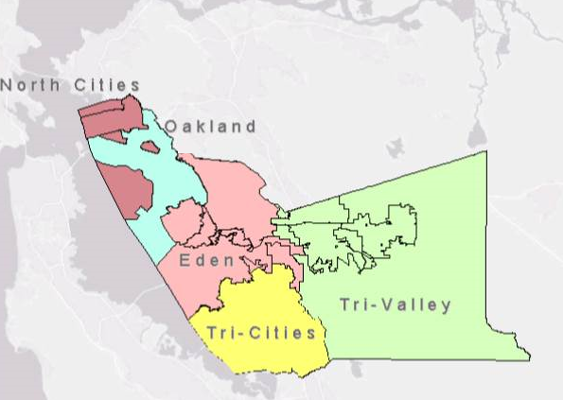

One-Stop/AJCC Site, Comprehensive

One-Stop/AJCC Site, Affiliate

Youth Provider

Service Delivery Area |  | One-Stop/ AJCC Service Provider | One-Stop/AJCC Career Center Location | Cities Served in Delivery Area
1 | EDEN | Rubicon Inc. | Hayward | Hayward, Castro Valley, San Leandro,  San Lorenzo and unincorporated areas: Ashland, Cherryland and Fairview
1 | - Youth Services | Hayward Adult School | Hayward
2 | NORTH CITIES | Peralta Community College District | Alameda & Berkeley | Alameda, Berkeley, Albany, Emeryville and Piedmont
2 | - Youth Services | Berkeley Youth Alternatives | Berkeley | Alameda, Berkeley, Albany, Emeryville and Piedmont
3 | TRI-CITIES | Ohlone Community College | Newark & Fremont | Newark, Fremont and Union City
3 | - Youth Services | La Familia/East Bay Community Services | Fremont | Newark, Fremont and Union City
4 | TRI-VALLEY | Las Positas Community College District | Dublin | Dublin, Pleasanton, Livermore and Sunol
4 | - Youth Services | La Familia/East Bay Community Services | Livermore | Dublin, Pleasanton, Livermore and Sunol

Mandated Partner Agencies Identified in the Workforce Innovation and Opportunity Act

Required Partner Agency | WIOA Program Areas
Alameda County Workforce Development Board | - WIOA Title 1 Adult  - Dislocated Worker  - Youth
Employment Development Department | - WIOA Title III Wagner-Peyser  - Trade Adjustment Assistance Act  - Unemployment Compensation
California Department of Rehabilitation | - WIOA Title IV Vocational Rehabilitation
Alameda County Social Services Agency/ Workforce and Benefits Administration | - Temporary Assistance for Needy Families (TANF)/CalWORKs
Alameda County Adult School Consortiums | - WIOA Title II Adult Education and Literacy  Carl Perkins Career Technical Education
Alameda County Social Services Agency/ Department of Adult and Aging Services, Area Agency on Aging | - Title V Older Americans Act  - Veterans
United Indian Nations | - Native American Programs
Oakland/Alameda County Community Action Agency | - Community Services Block Grant
Housing Authority of the County of Alameda | - Housing and Urban Development

One-Stop Partner Grid

Sharing Services for Shared Customers Summary – One Stop Partner Coordination
Which Career Services Are Applicable to Each One-Stop Partner?
- Take snapshot of services, by partners, B) Identify common service areas, C) Plan for a “seamless” customer experience and leveraged knowledge & resources

 | Adult / DW | Youth | AEL |  |  | WP/ TAA  & UC | VR | TANF | Title V & Vets | Nat. Amer | CSBG | HUD
Partner/Providers or Contractors | ACWIB  (One-Stop services) | ACWIB  (Career Readiness/  Partnerships | Adult Schools  (MACC) | Adult Schools  (SACC) | Adult Schools  (NACC) | EDD | DOR  (Job Placement Services) | SSA/  CalWORKs  (Welfare to Work) | SSA/ Dept of Adult & Aging Srvs | United Indian Nations (Employment Education Training) | Oak/Alameda  CCAA | Housing Authority  (Family Self Sufficiency)
BASIC CAREER SERVICES
Title I Program Eligibility | X | X |  |  |  |  | X | X
Outreach, Intake, Orientation | X | X | X |  |  |  | X | X |  | X |  | X
Initial Assessment | X | X | X |  |  |  | X | X |  | X |  | X
Labor Exchange, Job Search Assistance | X | X |  |  |  | X | X | X |  | X
Referrals to One-Stop Partners | X | X | X | X | X | X | X | X |  | X |  | X
Labor Market Information | X | X |  |  |  | X | X | X |  | X |  | X  from One-Stop Stats
Performance and Cost Information | X |  |  |  |  | X |  | X
Support Service Information | X | X |  |  |  |  | X | X |  | X |  | X
Unemployment Info & Assistance |  | X |  |  |  | X |  | X |  | X
Financial Aid Information |  | X |  |  |  |  | X | X |  | X |  | X  for Housing Authority of Alameda County (HACA) customers only. HACA has its own scholarship program. 5 year goals
 | Adult/DW | Youth | AEL |  |  | WP/TAA & UC | VR | TANF | Title V & Vets | Nat. American | CSBG | HUD
INDIVIDUALIZED CAREER SERVICES
Comprehensive Assessment | X | X |  |  |  |  | X | X |  | X
Individual Employment Plan | X | X |  |  |  |  | X | X
Career Plan, Counseling | X | X |  |  |  |  | X | X |  | X |  | X  Basic/General
Short-Term Pre-Voc Services | X | X | X |  |  |  | X | X |  | X
Internships, Work Experience |  | X | X |  |  |  | X | X |  | X
Out-of-Area Job Search | X | X |  |  |  | X |  | X
Financial Literacy | X | X |  | X  through our partnership with participant |  |  |  | X |  |  |  | X  on site workshops
English Language Acquisition |  | X | X | X | X |  |  | X
Workforce Preparation/CTE Training |  | X | X | X | X | X | X | X |  | X |  | X  on site workshops
Assistive Devices for persons w/ disabilities |  |  |  |  |  |  | X
Veterans services |  |  |  |  |  | X |  |  | X
AB104 Program Areas |  |  |  | X | X
High School diploma/equivalency/Basic Skill Education |  | X | X
Other |  | Referrals and tutorial services for GED | High School diploma/Equivalency/  Basic Skill Education |  |  |  |  |  | Title V-Senior Community Employment Services Program |  |  | All of our onsite workshops are conducted/facilitated by CBO’s (our partners) on site at the HACA

Abbreviations:
Adult/ Adult Services, DW/Dislocated Worker, Youth/Youth Services, AEL/Adult Education and Literacy, WP/Wagner-Peyser, TAA/Trade Adjustment Assistance Act, UC/Unemployment Compensation, VR/Vocational Rehabilitation, TANF/Temporary Assistance to Needy Families, Title V Older Americans Act, Vets/Veterans, Nat. American/Native American Programs, CSBG/Community Services Block Grant, HUD/Housing and Urban Development

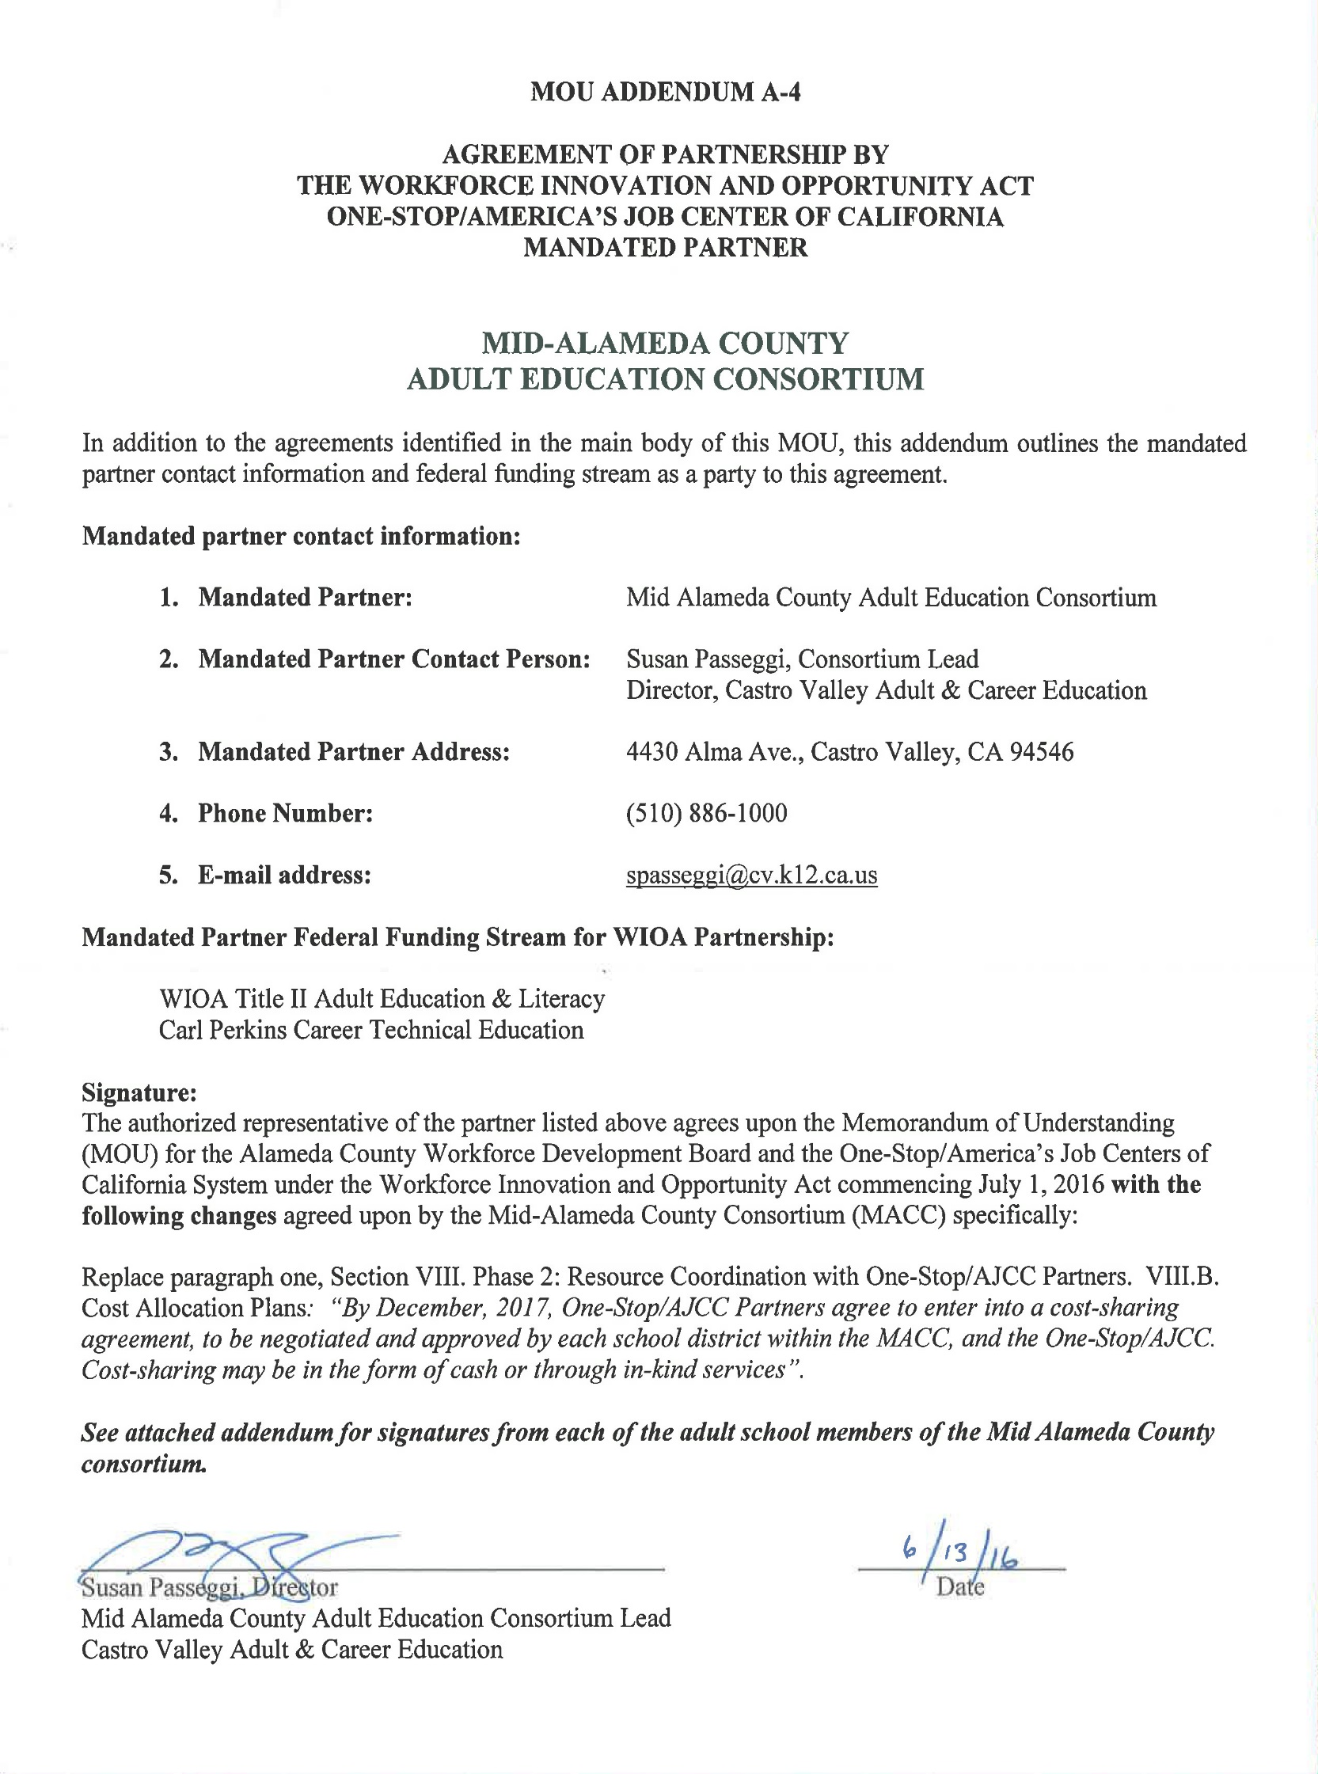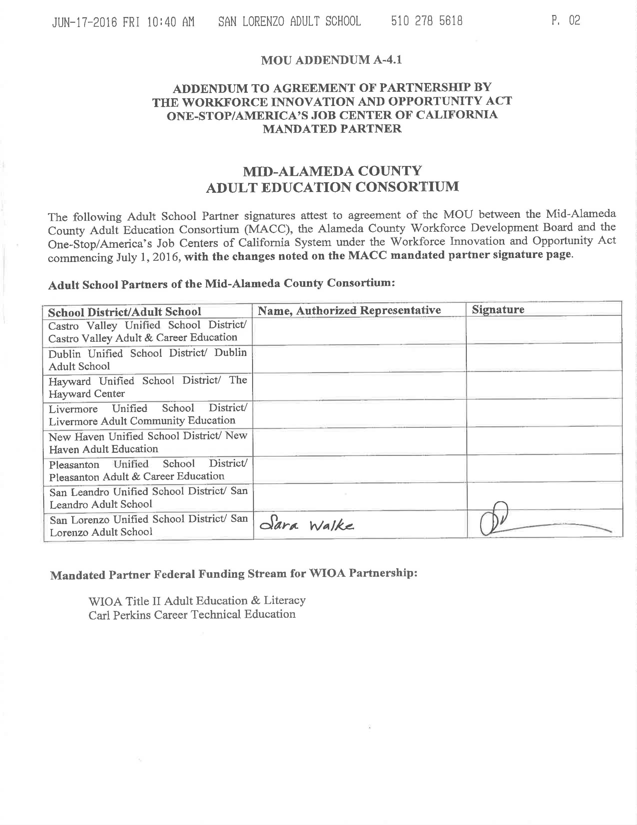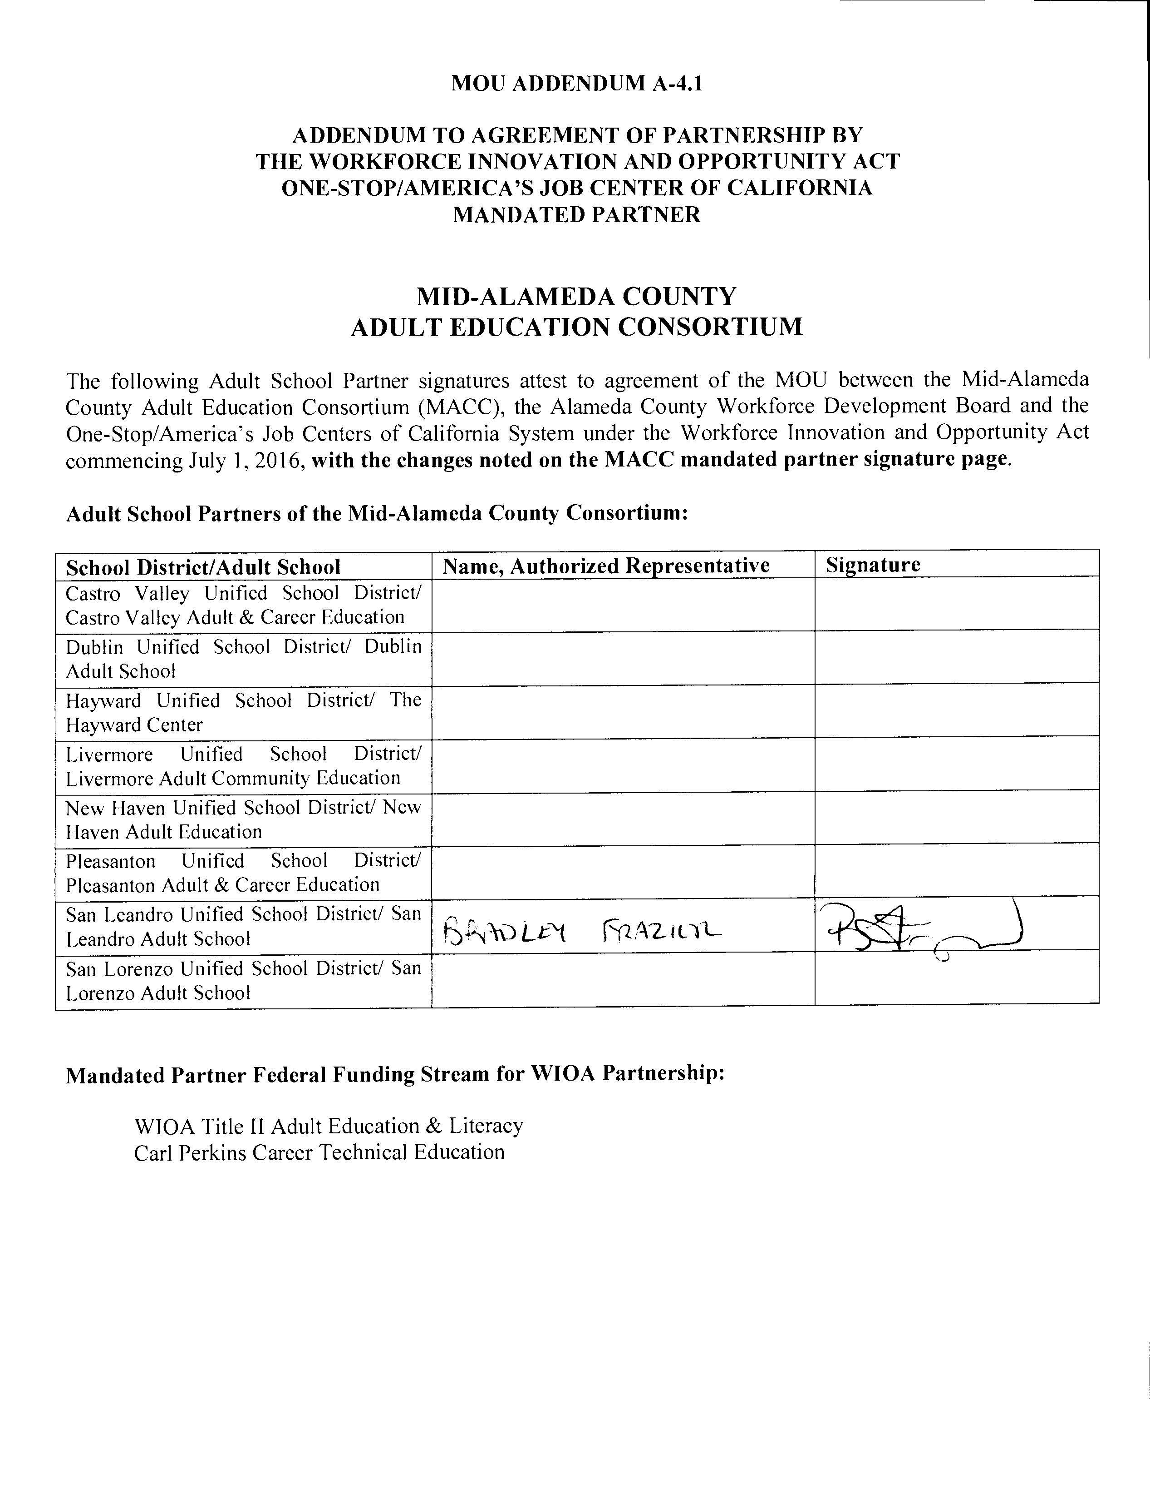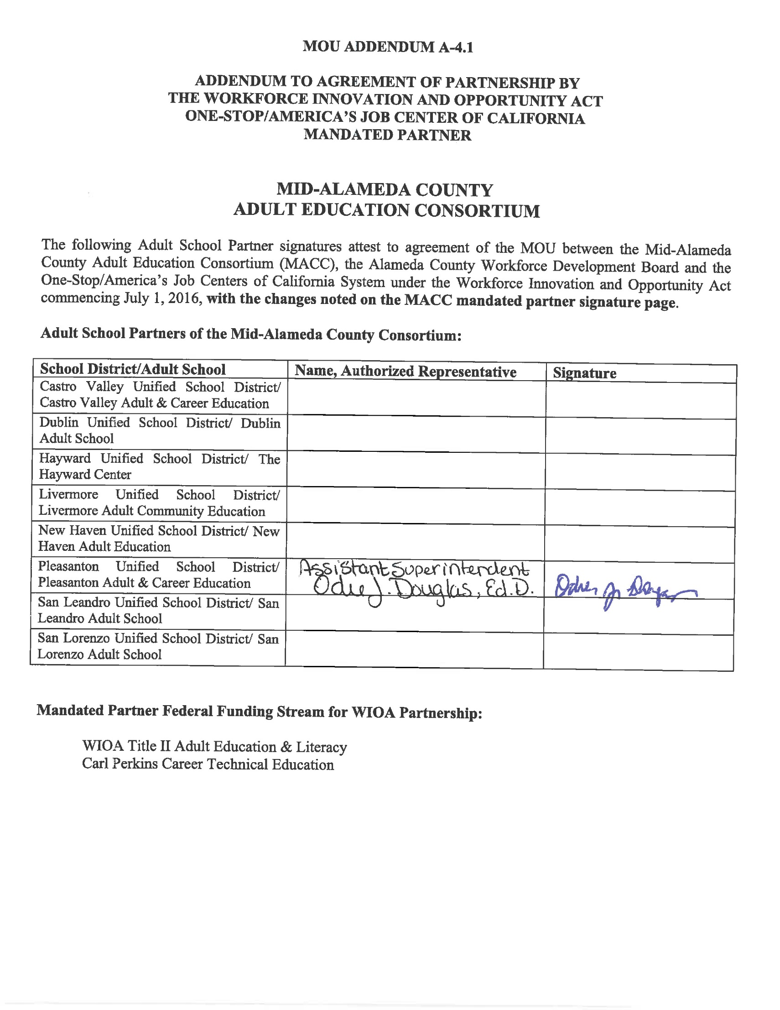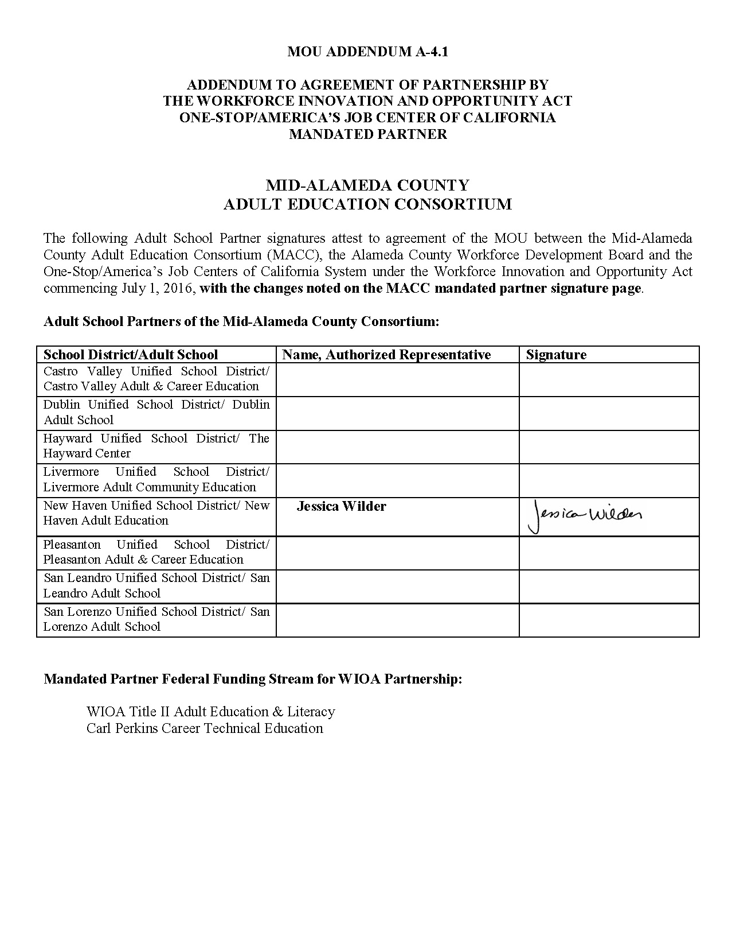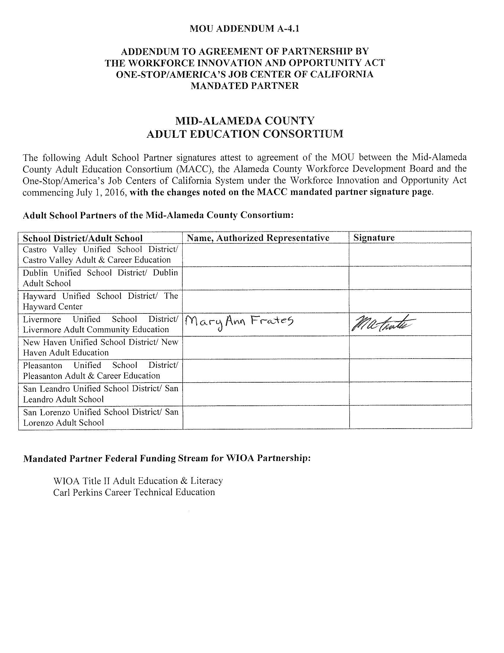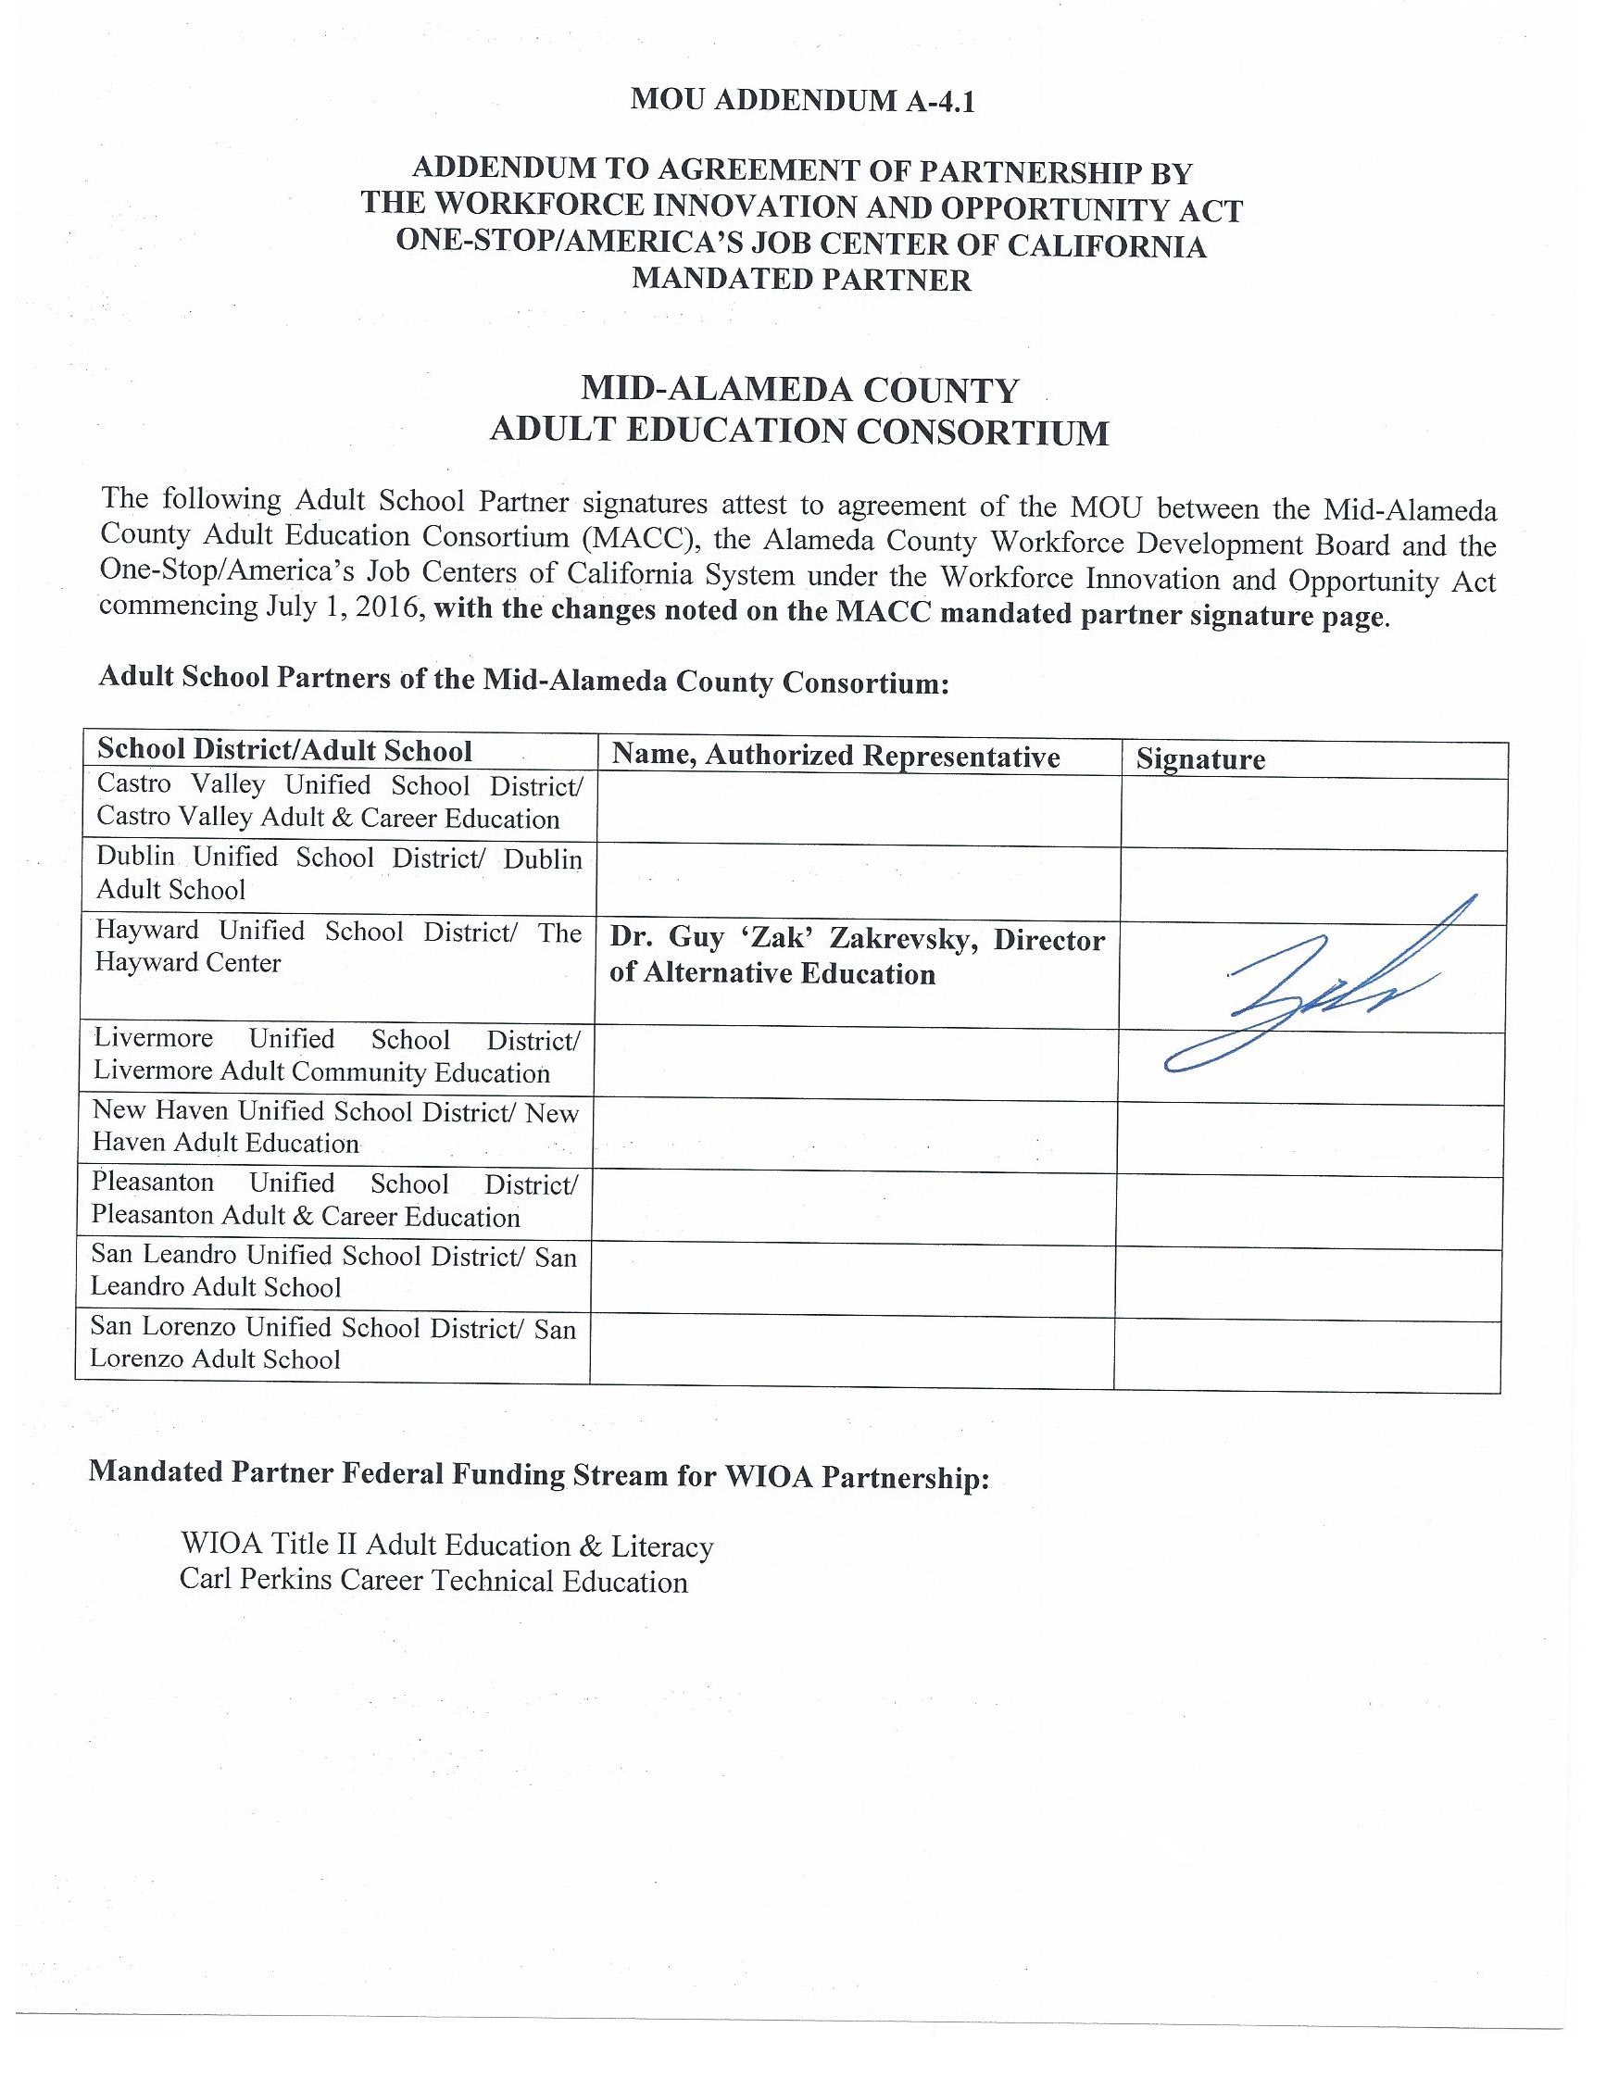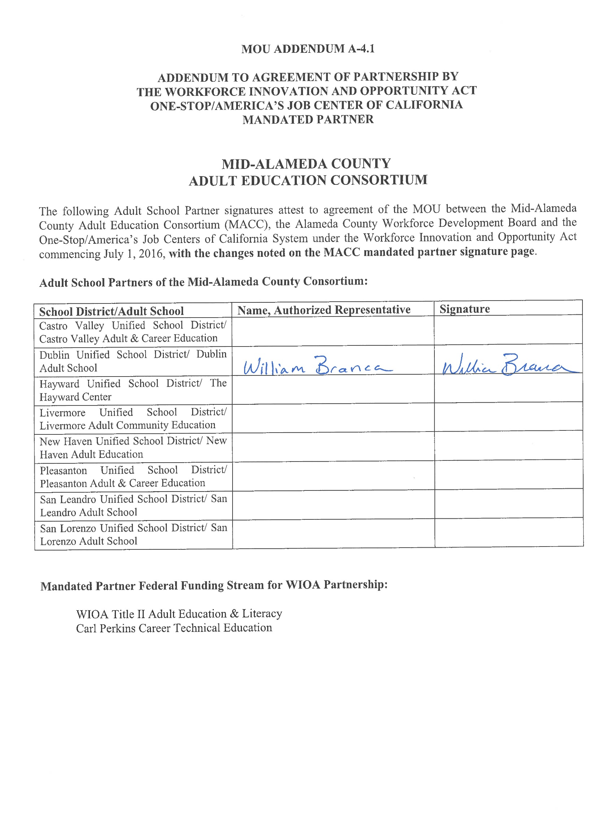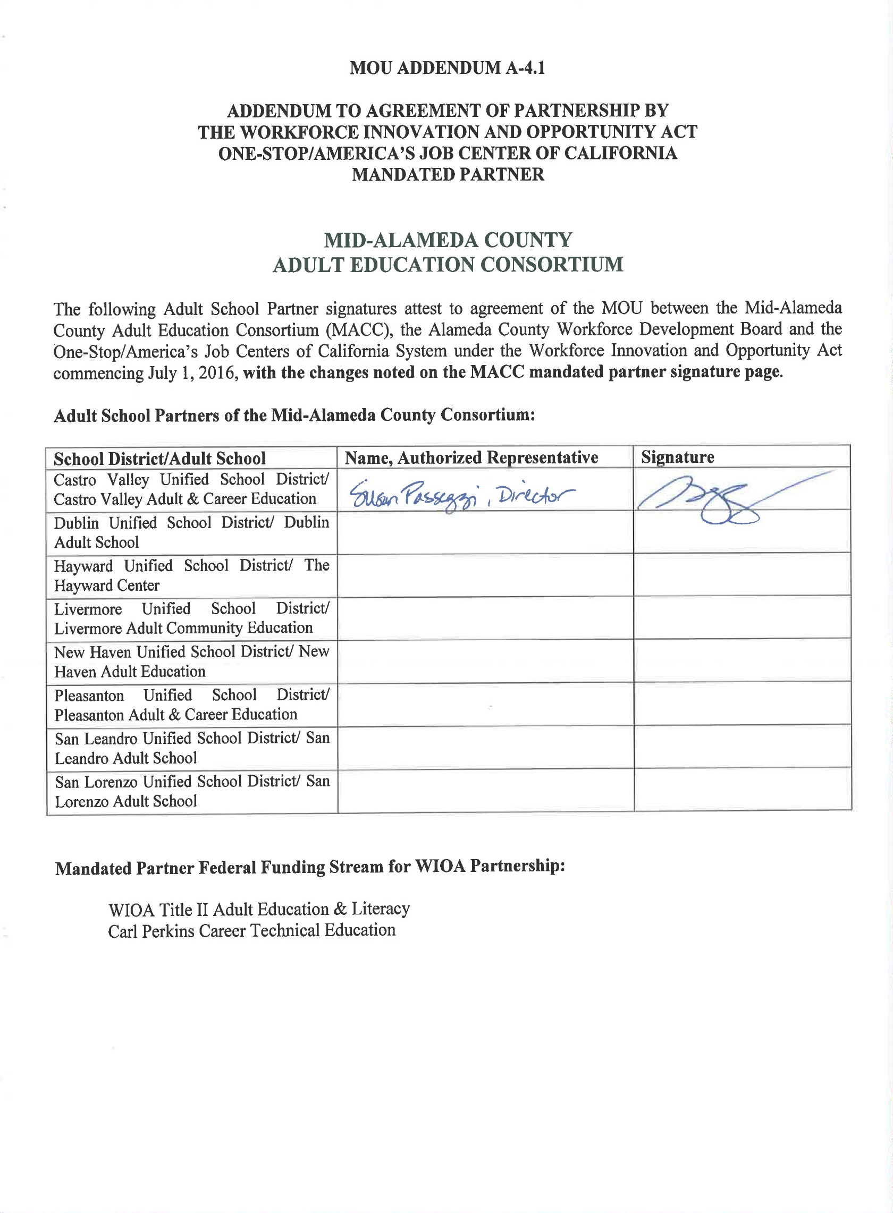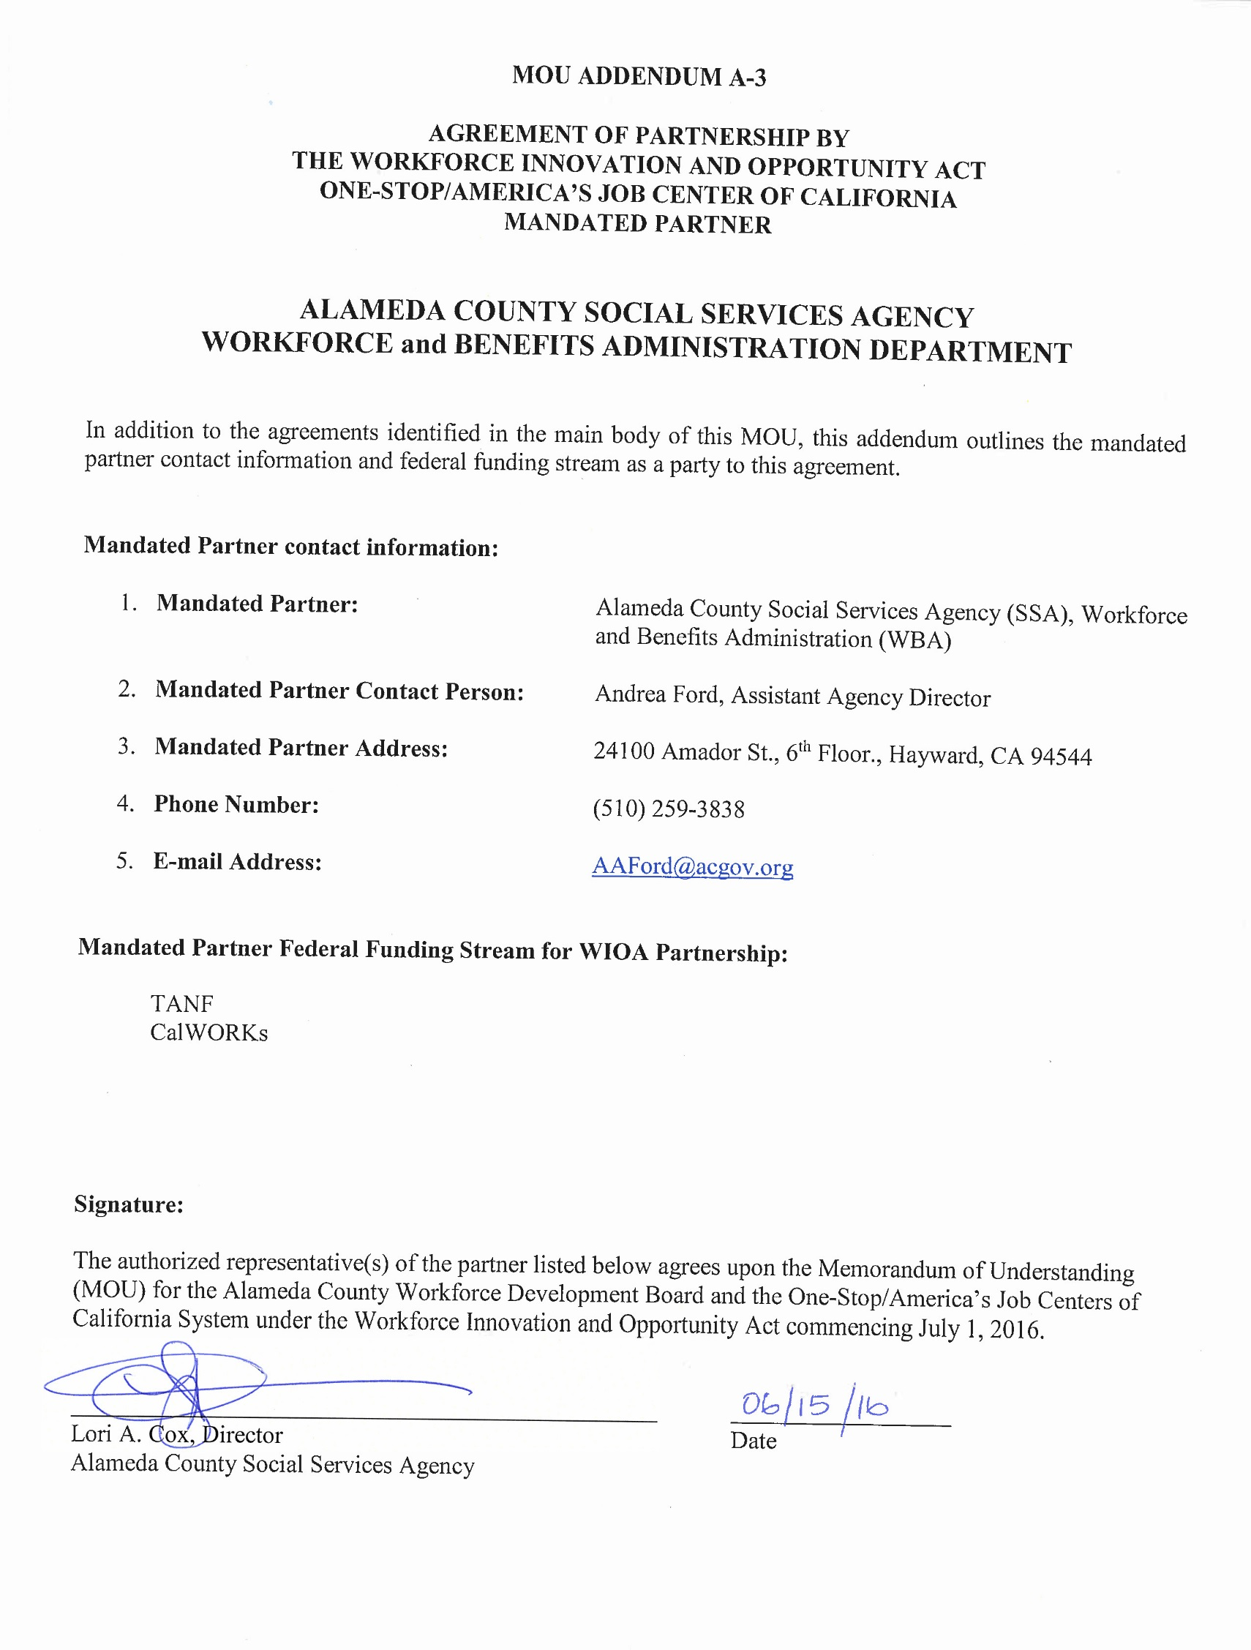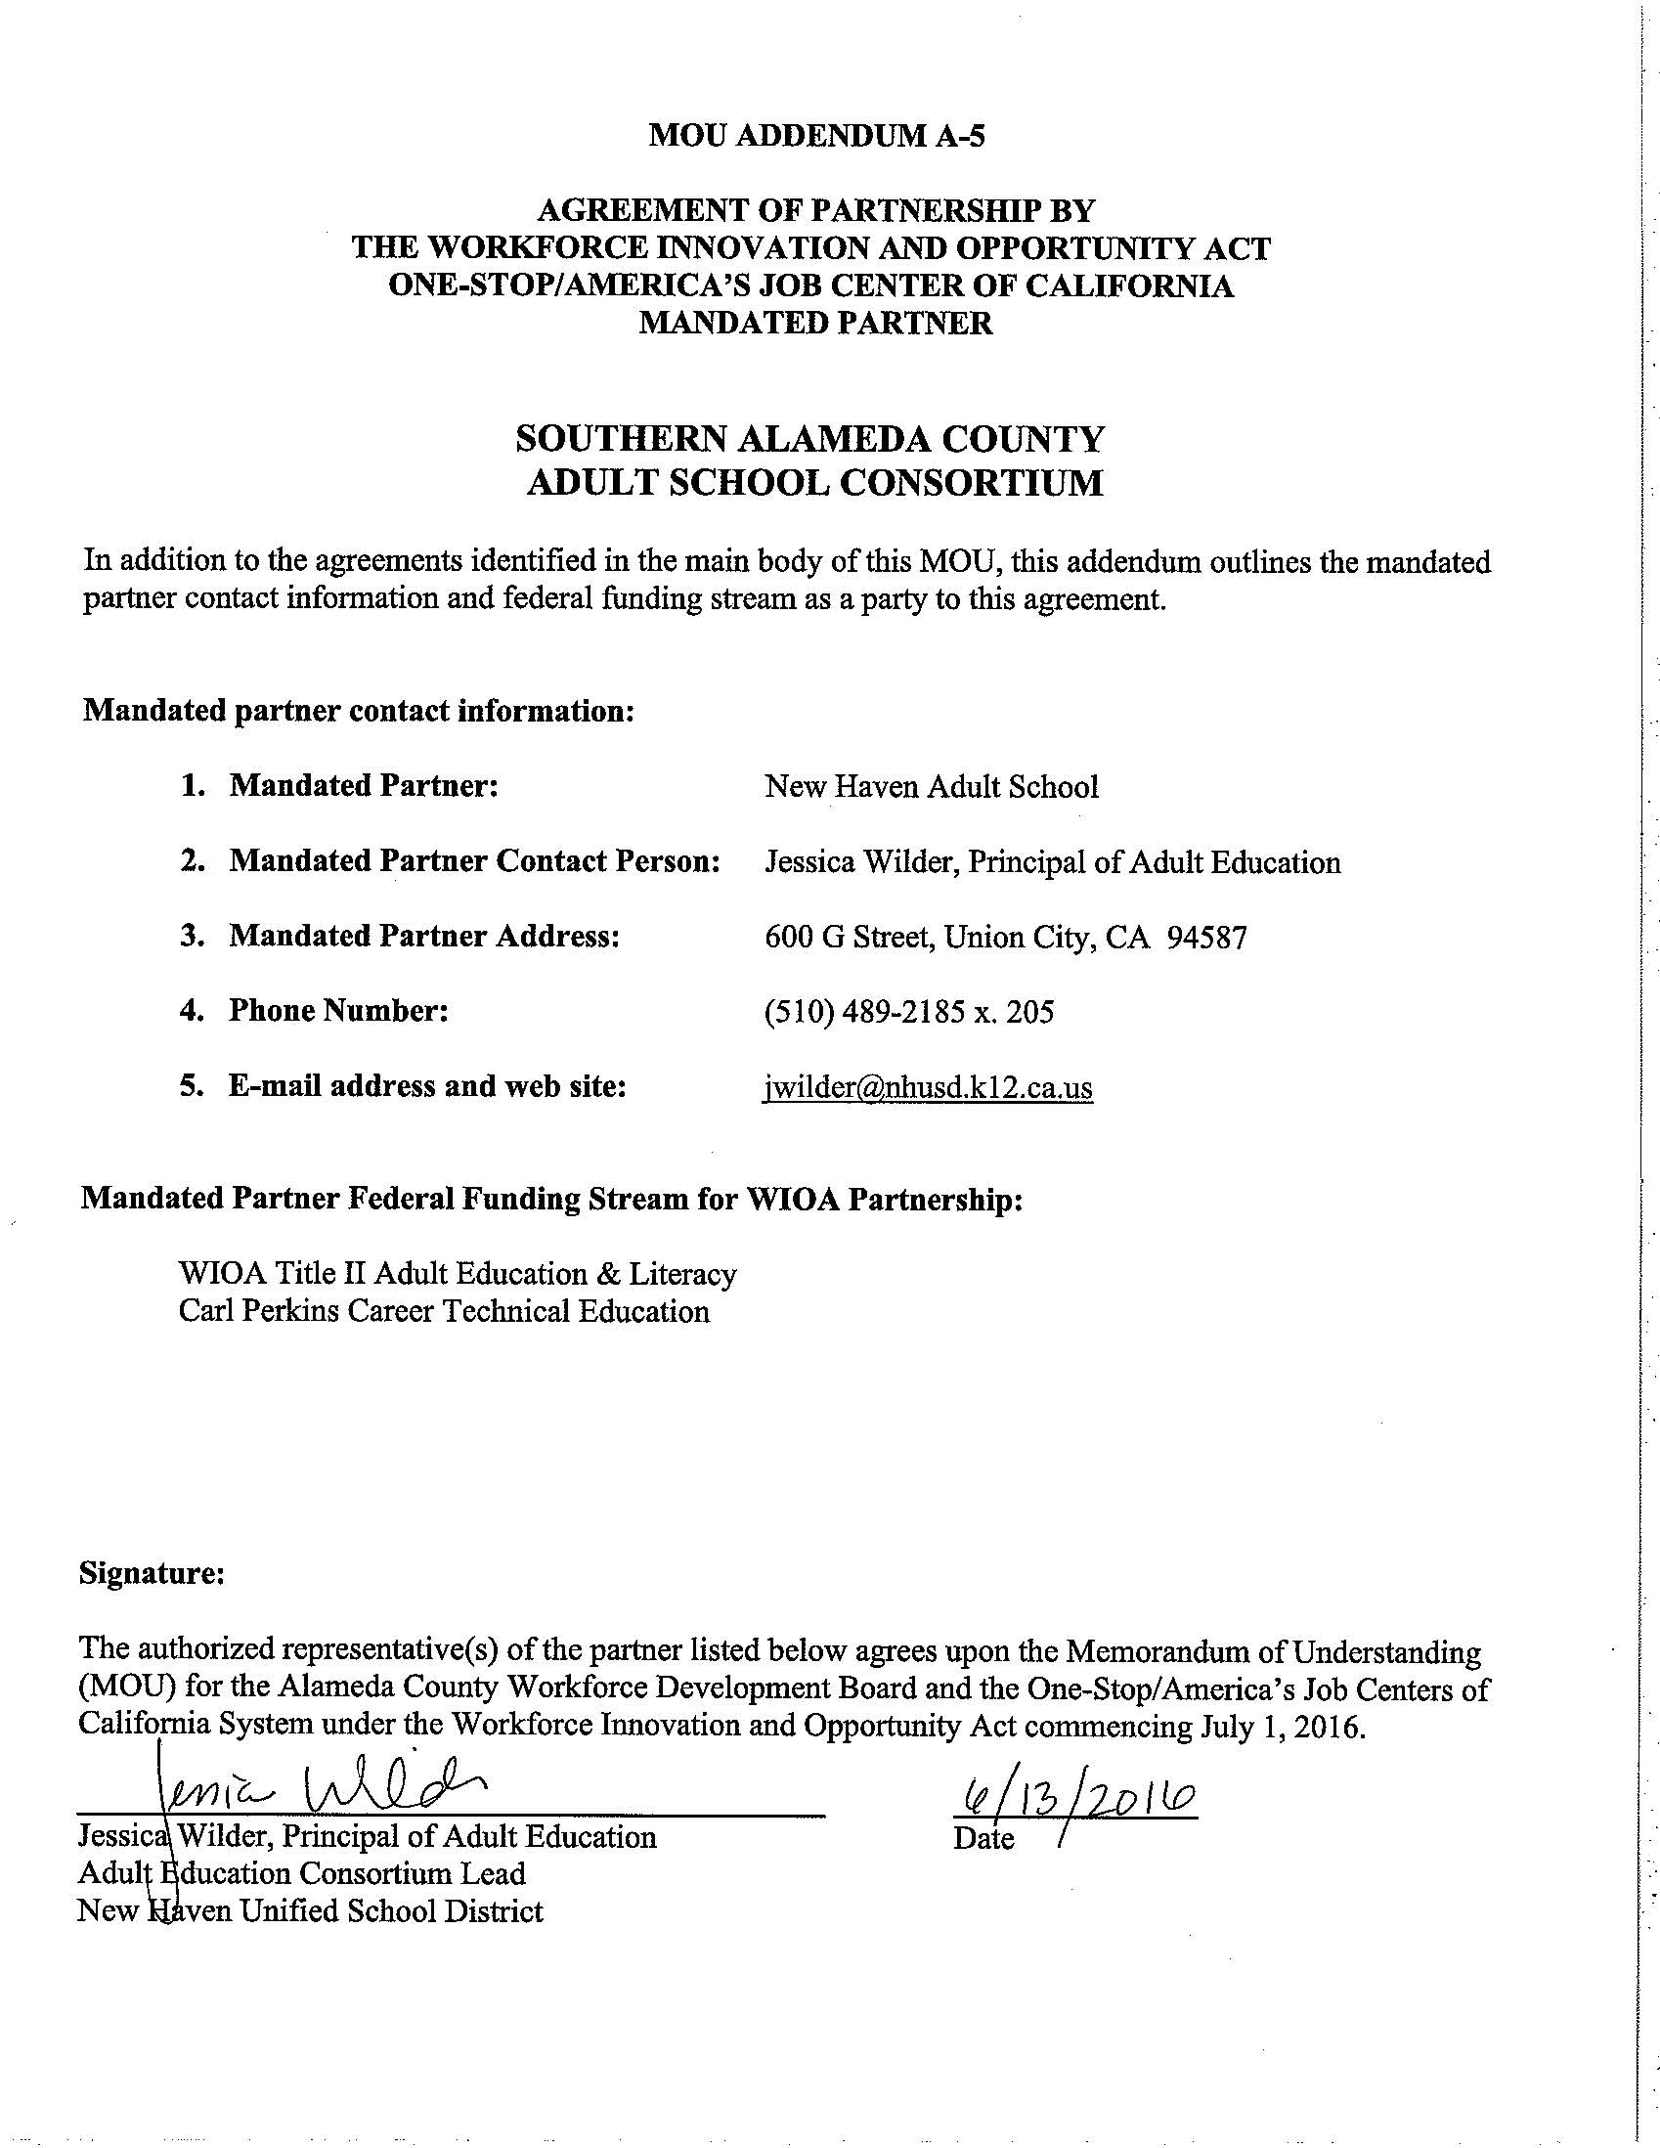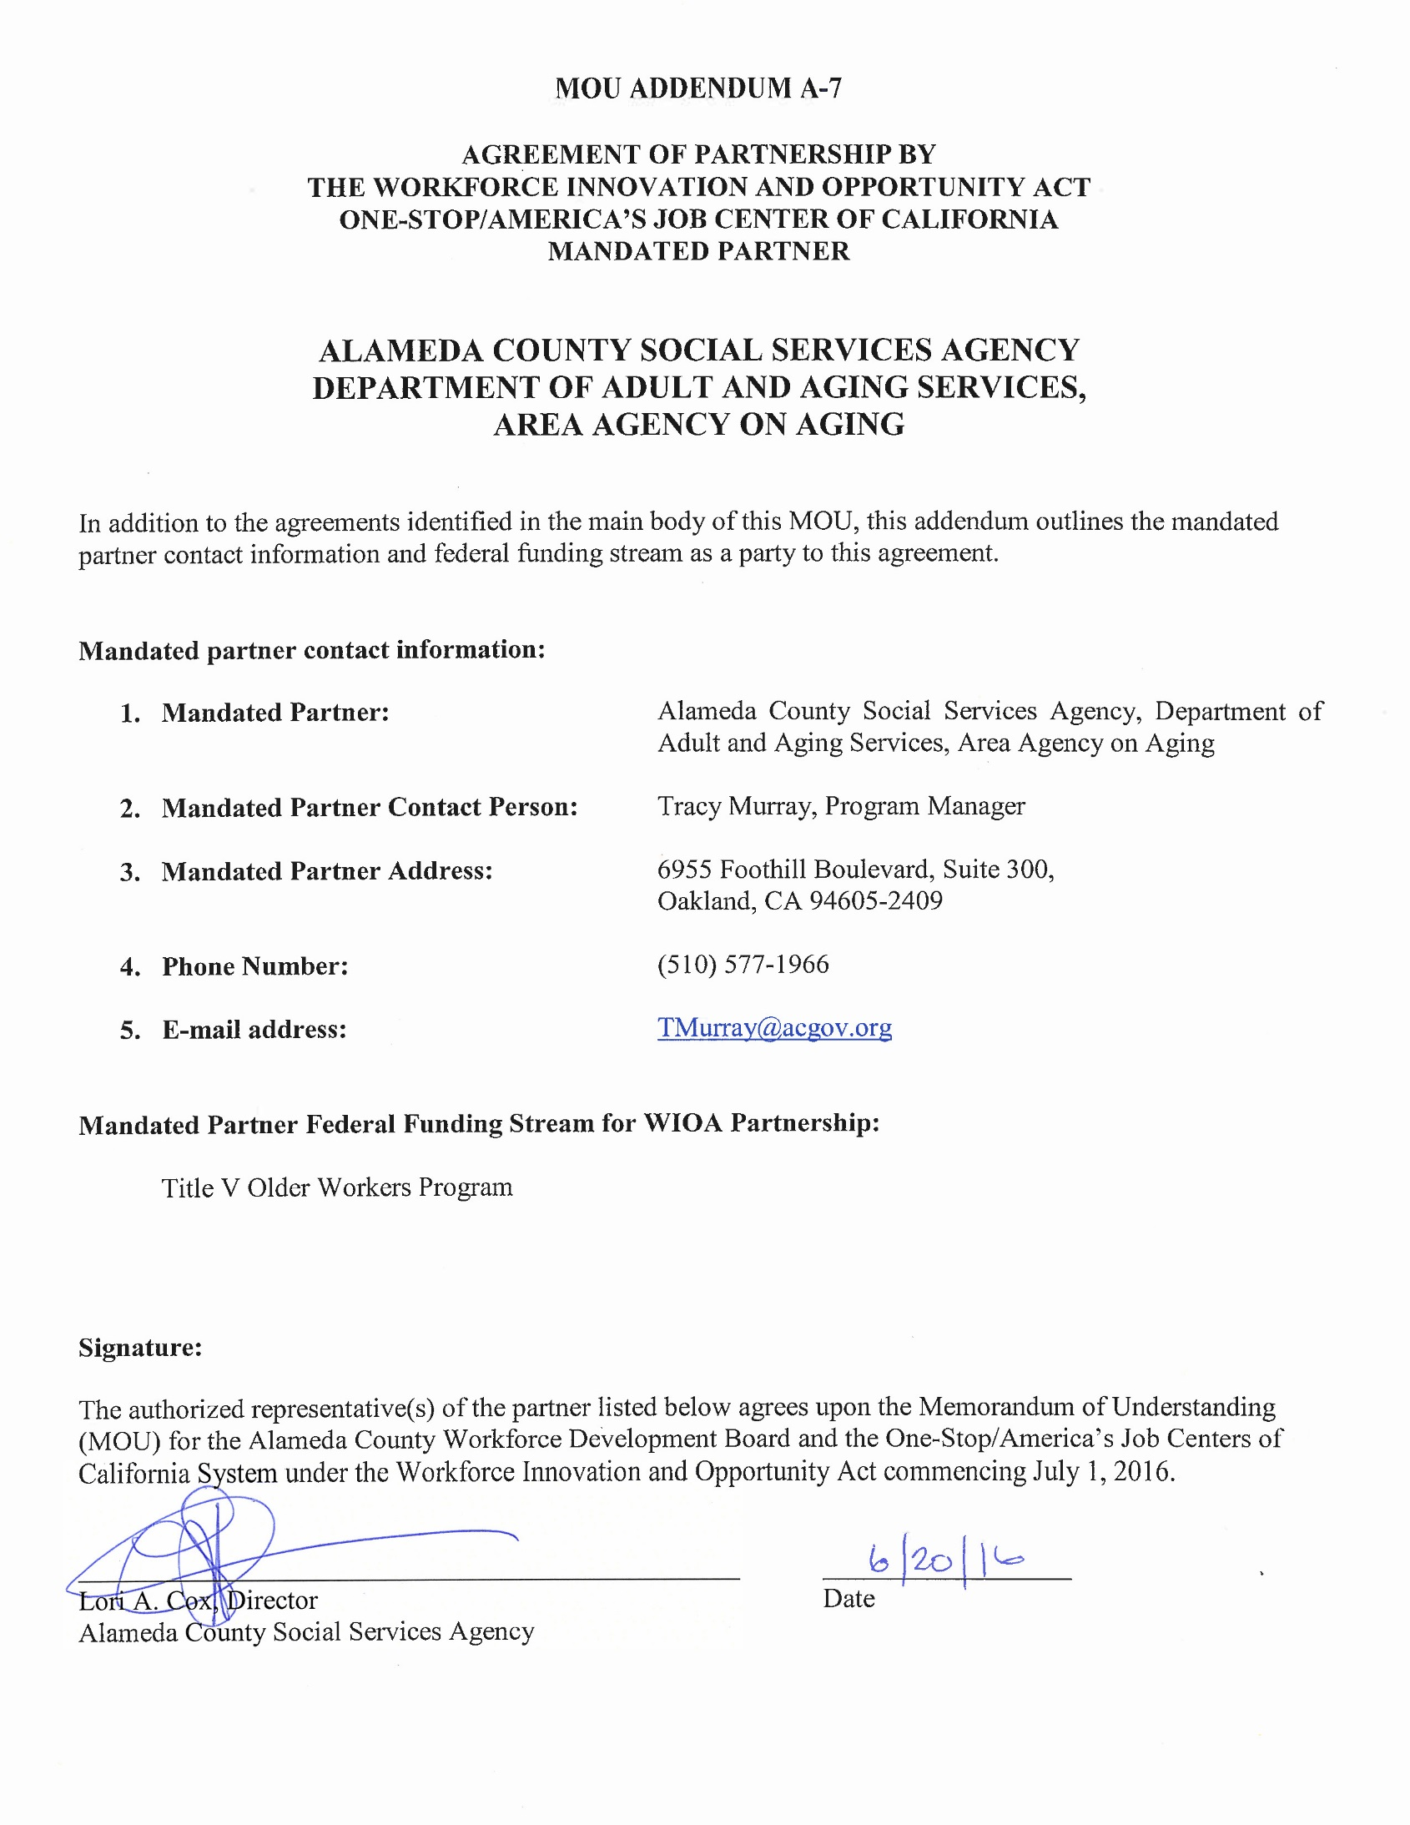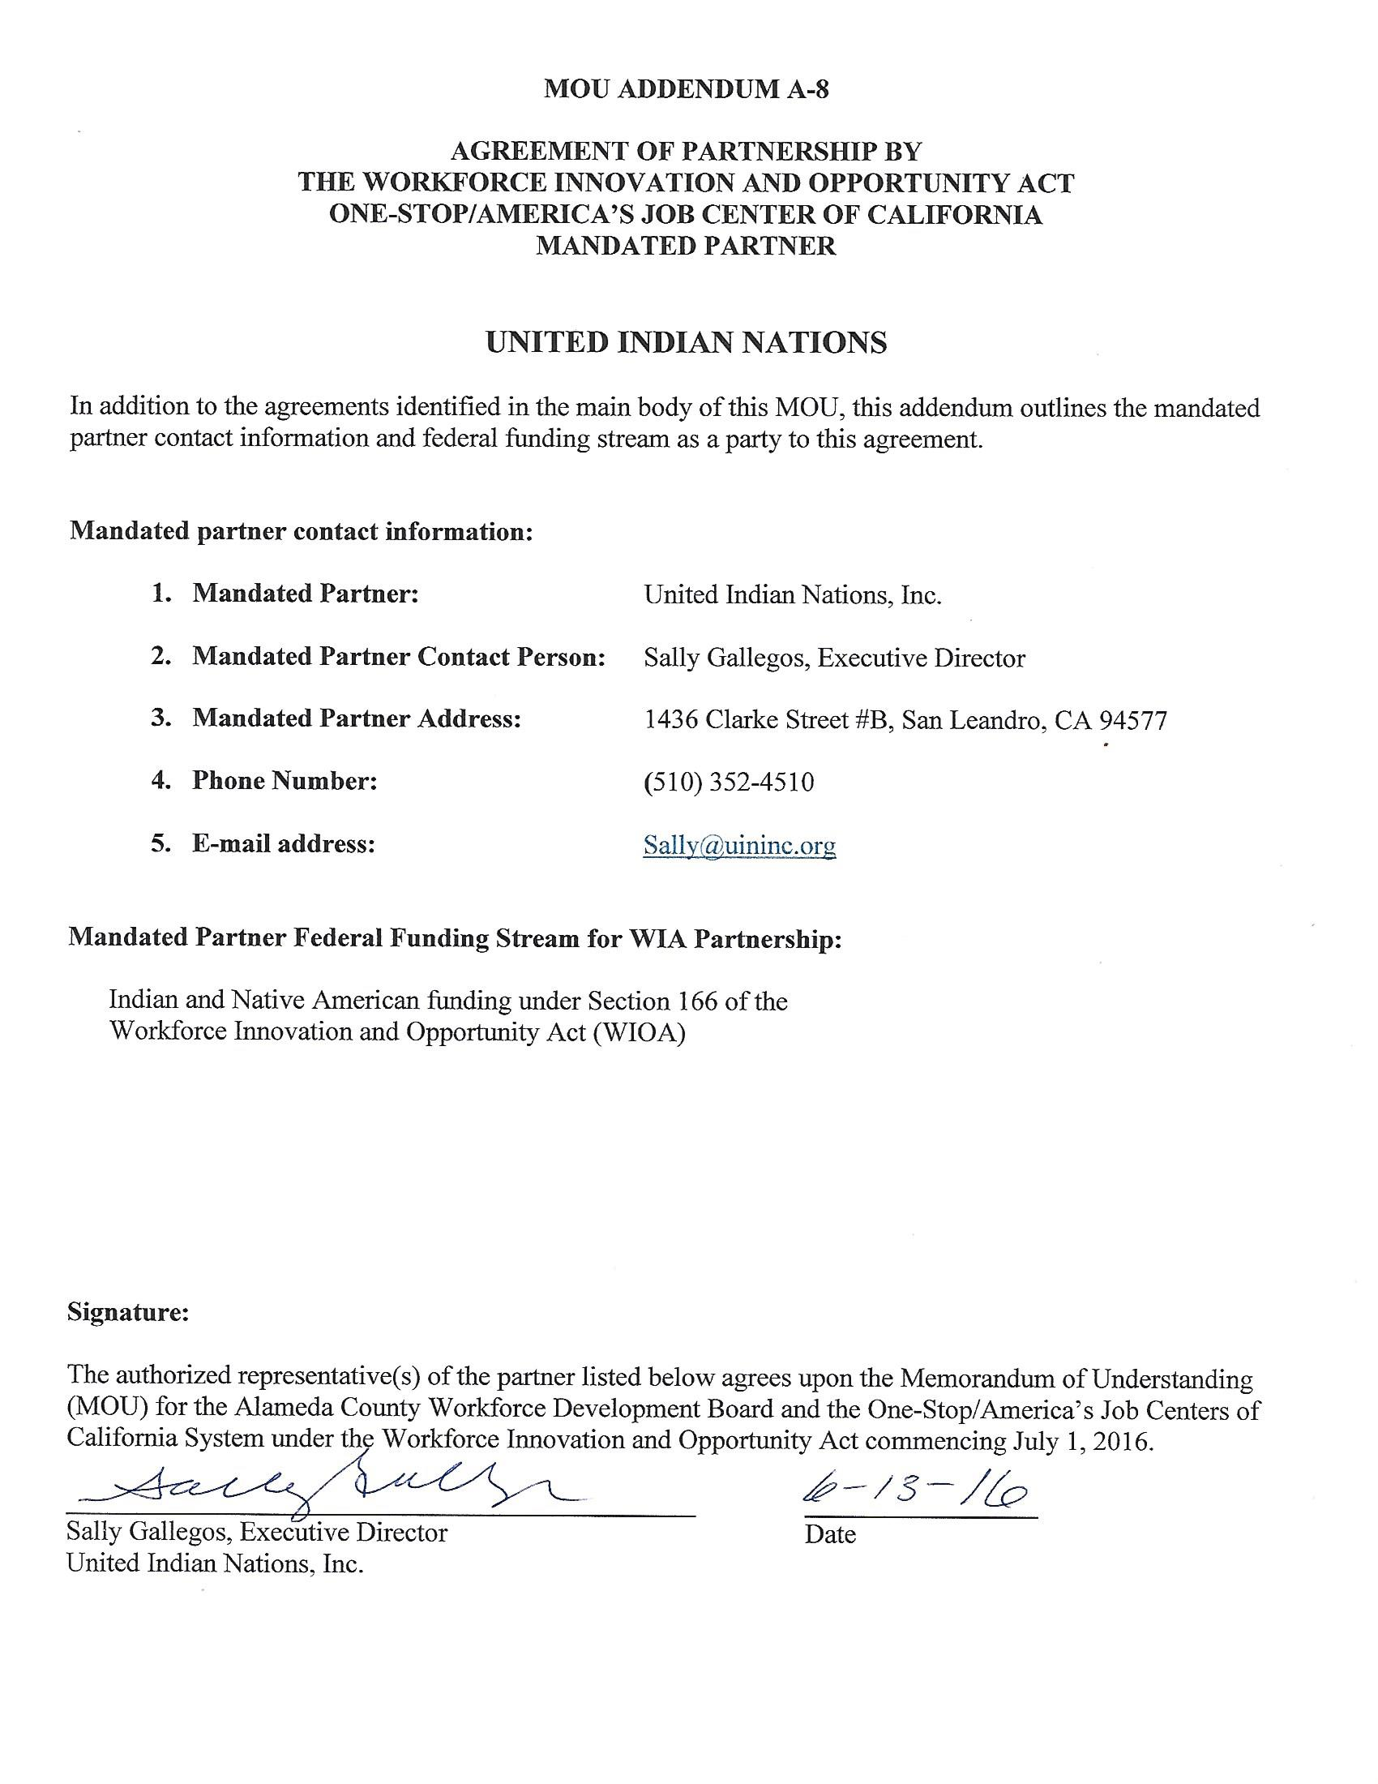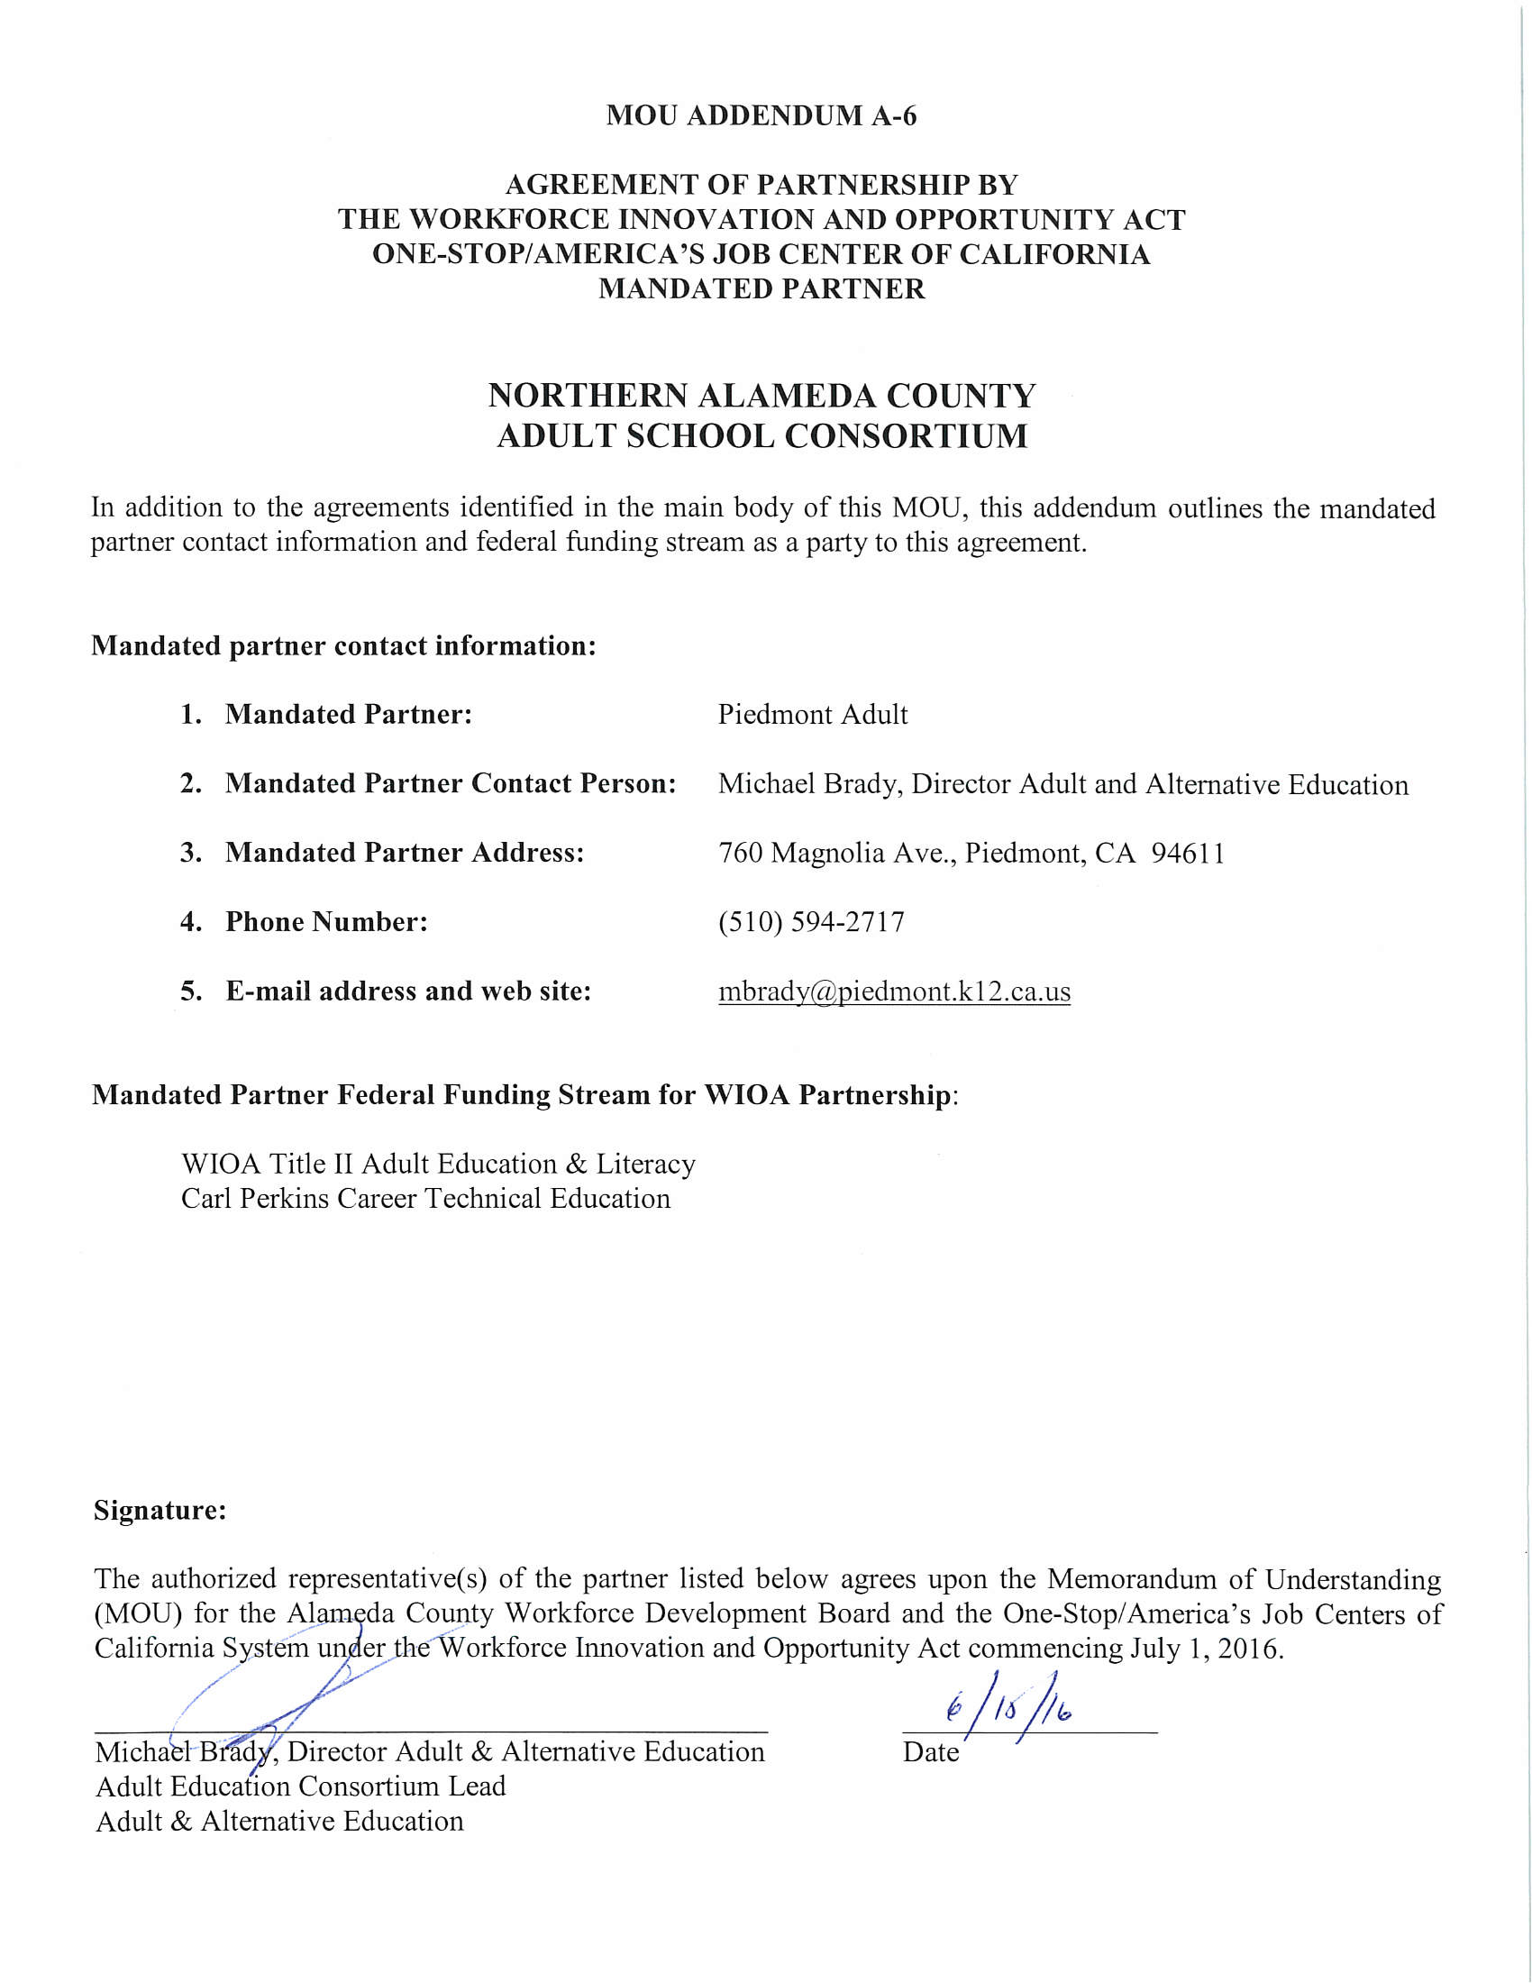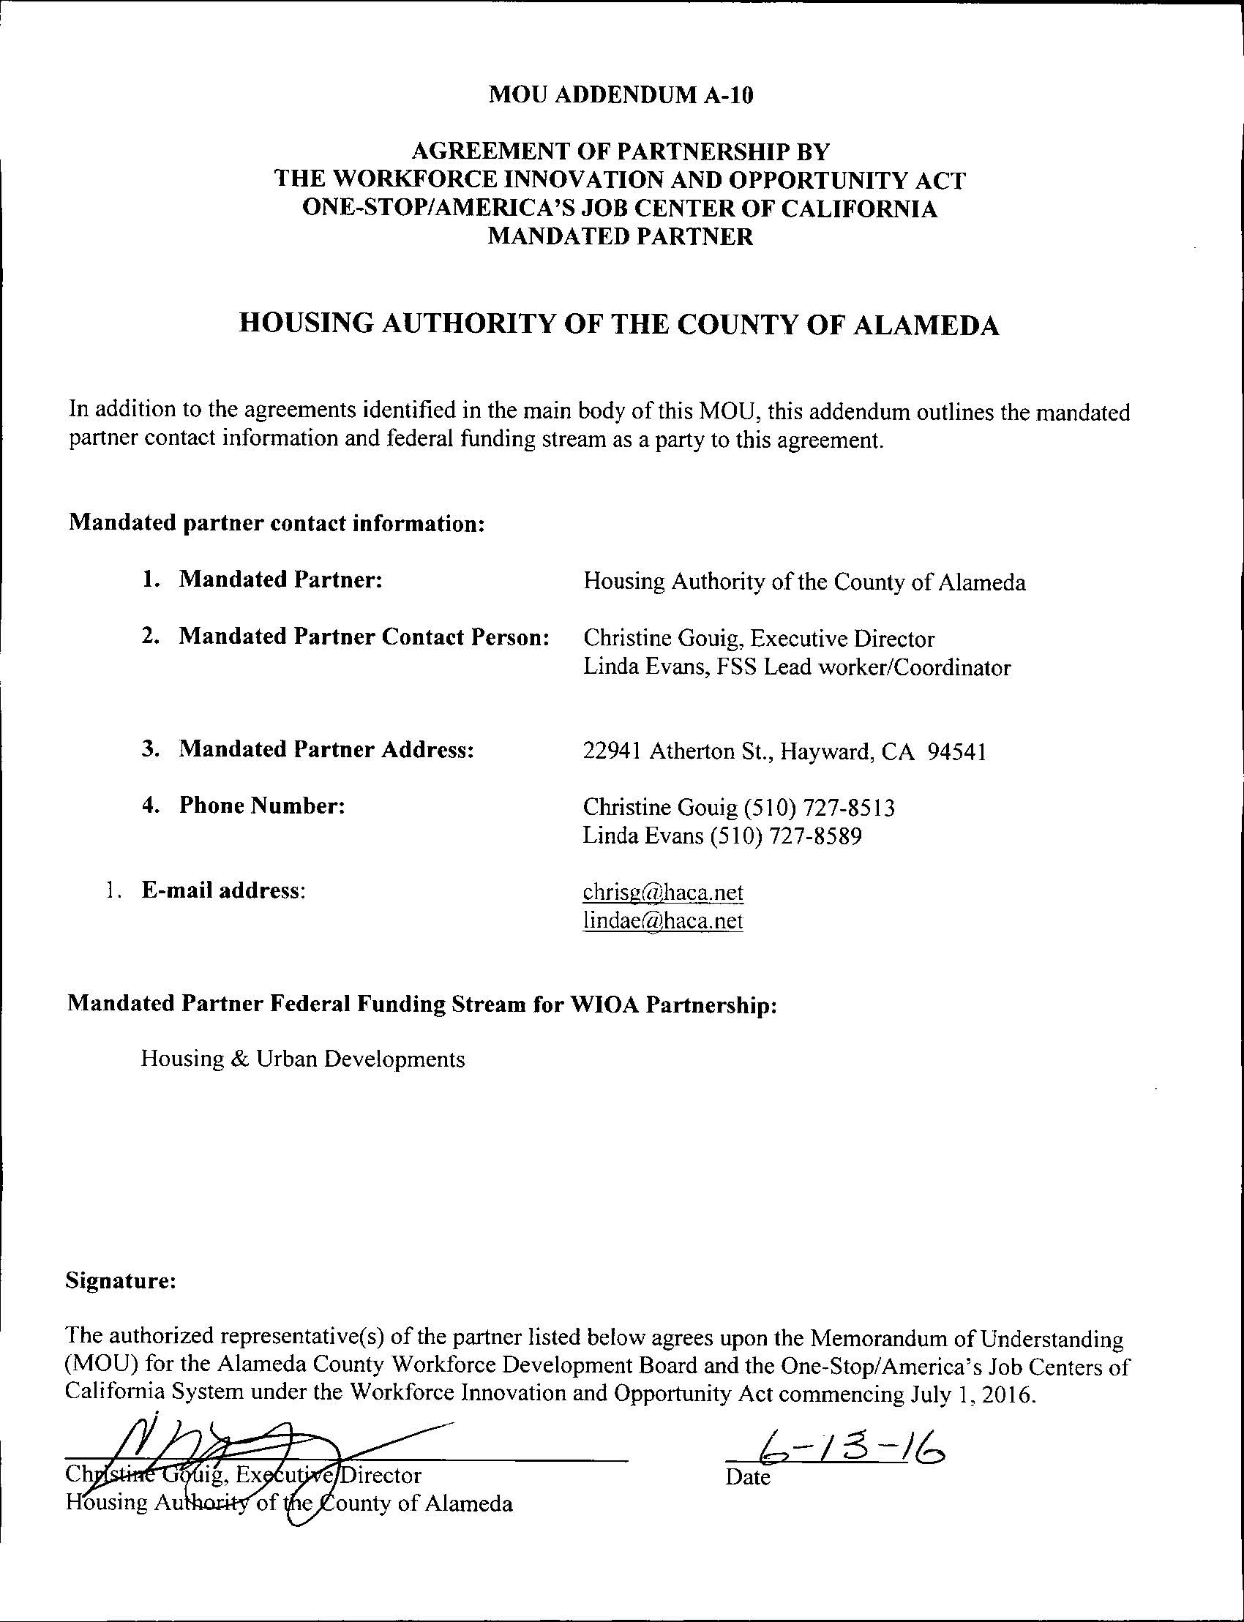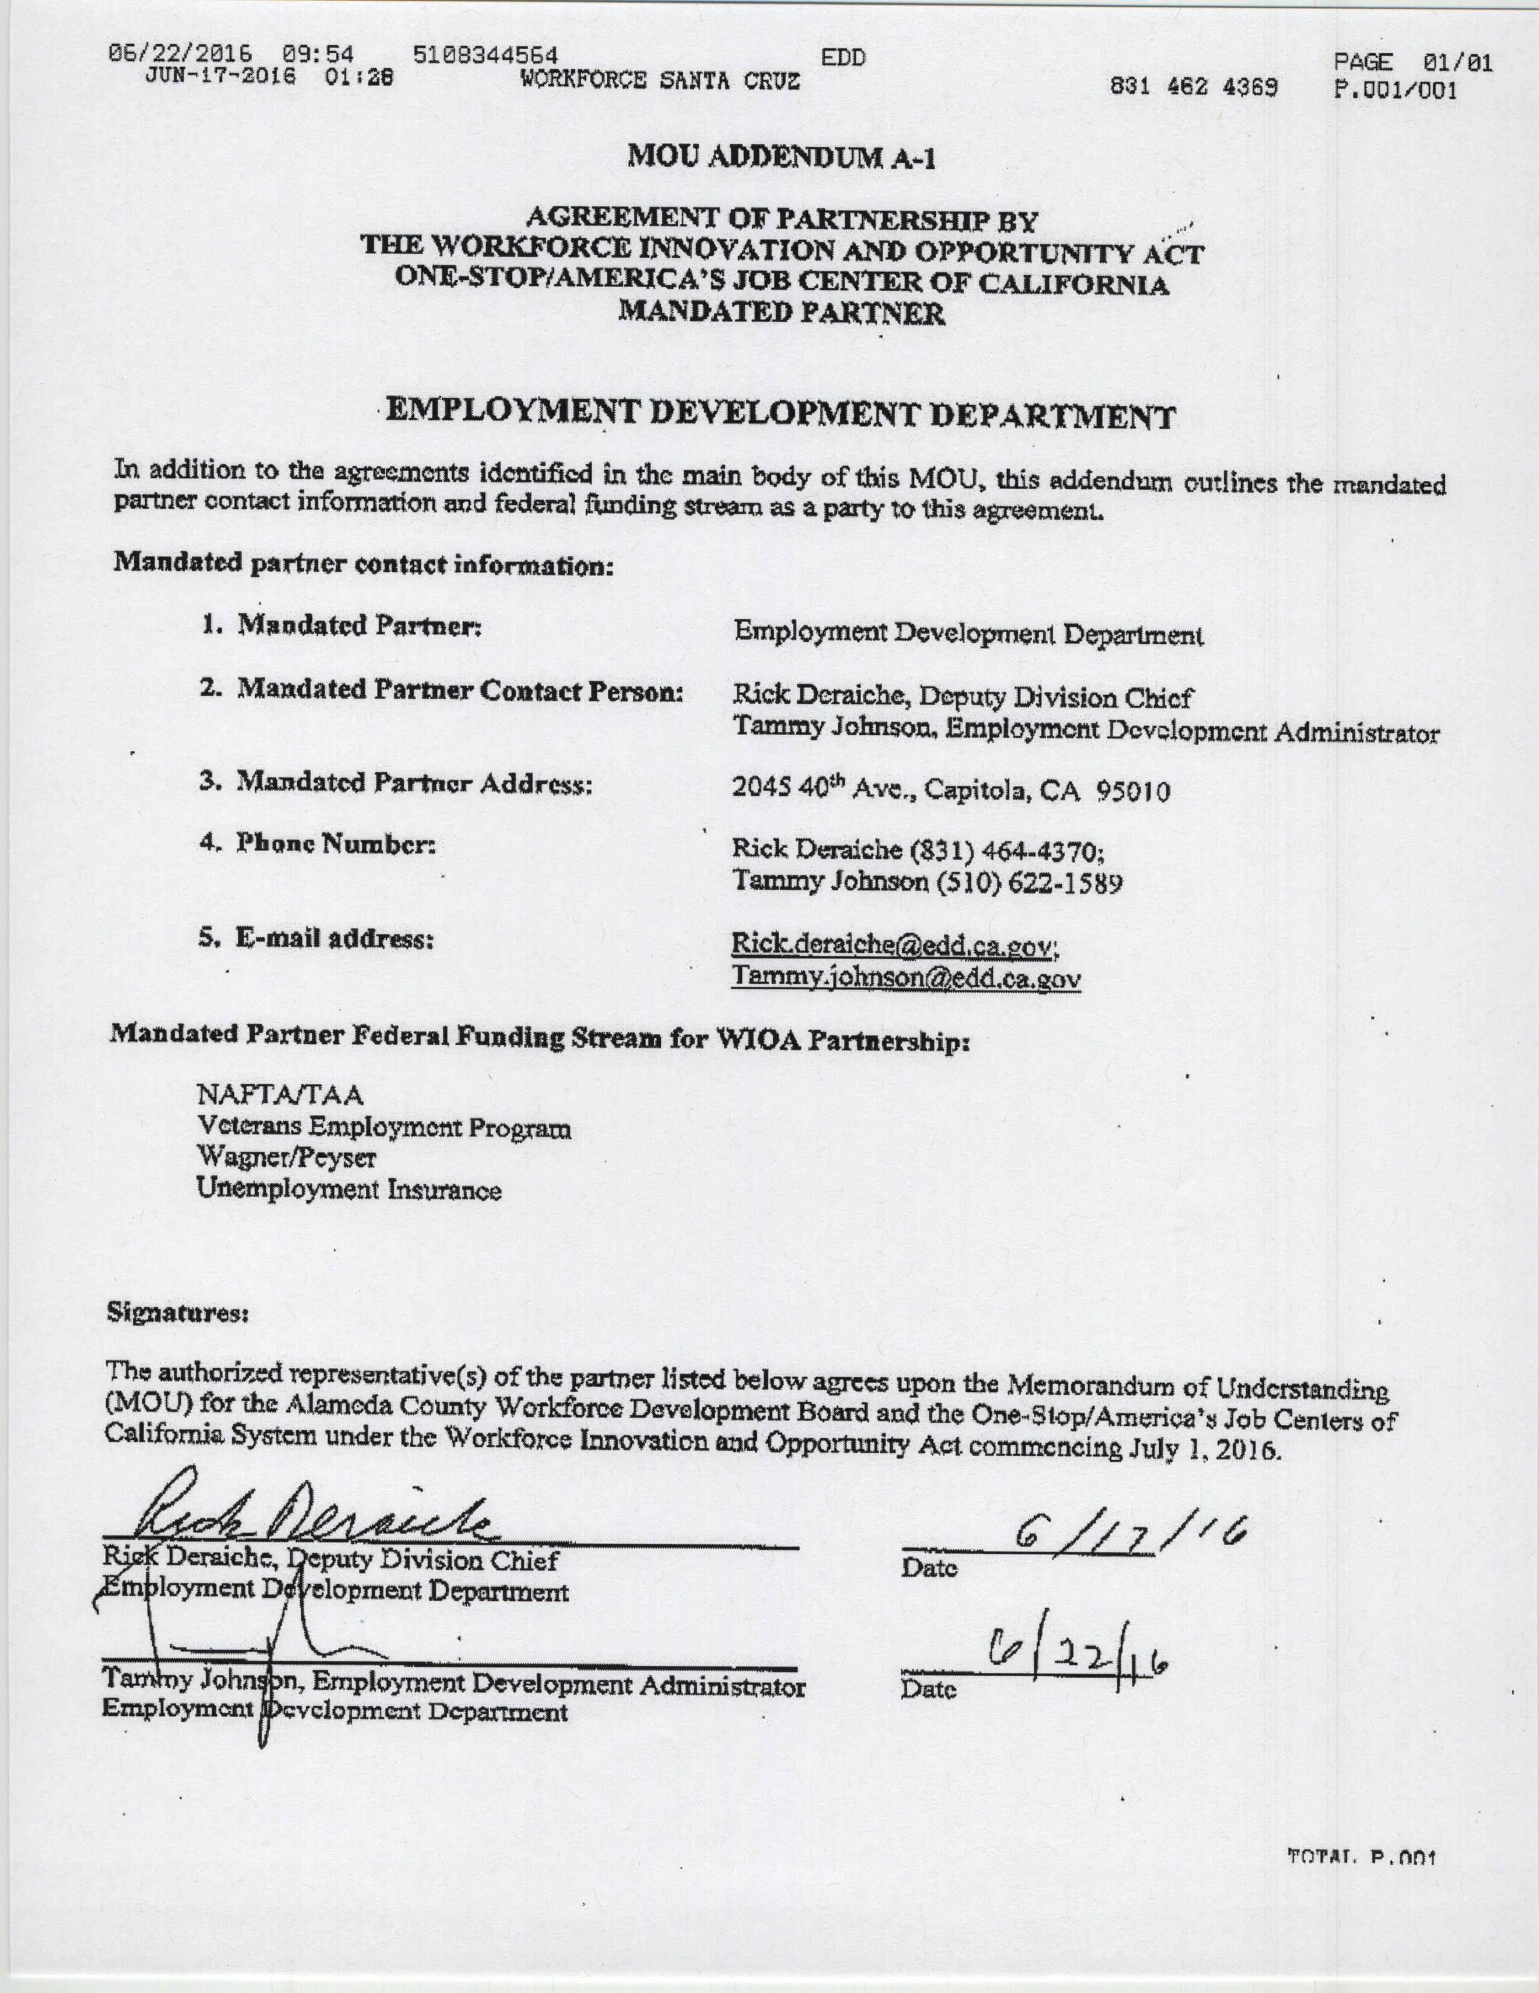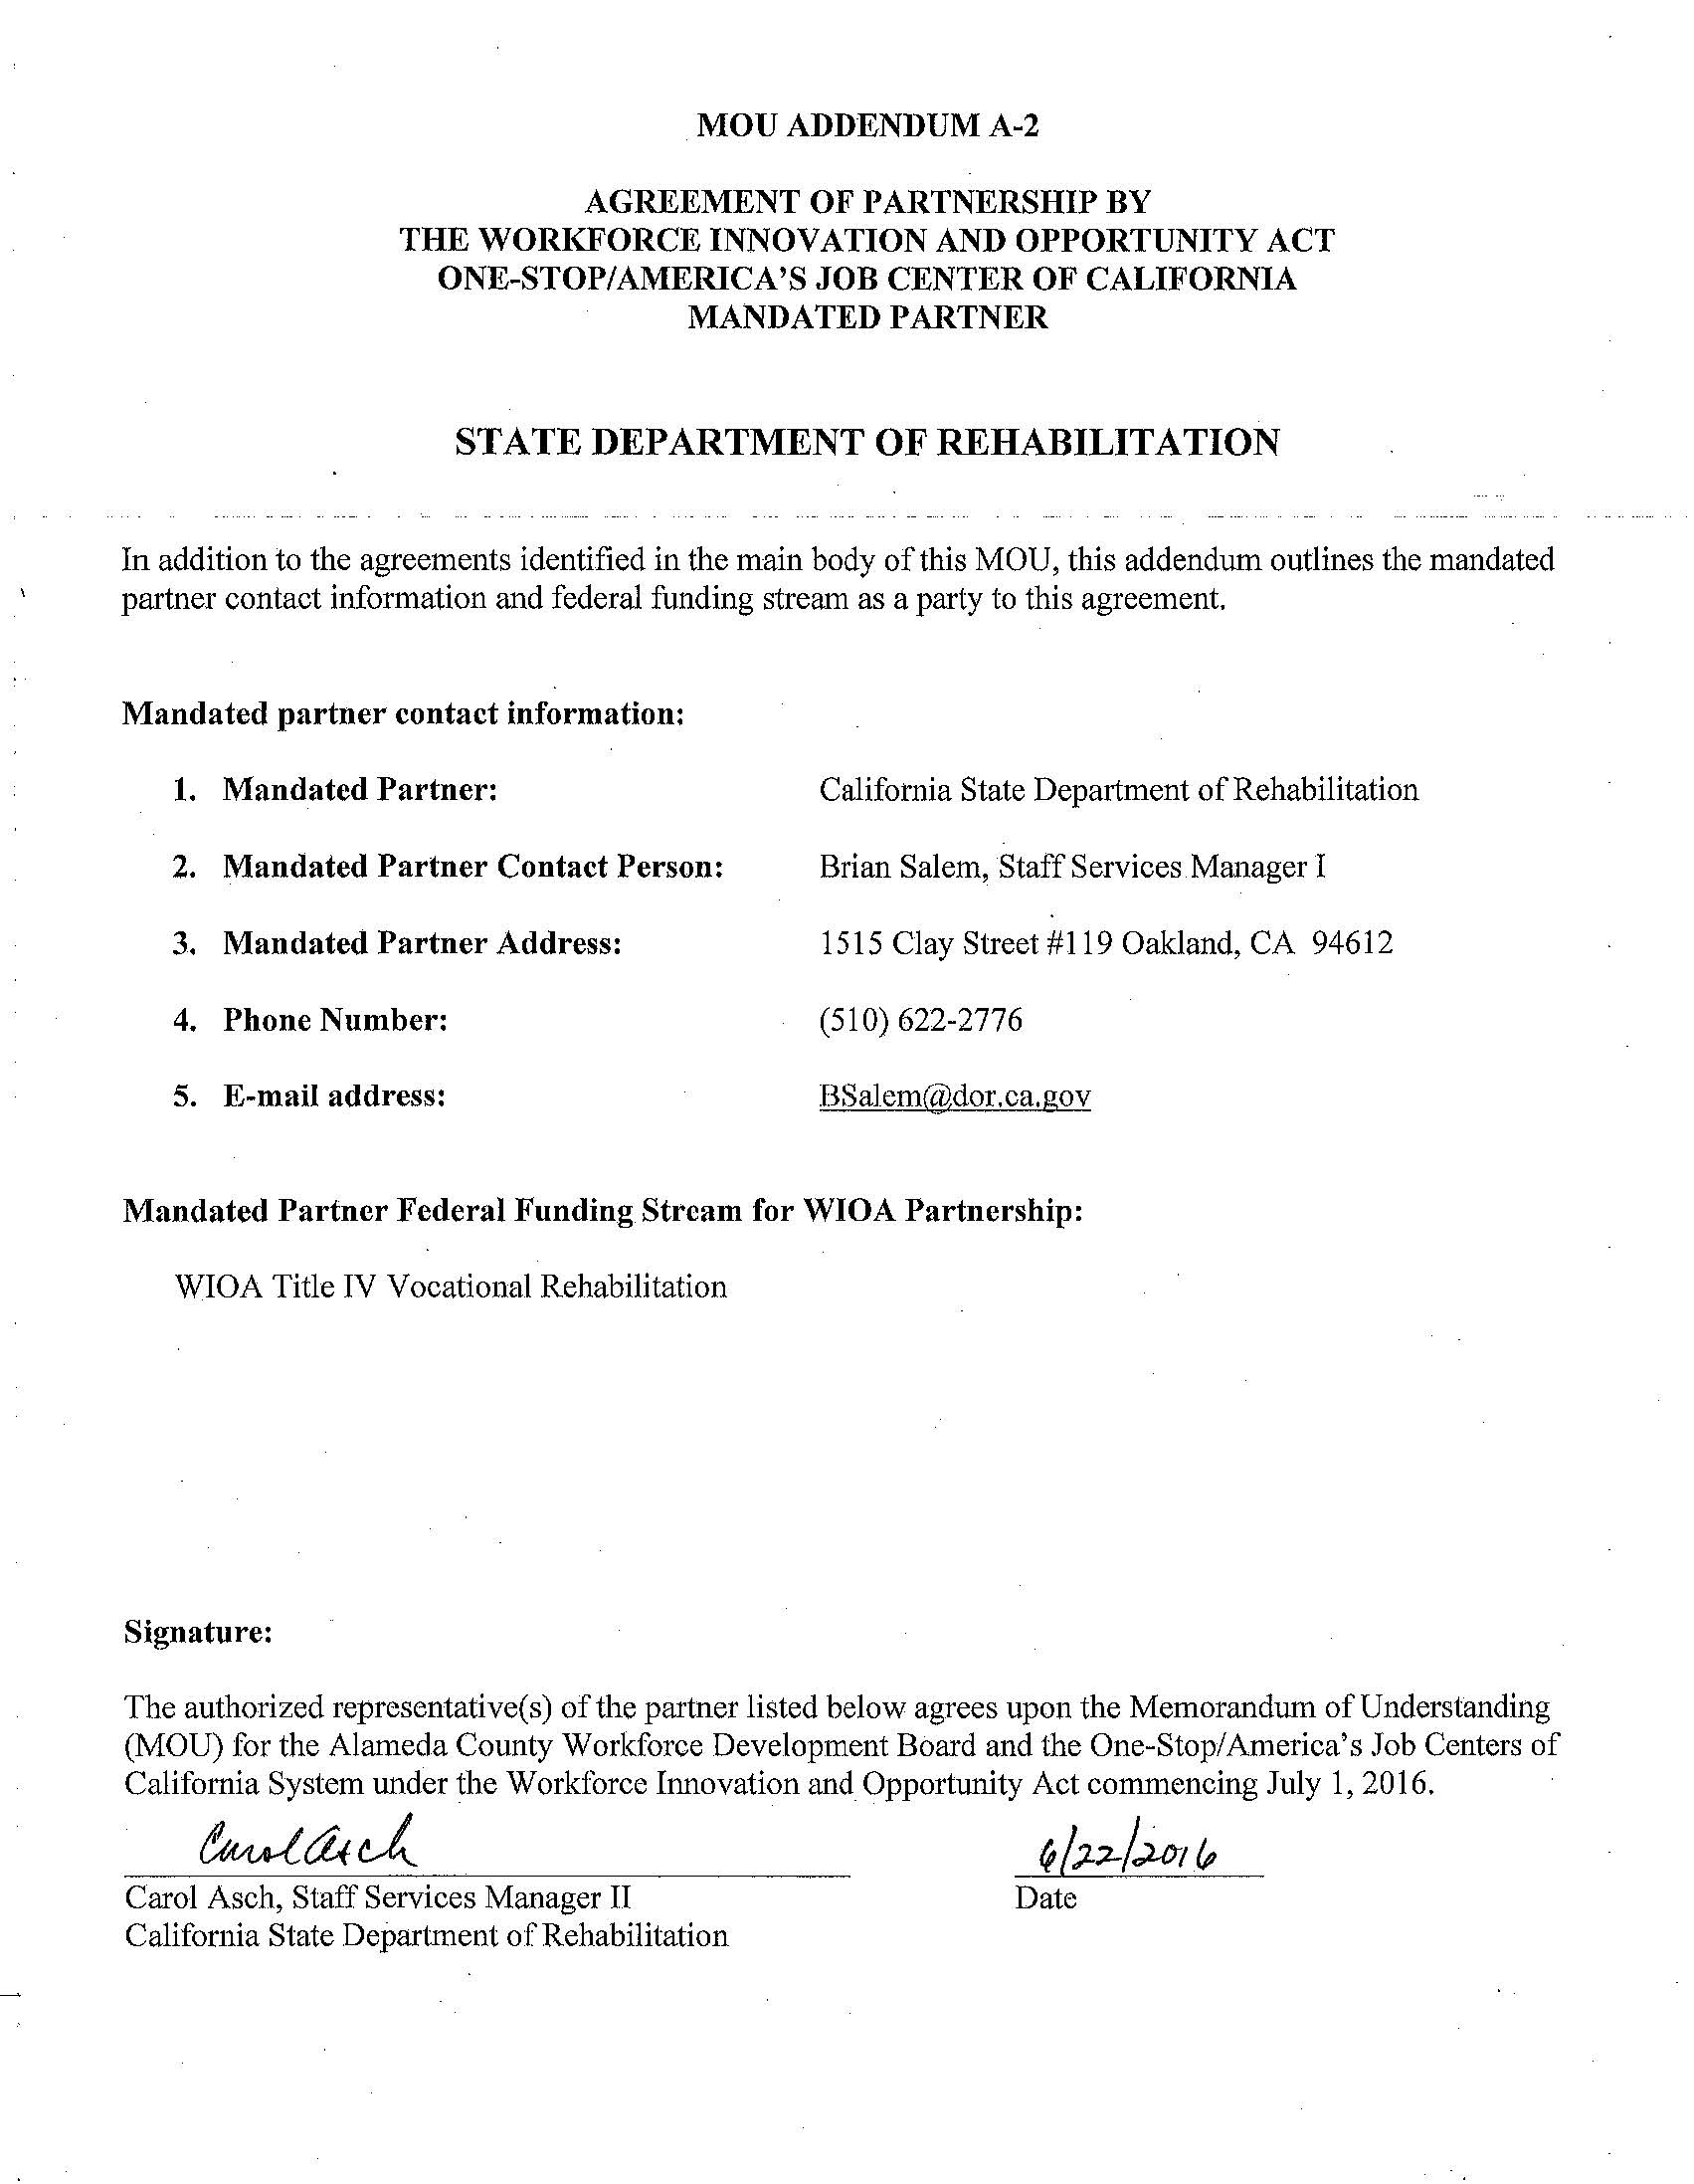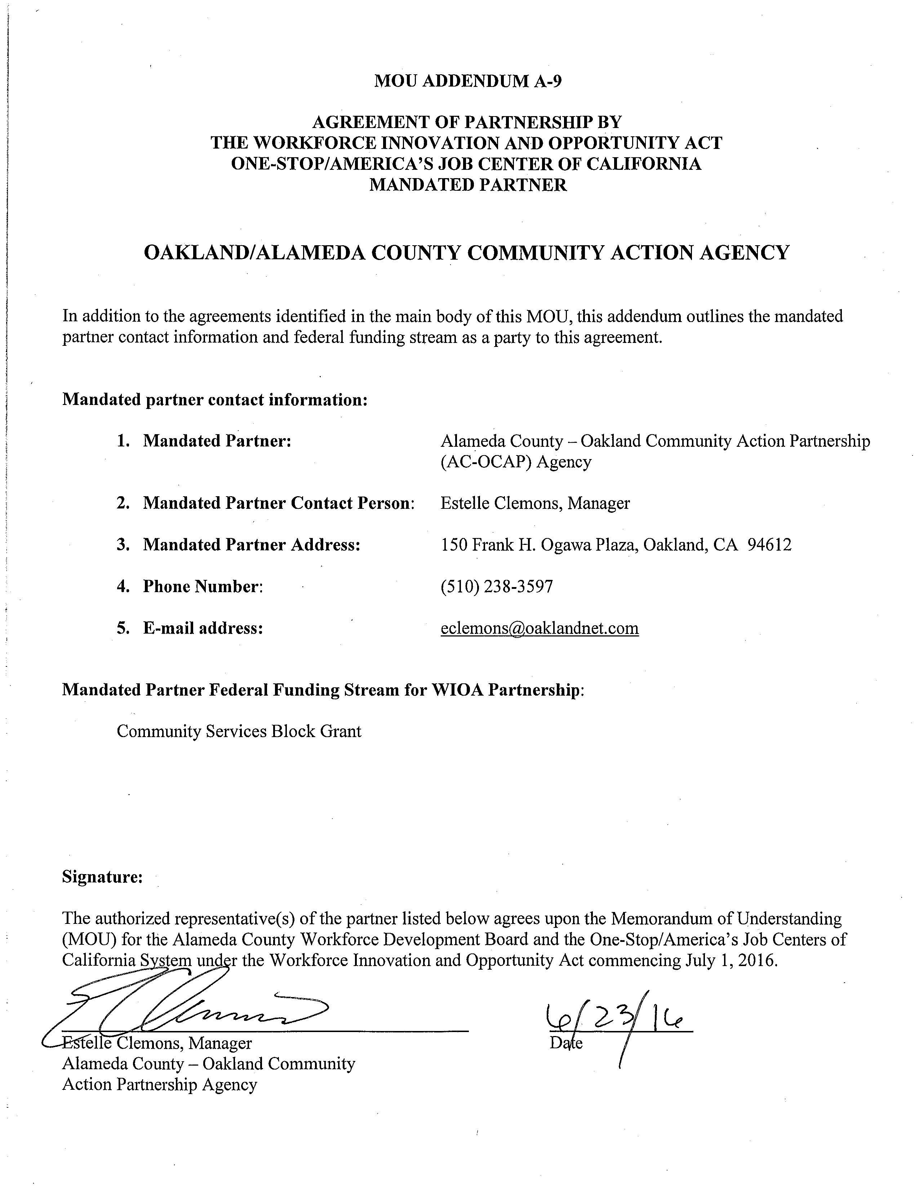
Attachment I – Table 1: ISOF Tier I Industries
Priority Industries per Planning Area
NAICS | INDUSTRY/OCCUPATION | Tri-Valley | Tri-Cities | Eden | North Cities
Health Care and Social Assistance
621111 | Offices of Physicians (except Mental Health Specialists) | 5th | 6th | 3rd | 4th
621491 | HMO Medical Centers | 1st | 4th |  | 3rd
621511 | Medical Laboratories |  |  |  | 6th
621610 | Home Health Care Services | 3rd | 2nd | 2nd | 2nd
623110 | Nursing Care Facilities (Skilled Nursing Facilities) |  | 5th | 4th | 5th
623311 | Continuing Care Retirement Communities |  |  |  | 8th
623312 | Assisted Living Facilities for the Elderly |  |  | 5th
624120 | Services for the Elderly & Persons with Disabilities | 2nd | 1st | 1st | 1st
624410 | Child Day Care Services | 4th | 3rd | 6th | 7th
Professional, Scientific and Technical Services
541310 | Architectural Services |  |  |  | 5th
541330 | Engineering Services | 3rd |  |  | 3rd
541350 | Building Inspection Services | 4th
541511 | Custom Computer Programming Services | 6th | 3rd | 3rd | 9th
541512 | Computer Systems Design Services | 2nd | 1st | 4th | 1st
541519 | Other Computer Related Services |  | 5th
541611 | Administrative Management and General Management Consulting Services |  |  |  | 7th
541613 | Marketing Consulting Services |  |  |  | 12th
541614 | Process, Physical Distribution, and Logistics Consulting Services |  | 6th |  | 10th
541690 | Other Scientific and Technical Consulting Services | 5th | 4th | 2nd | 2nd
541711 | Research and Development in Biotechnology |  |  |  | 8th
541712 | Research and Development in the Physical, Engineering, and Life Sciences | 1st | 2nd | 1st | 4th
541810 | Advertising Agencies |  |  |  | 11th
541890 | Other Services Related to Advertising |  |  | 5th
541930 | Translation and Interpretation Services |  |  |  | 6th
Construction
236118 | Residential Remodelers |  |  | 6th | 1st
236220 | Commercial and Institution Building Construction |  |  |  | 5th
237310 | Highway, Street and Bridge Construction | 4th |  |  | 6th
238210 | Electrical Contractors and Other Wiring Installation Contractors | 3rd | 3rd | 5th
238220 | Plumbing, Heating, and Air-Conditioning Contractors | 2nd | 2nd | 1st | 3rd
238310 | Drywall and Insulation Contractors | 5th | 1st | 4th | 7th
238320 | Painting, Heating, and Air-Conditioning Contractors |  |  |  | 4th
238390 | Other Building Finishing Contractors |  |  | 7th
238910 | Site Preparation Contractors | 1st | 5th | 3rd | 2nd
238990 | All Other Specialty Trade Contractors | 6th | 4th | 2nd
Advanced Manufacturing / Transportation & Warehousing
327320 | Ready-Mix Concrete Manufacturing | 4th*
331513 | Steel Foundries |  |  |  | 1st
332311 | Prefabricated Metal Building and Component Manufacturing |  |  | 2nd*
332322 | Sheet Metal Work Manufacturing | 2nd | 3rd | 1st
332710 | Machine Shops |  | 4th*
333249 | Other Industrial Machinery Manufacturing | 1st
333249 | Machinery Manufacturing (and NAICS 333514) |  |  | 3rd
333413 | Industrial and Commercial Fan, Blower and Air Purification Equipment Mfg |  |  |  | 2nd
333912 | Air and Gas Compressor Manufacturing |  |  |  | 4th*
333991 | Welding and Soldering Equipment Manufacturing |  |  |  | 3rd*
334111 | Electronic Computer Manufacturing |  |  | 7th*
334418 | Printed Circuit Assembly Manufacturing |  |  | 6th
334516 | Analytical Laboratory Instrument Manufacturing |  |  | 8th
335122 | Commercial, Industrial and Institutional Electric Lighting Fixture Mfg |  |  | 5th
335311 | Power Distribution and Specialty Transformer Manufacturing |  | 2nd*
335929 | Other Communication and Energy Wire Manufacturing |  | 1st*
335999 | All Other Miscellaneous Electrical Equipment and Component Mfg | 3rd
336120 | Heavy Truck Manufacturing |  |  | 4th
484210 | Used Household and Office Goods Moving |  |  | 10th
485410 | School and Employee Bus Transportation |  |  |  | 9th
485991 | Special Needs Transportation |  |  | 11th
485999 | All Other Transit and Ground Passenger Transportation |  |  |  | 6th
488310 | Port and Harbor Operations |  |  |  | 5th
488510 | Freight Transportation Arrangement | 6th* | 5th | 9th | 8th
492110 | Couriers and Express Delivery Services |  |  |  | 7th
493190 | Other Warehousing and Storage | 5th* | 6th | 12th

Attachment J – ISOF as a Tiered System (graphic)

Alameda County Workforce Development Board. (2016). Workforce Innovation and Opportunity Act updates. Retrieved from: http://www.acgov.org/board/bos_calendar/documents/DocsAgendaReg_11_28_16/PUBLIC%20ASSISTANCE/Regular%20Calendar/Workforce_Innovation_and%20Opportunity_Act_11_28_16.pdf
Employment Development Department. (2016). Regional planning unit summary: East Bay. Retrieved from: http://www.labormarketinfo.edd.ca.gov/Publications/REA-Reports/East-Bay-RPU-Summary.pdf
United States Census Bureau. (2015). Quick Facts Alameda County, California. Retrieved from: http://www.census.gov/quickfacts/table/PST045215/06001
These policy objectives can be found in Chapter 3: Comprehensive Overview of Policy Strategies (Corresponding to Strategic Planning Elements Required Under WIOA Sec. 102(b)(1)(D-E)) of the California State Unified Strategic Workforce Development Plan on page 73.
United States Census Bureau. (2015). Quick Facts Alameda County, California. Retrieved from: http://www.census.gov/quickfacts/table/PST045215/06001.
Alameda County Workforce Development Board. (2015). Industry and occupational projections and analysis 2017- 2022: Presentation on the opportunities in the future for the labor Force in Alameda County. Retrieved from: http://alamedasocialservices.org/acwib/info-research/documents/display.cfm?folder=documents&filename=Industry_Analysis_Presentation_V3_March1.pdf
California’s Unified Strategic Workforce Development Plan, under WIOA Program Years 2016-2020. The State Plan references low wage jobs in California were wages that were below $19.20/hr. ACWDB has a local policy within the ISOF that calls for occupations to exceed that wage threshold in relation to ITA’s and OJT’s within the AJCC programs. The ACWDB does not require that all occupations in the ISOF exceed 19.20/hr. to account for the fact that people will need entry-level on-ramps and paths as they move along their career’s trajectory, giving the ISOF some flexibility to engage with a variety of clients with different needs.
Employment Development Department. (2016). Regional and Local Planning Guidance for PY 2017-2020. Retrieved from: http://www.edd.ca.gov/jobs_and_training/pubs/wsd16-07.pdf
California Community Colleges. (2016). $200M Strong Workforce Program roll out. Retrieved from: http://doingwhatmatters.cccco.edu/StrongWorkforce.aspx
Living Wage Calculator. (2016). Living wage calculation for Alameda County, California. Retrieved from: http://livingwage.mit.edu/counties/06001.
Alameda County Social Services Agency (2012). Agency initiatives. Retrieved from: https://www.alamedasocialservices.org/public/about_us/agency_initiatives.cfm.
Alameda County Workforce Development Board. (2016). Memorandum of Understanding between the Alameda County Workforce Development Board and the Workforce Innovation and Opportunity Act mandated partners.
United Indian Nations, Inc. (2016). Letter of commitment between the United Indian Nations, Inc. and Rubicon Programs, Inc. /Comprehensive One Stop Career Center.
East Bay Works. (2016). East Bay/San Diego/San Francisco Economic & Workforce Development best practices.
Workforce Development Board of Contra Costa County. (2014). East Bay Region SlingShot initiative. Retrieved from: http://www.wdbccc.com/docs/default-source/Other/east-bay-slingshot--cwib.pdf?sfvrsn=2
Alameda County (2016). Small, local & emerging business program. Retrieved from: https://www.acgov.org/auditor/sleb/index.htm
Public Consulting Group, Inc. (2015). Anchor Institution Initiative research report. Retrieved from: http://alamedasocialservices.org/acwib/info-research/documents/display.cfm?folder=documents&filename=Anchor_Institutions_Alameda_County4.pdf
United States Census Bureau. (2015). Quick Facts Alameda County, California. Retrieved from: http://www.census.gov/quickfacts/table/PST045215/06001
Ibid.
Brown Act, Government Code §§ 54950 et seq.
Although the Brown Act requires notice be received by members 24 hours before the special meeting. The Local Plan states that the WDB requires 7 days’ notice for meetings.

